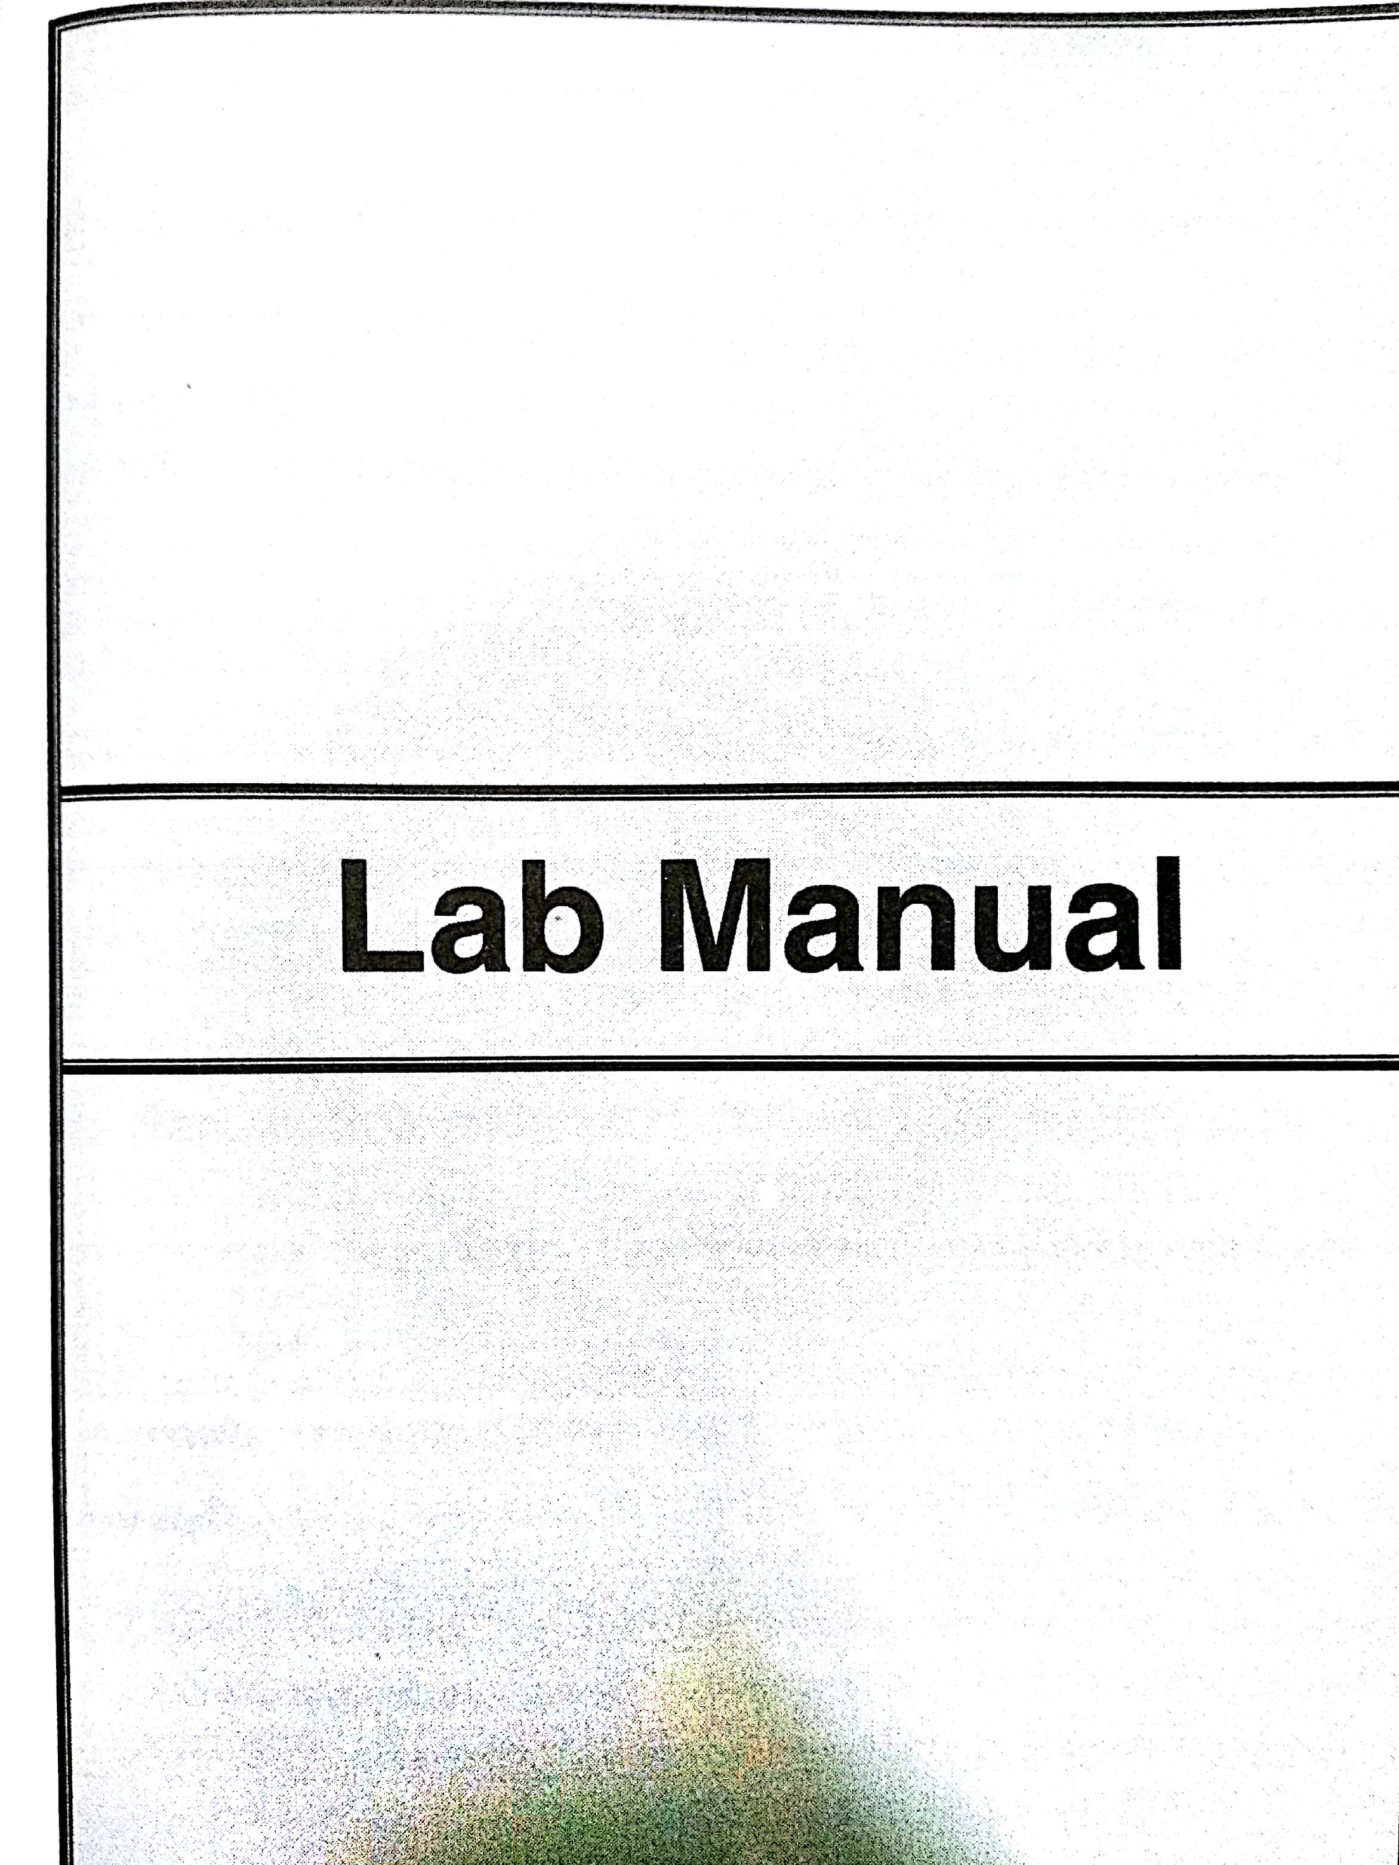



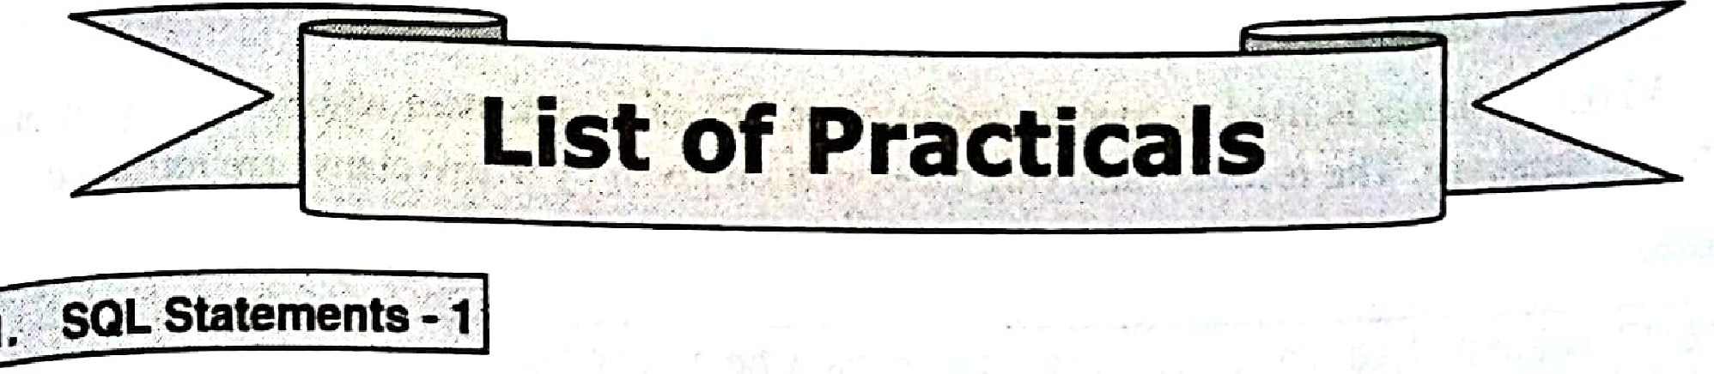

1. **Writing basic SQL SELECT Statement.**

**SELECT Query**

SELECT query is used to retrieve the data from database. SELECT query never make any change in the database.

**Syntax**

:::,SELECTcolumn name1, column namel... fro_mtable name;

If we want to retrieve data from all the columns of a table then instead of writing all the

[column name just use](https://e-next.in/) '*'. [The](https://e-next.in/) '* ['symbol represent all the columns.](https://e-next.in/)

[**For Example**](https://e-next.in/)

+

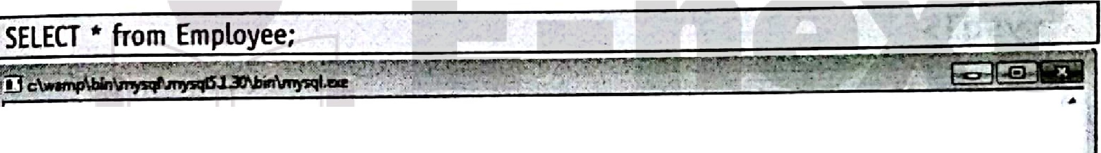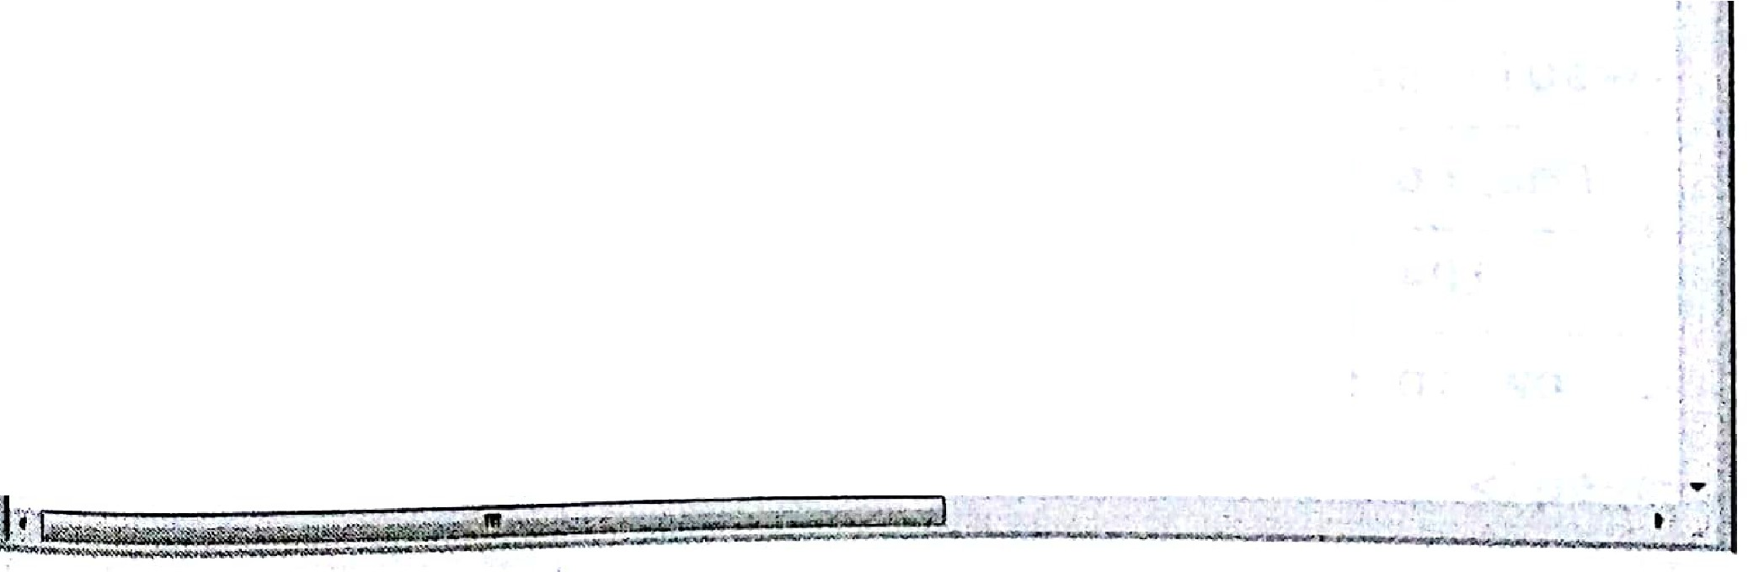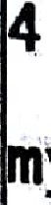

[I](https://e-next.in/)

[**.mysql> select* fro Employee;**](https://e-next.in/)

r I **Emp_no** I **Name**

[+--------+--------+--------+ +](https://e-next.in/)

[0](https://e-next.in/)

f I'

11

.

**101** I

+

**esh**I

+

I **city** · I **salary.** I

**mumba1** I

I+

I

I

+

1

103 I swati I

**102**

**vedant**

**Raj**

**pune** .

11

mumbai

,+-**rows** in +set (0.00+ sec).

·ysql>-

' I

104 I Smar

nagpur

I

+

**15000**

**25000**

15000

28000

I

I

+

With SELECT statement different clauses can be used to display the data as per our

, · requirements.

.:-·'

. .. ...·. . .. *,:*·. ; -

.,

,·

. ,.,

!,.i,-

--_·

DBMS (MU-BSC JT) L-2 Lab ManuaJ

WHERE clause

WHERE clause is used to specify condition in SELECT statement while fetching records from the database. The records satisfying the condition given by where clause are retrieved.

Syntax



SELECT column 1,columns 2... from table name where condition;

For Example

select •·from Employee where Salary > 15000;

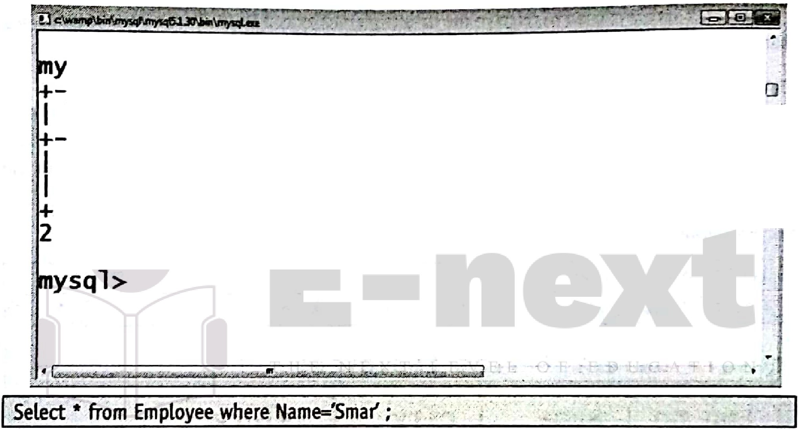

-E-m-p-_-n-o-+I

sql> select* from Employee where salary>-15000;

-------+--------+--------+ +

**Name** +I c-i-t-y

+I -s-a-l-a-r-y +I

102 I Vedant I mumbai I 25000 I

[--r-o-w-s--i-n+.-s-e-t-(-0-.-0-+2--s-e-c-)---+ +](https://e-next.in/)

104 I Smar

I nagpur I 28000 I

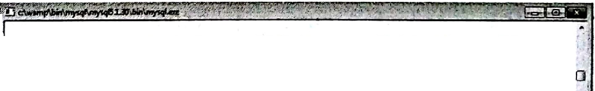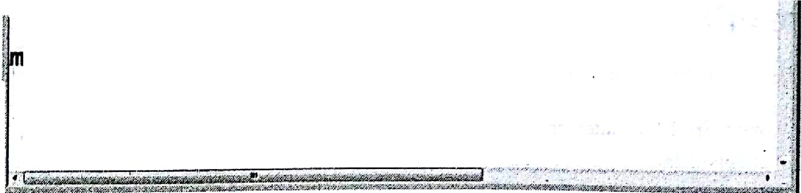

*C*. *"*

·+I Emp_no +I Name +I city

ysql> select * from Emplo·yee where·Naine='smar';

.:+I

:t+l

+I salary I+

row in s+et (0.0+2 sec)

104 +I Smar I+ nagpur I+ 28000 I+

+

+

ysql>



1. **sestrlcting and Sorting Data.**



eMS (MU-BSC IT)

L-3

Lab Manual

**DISTINCT clause**

'fhis clause is used to avoid selection of duplicate rows.

consider a situation where duplicate values for Salary column are present in Employ [3ble. and the manager wants to know the salary amount given to the employees. To avoid duplication of salary amount we use distinct keyword as follows:

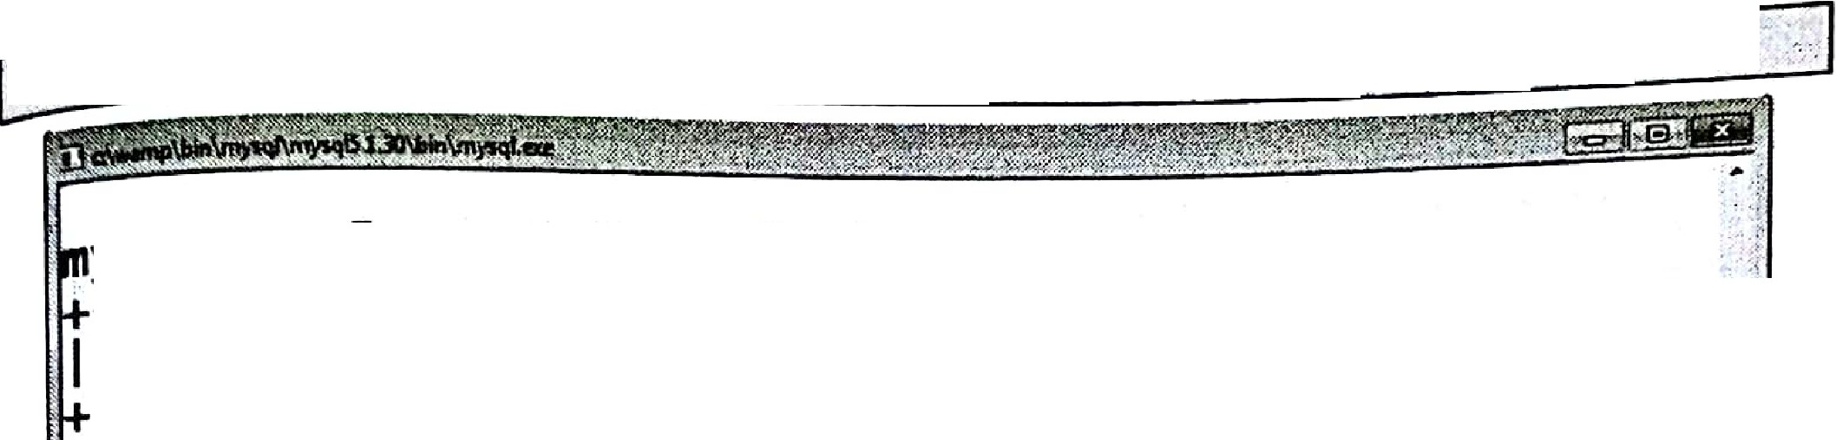

··ct..ectdistind(salary)_fro·rn··Em'ployeef·.:;<,_.,.::?*::.?:.:'.._;-·<*- *:* _:-_:_·::·.\''./ './;· \:';.'.;•:·*t;_·*·*_*

.:·{.:.> ,:.._,:

. ,.;.• ,.,.!'"..,· -. - ,,,,,,, ,.(., ......._) _.. ; .... ,. ··;,,- -- )." . -

-**y**-**s**-**ql**-**>**--s--e+l-ec-t--*--f-r+o-m--E-m-p-l-o-y+e-e-; +

I Emp_no I Name I city· I salary I

I .1-0-1-_+I j e-s-h-.+I p-u_-n-e

I

. I 102 I veaant I mumbai

I ·103 I swa i I _umbai

+I is-o-oo-+I

I 2s.ooo I

15000 I

[. I ,104· I smar I nagpur 28000 I](https://e-next.in/)

[' --ro-w--s-i--n+-se-t - (-o-.o-+o--s-e-c)---·+ +](https://e-next.in/)

[ysqi> select- distinct(sata·ry)- from Empl _yee;](https://e-next.in/)

[- +](https://e-next.in/)

[I](https://e-next.in/)

[salary I](https://e-next.in/)

[.-+](https://e-next.in/)

[I 1sooo·I](https://e-next.in/)

· 1 2so_oo I

· 28000 I

'3--ro-w-s_-· in-+ set (O •.03 sec-).

ORDER BY clause

To arrange the displayed rows in ascending or descending order of given column, Order

By Clause is used.

For **Example**

We need to display the employee information as per their joining dates in ascending order,

the query will be-



• - • I

. ,• -

.

' • ·.

·**l**·**_**:. .--'.'...-,::· ·' : ·.' _'..

DBMS (MU-8 C IT) L-4 Lab Manual

Select * from Employee order by Name;

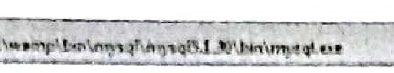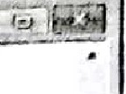

ysql> select* from Employee order by Name;

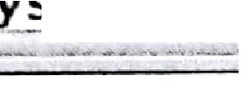

+--------+--------+--------+ +

I Emp_no I

Name I city I salary I

0

I 1041

I

+--------+--------+--------+ +

SRmaajresh f

npaugnpeur '

2185000 J

103

I 102 I

swati I mumbai I 15000 I

Vedant I mumbai I 25000 I

+--------+--------+--------+ +

4 rows in set (0.00 sec)

ysql>

_...

,,_.,_, ; -·...., ,._1:- :..,.,'.c;..,,r•••; •'•.-• . -<.,W.V• ') -.( ,. .'., .!., . "• • ' ,,.,., ...,.. ..._ ._. •• •- ,, •-: ••• ..,.., ,...,.

. . .

Now *to* display same information in descending order on job the query will be

Select * from Employee order by Name desc;

[ysql> select* from Employee order by **Name:**](https://e-next.in/)



[+I Emp_no +I Name +I city I+ salary *I*+](https://e-next.in/)

[+I ---- ---+--------+--------+ +](https://e-next.in/)

[101 I Rajesh I pune I 15000 I](https://e-next.in/)

[I 104 *I* Smar I nagpur f 28000 I](https://e-next.in/)

[*I*](https://e-next.in/)

[103 Swati I mumbai 15000 I](https://e-next.in/)

[*I*](https://e-next.in/)

[, 102 Vedant I mumbai I 25000 *I*](https://e-next.in/)

[+--------+--------+--------+ +](https://e-next.in/)

·4 rows in set (0.00 sec)

ysql> select* from Employee order by

**Name desc;**

+I Emp_no +I Name +I city +*I* salary +I

+--------+--------+--------+ +

102 I vedant I mumbai I 25000 I

*I*

103 I swati *I* mumbai I 15000 I

I 104 *I* Smar I nagpur I 28000 f

I 101 *I* Rajesh I pune I 15000

--------+--------+--------+ +

4 rows in set (0.00 sec)

1. **Single** - **Row Functions**

Single row functions can be

o **Case Conversion functions** : Accepts character input and returns a character value.

Functions under the category are UPPER, LOWER and INITCAP. o **UPPER** : UPPER function converts a string *to* upper case.

* 1. ,0WER : LO\VER fu ·

*o* llClton converts a string to lower case.

*0* INITCAP : INITCAP r, · . r

case.

For example

unctJon converts onJy the in.itfol alphabets of a stnng lo uppe

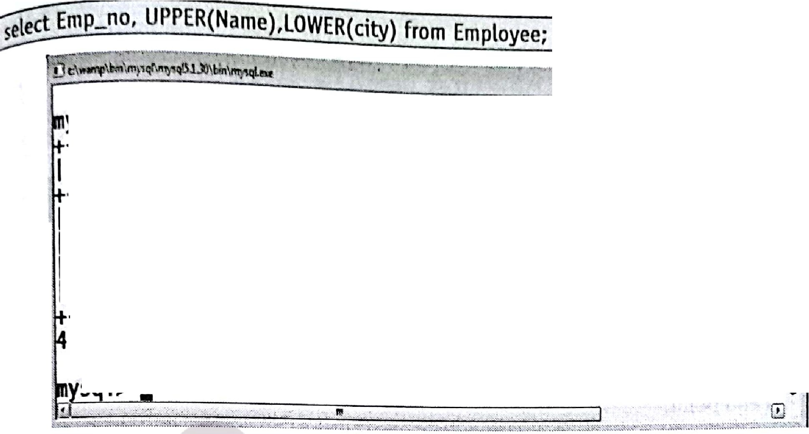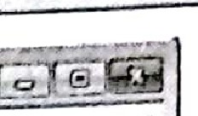

.

- ! -

: - : R(Name) , uiw;R(ci ty) from Employee;

I Emp_no I UPPER(Name) I LOWER(city) J

,

I

.

I--------+-------------+ +

101 I RAJESH

I pune

I

D

I

102 I VEDANT

I

103 I SWATI

I mumbai

I mumbai

I

--r-o-w-s--i-n+-s-e-t--(-0-.-0-0--s-e-c+) +

s 1>

104 I SMAR

I nagpur

I

I

* [**Character functions** : Accepts character input and returns number or character value. Character functions are as follows:](https://e-next.in/)
* [**CONCAT** : CONCAT function concatenates two string values. ](https://e-next.in/)

[For example](https://e-next.in/)

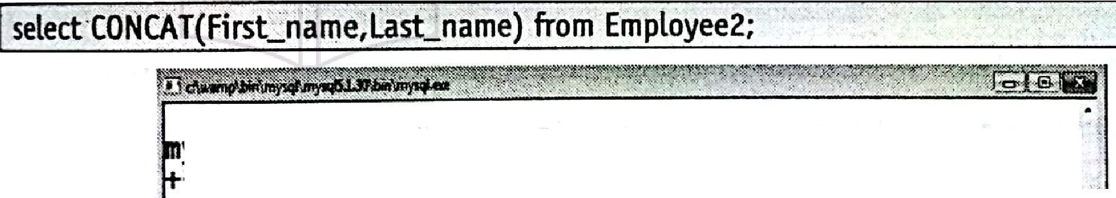

ysql> select• from Employee2;

+

+

+

+

; '. I

:I Emp_no I First_name I LasLname I city I salary I

+

: I

101 I Rajesh

+

------+I -----------+I --------I+ +I

'. I

1 I

102 I vedant

104 I smar

103 I swati

I P.owar

I sawant

I pat1l

Jadtaav

I pune . I 15000 I

I mumba1 I 15000 I

mumba1

25000

. I

I nagpur I 28000 I

<

rows in set (0.00 sec)

+ ·

+

+

+

+

*I*

'.I -m;, ; ,;;;:Last_name) I

ysql> select CONCAT(First_name,Last_name) from Employee2;.

- +

' .

l_j

r

**Rajeshpowar**

veilantjadhav

+I

: . -**S**:**l**-**l**-**a**-**r**-**s**-**a**-**w**-**a**.**n**-**t**- -.;:Jt_::"S: - . :_- - _t, 7"""""- -·-:-··-, J.

swatipatil

f fa1t1-·ab·;,rial>-····$$· *7iJ;,* t , - -;- L !. •, · ·

I



. !•'., ...

*twi* □sMs(Mu-ssc IT) L-6 Lab Manual

o **LENGTH** : LENGTH function returns the length of the input string

**For example**

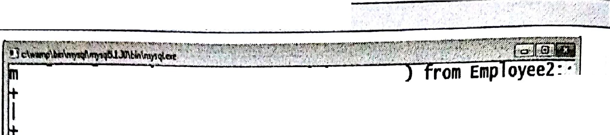

Select First_,n'am ,.LENGTH(First_name) from Employee2; :.

· ysq > se ect F1rsLname, LENGTH F1rst_name

I --F-i-r-st-_-n-a-m-e--+I -L--E-N-G-T-H-(-F-i-r-s-L-n--a-m-e-)-+I

'. .

I R-a-jesh

vedant

_swati

smar

r-o-w-s-i-n

**ysql>.**

+I

I

.-6-+I

I

s-e-t-+(-0-.-0-2

I

*.,s* I

6 I

s-e-c)

4 I

·+

* [**SUBSTR** : SUBSTR function returns a portion of a string from a given start point to](https://e-next.in/)

[an end point.](https://e-next.in/)

* [**INSTR** : INSTR function returns numeric position of a character or a string in a](https://e-next.in/)

[given string.](https://e-next.in/)

[**For example**](https://e-next.in/)



r

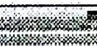

*t*

! **ysql> select F-irst_name, INSTR(First_name,_\s')**

d-----------+I----------rs-t-_-n-a-m--e-, ' +

Fi rst_n.;a,.._m-_-e+_ -:--I:N-S-.T-R.-(:F.i.

·:..s ')-"."'.·-t+

..

U vedant

f I Rajesh

q smar

I swati

I s I

·1

.1

-a I

o I

:

f: I swaraj

!i5 rows in set (<LOO 'sec)'

+ .-';"'.: : .-:

I I

: "':'. :-+·

1 I

1 I

-

,.

..·..

(' ysql>•,

•

* LPAD and RPAD functions pad the_given string upto a specifi length with a given character. *1* •
  + , I,
* **TRIM: TRIM** function.trims the string input from the start or end.

*.:* ' -, .. 

.. ... -,



MS (MU-BSC IT) L-?

for cxnmplc

Lab Manual

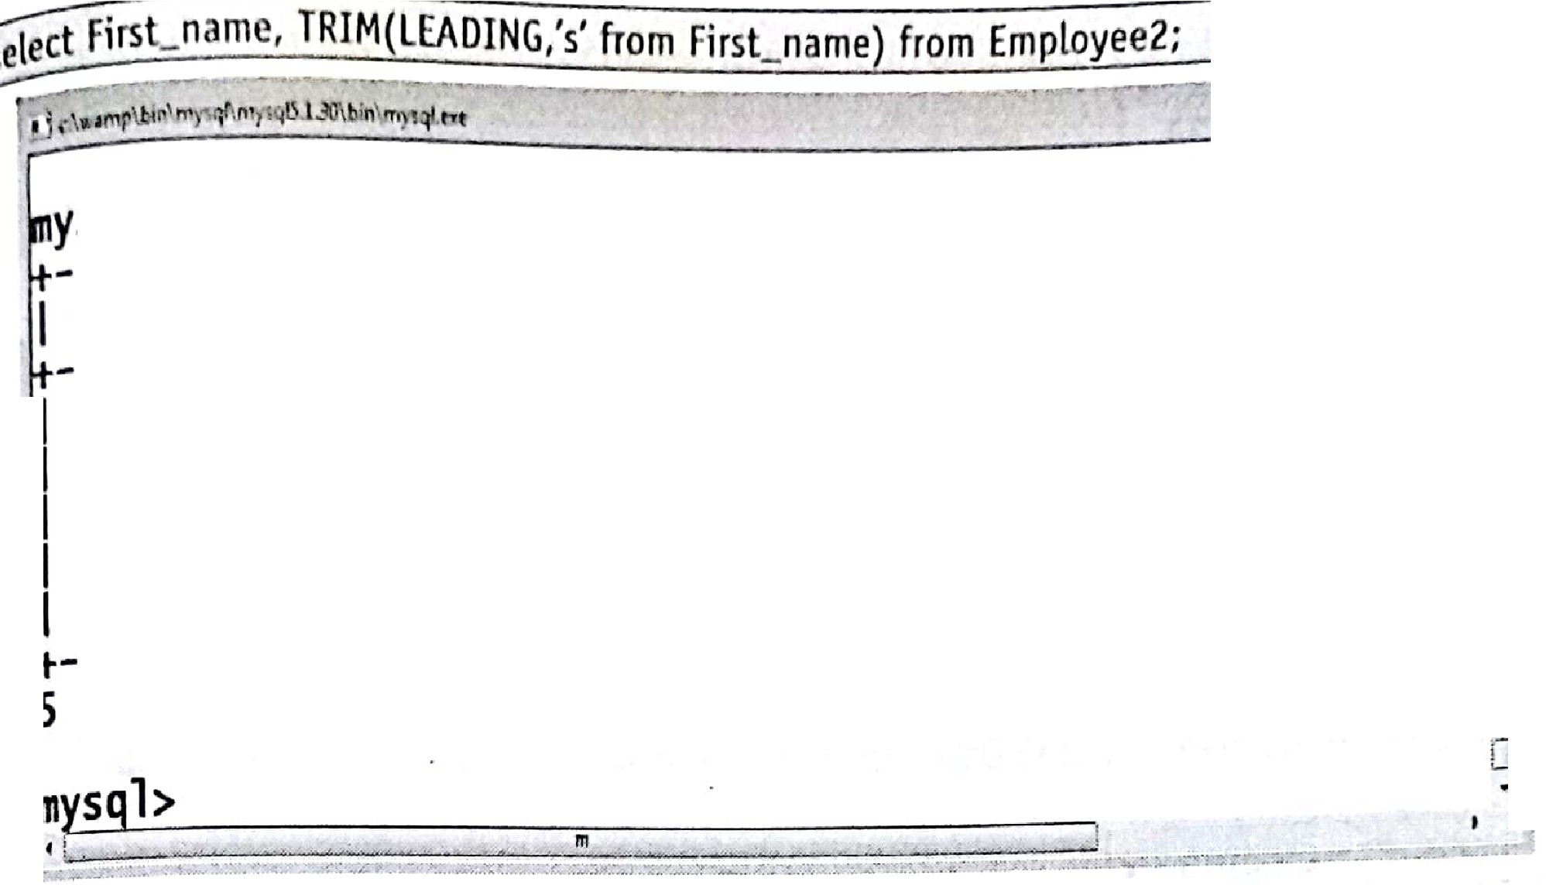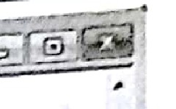

I F-i-r-s-L-n-a-m-e

· I R-a-j-es-h

ysql> select First_name, TRIM(LEADING 's' from First_name)

+I TRIM(LEADING '-s-'

f-r-o-m

I

ve ant

+I R-a-j-e-s-h

I vedant

I smar

swati

I wati

I mar

F-i-r-s-t-_-n-a-m-e-)-+I

+I

I I I

s--r-ow-s--i-n--s--e-t+(-0-.-0-0--s--e-c-) +

I swaraj

I waraj

I

o.

* [**REPLACE** : REPLACE function replaces characters from the input string with a given character.](https://e-next.in/)
* [**Number functions** : Accepts numeric input and returns numeric values. Functions under the category are ROUND, TRUNC, and MOD.](https://e-next.in/)
* [ROUND and TRUNC functions are used to round and truncate the number value.](https://e-next.in/)

[**For example**](https://e-next.in/)

I SELECT ROUND(84.555,1) from dual;

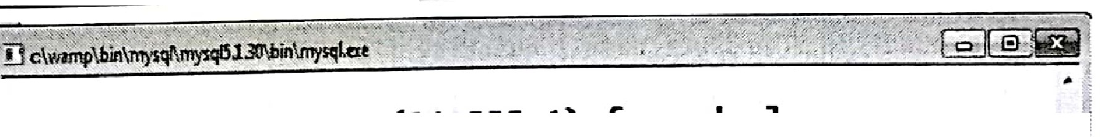

*i* ysql> select ROUND(84.555,1) from dual;

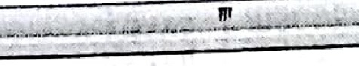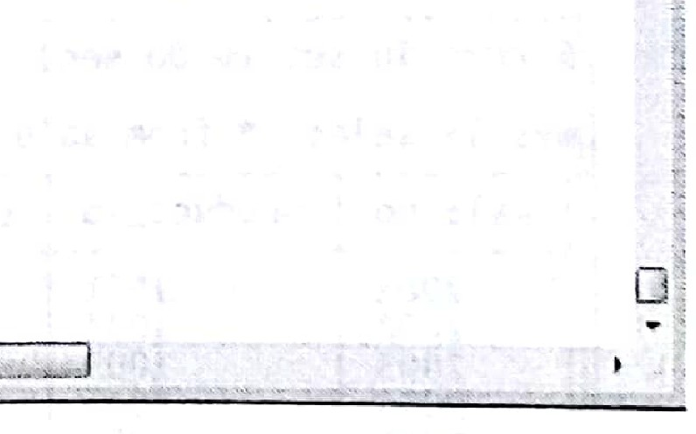

Id

I +

ROUND(84.555,1) I

84.6 I+

1 row in set (0.03 sec)

- +

o MOD is used to return the remainder of the division operation between two numbers.

**For example**

@:_LECT MOD(10,2) from dual;

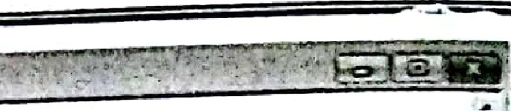ff]:DBMS (MU-BSC IT) l-8 Lab ManuaJ

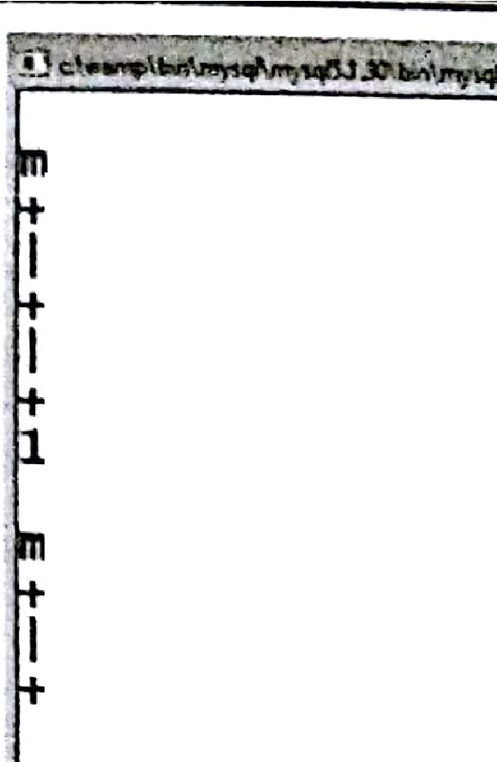



ysql> SELECT MOO(l0,2) from dual;

I --M-O-D-(-l-0-,--2-)-+I

I o-+I

--r-o-w--i-n--s-e-t+(0.00 sec)

-y-s-q-l->--S-E-L-E-C+T MOD(25,2) from dual;

I M00(2s, 2) I

I 1 -+I

. +

:1 row in set (0.00 sec) @!

.

*:*

12 **SQL Statements** - **2** I

1. [Displaying Data from Multiple Tables.](https://e-next.in/)

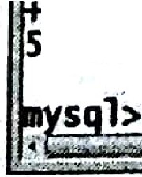

[To understand joins consider following two tables.](https://e-next.in/)

[For example](https://e-next.in/)

sql> select* from·product_details;

+ +: + , +

_f product_id I productJ'lame I quantity I price I

: I ------1-0--0-1I--+-p-e-n-d-r-i-v-e-----·-1+------1-00---I+---90-0---I+

I 1002 **harddisk** I 200I **4000** I

1003I headphone I 1000 15000.f

-1 1004 DVD 20 I 1000

I 1005 I speaker 600 I 2400 I

. +

·S **rows** in set (0.00 sec) •,

' 'l:

. t -

·: sql>·selett • from sale_details; L;'.,

+ - + . -+. - + + ·I

I sale_no J producLid I_quantity I price I customer: name ff

+

+

.+ . + , +·•a.

## . I,

2001 I 1001 I 50 I "900 I savni lh

2002 1004 I .10 I .1000 I savni fi/'

,- 2003. · 1Q03 I ,120·11sooo1-savni 11/

. . · 2004, 1005 I '420 2400· harsh i:::

, · · ··· · · ·•

+· s:;:·

I 2005, 1002 I 40 4000 -Akash

s·•*'inl.s+et (0.02 sec+)...,·.,

· ·,··-+···

t*v*·

, -"

., · ..

•. .'.'_;_.,:·..*;;.:*

:. ,,.-,, ,",',

:..

* 5':t r :'?'.it:t{t ):LS:::ft'{f;f.t'.



Lab Manual

Jnller Join (Equi Join)

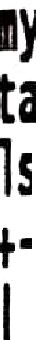

Toe INNER JOIN is used to display records that have matching values in both tables.

syntax

select column_name_list from table_l .

INNER JOIN table_2

where table_l.column_name =·table_2.column_name

**For Example**

elect product_details.product_id, product_name, customer_name , sale_detai_ls quaritityi.'. product_details.price from product_details INNER JOIN sale_details

on · ·. .· ··· · ··. ;·

product details.product id=sale details.product id ; ·.·-_

¥,

(

- ....::.:::..;s:::.:..!£li. :E 222 _:_ ===l

' .. ;

· ysql> select product_details.product_id, product_name, customer_name, sale_de.*l* [ails.quantity, product_details.price from product_details INNER JOIN sale_detai](https://e-next.in/)

[ls on product_details.product_id=sale_details.producLid ; :](https://e-next.in/)

##### [I](https://e-next.in/)

[: -I](https://e-next.in/)

[product_id I product_nue I+customer_name I quantity I price J](https://e-next.in/)

[I '](https://e-next.in/)



.

[1001 I pendri ve I savni 50 *I* 900 I](https://e-next.in/)

[,I 1004 I DVD I savni 10 I 1000 I](https://e-next.in/)

[,I 1003 I headphone I savni 120 I 15000 I](https://e-next.in/)

;I 1005 I speaker harsh 420 I 2400 I -

;I 1002 I harddisk Akash 40 I 4000 I :··(

I•••------•• •--•---••---•-+••--••••-••••• -------• ••---- :i.



;5rows in set {0.02 sec) \j

*1*•.•

t:::. j :_+w- -!;;:"r:- :> ""t

**y**;**s**;**q1>** t■,.r ..;,. ""'- -- *"' ...*

*-*,*:-*·*..* •> • .1 ,,;_.a ,-_, ;

*tto. J"•'.* l

. *.J;.::...,:.u.:..*

*:!..2l;ff"* • '

'.r.i;;". -;7,-)i"-•,'·• •· . .

J. •

Outer **Join·**

Outer Join is based on both matched and unmatched data. Outer Joins subdivide further

into,

, (i) Left Outer Join ·: (ii) Right Outer Join

. I, ,

,• ,_ .

_·., ....

t!

.. '

" •. •

'



•

T

I --!• *:,*

KPL DBMS (MU-BSC IT)

L-10

. ***,z***

Lab ManuaJ

iii

1. **Left Outer Join**

The SQL LEFT JOIN returns all rows from the left table, even if there are no matches in ·

the right table. Null values are shown at the place of right table values.

**Syntax**

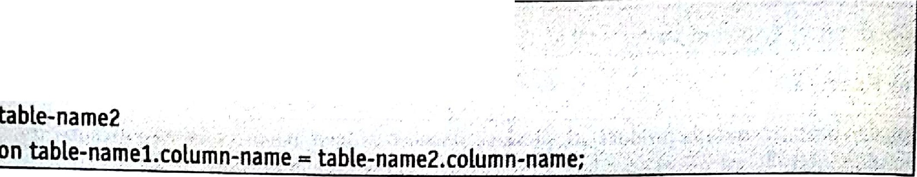

SELECT column-name-list

from table-namel

LEFT OUTER JOIN . · ·.. ·

., .

,,

**For Example**

_sal ..::.details.customer_name FRo'M product etails.LEFT;puJE**-**R**IN**sale:.:.d tai :_0 (</.-.!,:/f

S ECT product.:detail.s ptodutt.Jd;··product detaits:Jiro8 c(.11 ·m·e {- -_< , ·:,_..··::,,.- : . *) ·:*\;

sale details.product id =product detaUs.produdJd;":-/·:_/':;·_·:- \;.',, ·;:" ·. ; :'. .; ·*,*.*::*·:;,._';/

1

[, ,](https://e-next.in/)

*:·*



['](https://e-next.in/)

[... '" .• •' •· , ··- ,, •, • ,--s., ;](https://e-next.in/)

[l](https://e-next.in/)

* [...1](https://e-next.in/)

[!: fSqb SELECT product_det ils.produc _id, pr0duct_detai1s.product-=11ue, **sale_det.**](https://e-next.in/)

[*:* 1ls.cust011er_nue FROM producLdeta1ls LEFT OUTER JOIN sale_deta1ls ON sale_det -](https://e-next.in/)

[: ils.producLid =product_details.product_id; , · , ,,](https://e-next.in/)

[+](https://e-next.in/)

[;r](https://e-next.in/)

f· 1 product_id I prodlJct_name I customer _name I } ·!

t ----------- --------------+---------------+ : 1iJ

. I 1001 I pendrive I savni I

iI 1002 I harddisk I Akash I *:* :;,

1003 I headphone I savni I 1

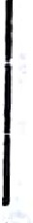

1004 I DW savni_ I j

, 1005 I speake.r harsh . I :

l 1:

-••••-•--•- •-•--•--•••-•• ••• •-•--•••

'.,1,,.

j rows in set (0.02 se ) ti

. . tJ1

*i'.,} jt <'fi J;!r:;;:4hfuraf.¢:i:1mwimitY&'&. 11 -it 7iir:k i,t i$w' ffe.'iit:ii %1F .ii :tt;W..¾:} izt\it. i J*

1. **Right Outer Join**

Returns all rows from the right table even if there·are no matches in the left table. Null values are shown at the place of left table values.





(MDBMS (MU-BSC IT) L-11 Lab Manual

**Syntax**

-select column-name-L;st

from table-namel

RIGHT OUTER JOIN

table-name2

on table-namel.column-name = table-name2.column-name;

**For Example**

SELECT pr?duct_details.product_id, product_details.product_:_name,· . sale_deta ls.customer_name FROM product_details RIGHT OUTER JOIN sale_details ON sale_deta1ls.product_id =produd details.product id;

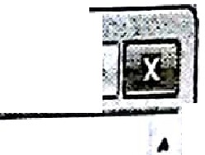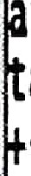

## · _rs'1.t. :-

. ., ,. .- ·. . .

: ysql> SELECT product_details.product_id, product_details.product_name, sale_det.

[· ils.customer_name FROM producLdetails RIGHT OUTER JOIN sale_details ON sale_de](https://e-next.in/)

[. ails product_id =product_details.product_id;](https://e-next.in/)

[I. + +](https://e-next.in/)

[product_id I product_name I customer_name I](https://e-next.in/)

[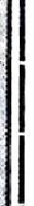: 1001 I+ pendrive . I savni +](https://e-next.in/)

[1004 I DVD I savni](https://e-next.in/)

[1003 I headphone I savni.](https://e-next.in/)

!I 1005 I speaker I harsh I

I 1002 I harddisk I Akash I

:' + +

isrows_in set (0.00 sec) ri -

!=:-ii

/,; .:. } ,. ;\/:;;tr tS :iJ/rft,·tM•"/l,..'.l "' F;"W.• ....1,-::<10rx· -i:,::-irhz-•.,.rt 1;, ,,:r- •:;:t•.;•, --":":1,;:;',:;; "1,.:i/ ,·::-,\...:,.. >..:.;:·""_-·«_.,-',-·•,•,··:'.':1 v:,·-.:;,• --:··v":', '.

1

1. **Aggregating Data Using Group Functions.**

**CountO**

This function returns total number of values of specified column of the table.

*;:-* . . **For Example** . . . .

... .- ... t

. ',

.,!,,.. • • '

.



'.

'i-1.

*L:i :ii:LZ1il'*.*.i*.*t.*•::::- ;:;,.·.

Writea q1,1ery toretrieve count of employees who join in 2015 year.

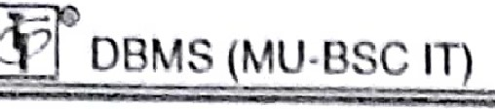

L-12

Lab Manual



ysq s ct* ram Emp oyee2;

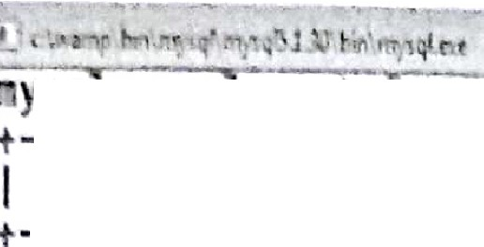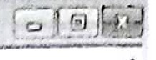

+ + + + +

I Emp_no I First name I Last name I city I salary I

+

+

+

+

+

101 I Rajesh I powar I pune I 15000 I

I

I

I 102 I Veda t I jadhav mumbai I 25000 I I 103 Swat, I pati1 I mumbai I 15000 I I 104 s ar I sawant I nagpur I 28000 I

I 105 I swaraj I sawant I nagpur I 20000 I

5 r-o-w-s in+set (0.00 sec+)

+ + +

ysql> select count(Emp_no) from Employee2 where First_name like 'swa91i'; count(Emp....no) I

I +

- +

I

2 I

. +

row in set (0.00 sec)

· = , I .. :



........ ,_ -:-(-.:·· ---= -·-- · : 1. -.:j i. :·: - . - :.:t.t-::··,: ·-· :., *--:* \ '";..l

**SumO**

[This function returns sum of a]) the values of specified column of the table.](https://e-next.in/)



[**For Example**](https://e-next.in/)

[Write a query to to find total salary amount paid to all the employees.](https://e-next.in/)

[I select Sum(Salary) from Employee2;](https://e-next.in/)

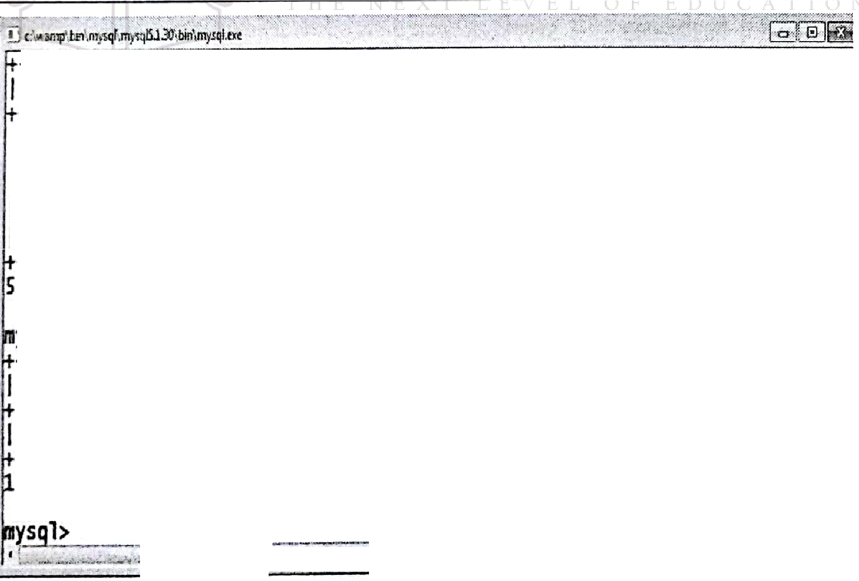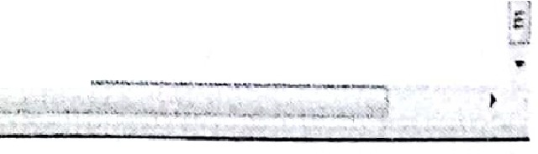

I --------+------------+-----------+--------+ +

--------+------------+-----------+--------+ +

Emp_no I First_name I LasLname I city I salary I

I I I

J

103 I swati

102 I vedant

101 I Rajesh

I patil

I jadhav

I **powar**

I pune I 15000 I

I mumbai I

I mumbai I

25000 I

5 rows in+

I

105 I swaraj

104 I Smar

I sawant

I nagpur I

15000 I

28000 I

set (0.00

sec)

I sawant

+

I nagpur I

+

+

20000 I

+-

ysql> select sum(salary) from Employee2;

I -s-u-m-(-s-a-l-a-r-y-)--+I

I

- +

1-0-3-0-0-0

+I

row in set (0.00 sec)

_\.,:.,w-4,...." ,.:..!L :.::. ·.:

_.; .....'!.!..,:.... ,,....

*'F*

•• . *r*••.11.

•

;

**jiP**

**l\1in()**

Titis function·returns smallest value from specified column of the table.

**For Example**

\¥ritea query to retrieve record of employee who gets leastsalary.



f. -s-e -:_! -**E**

**loyee2;**

·

Select from Employee2 where Salary -(Select min(Salary) from Employee2);



* I **Emp_no** -+I **First_name** I **Last_name** I **city** I **salary** I



. + ---------+--------+ +

I--------+------------+-----------+--------+ +

101 I Rajesh I powar I pune I 15000 I

[](https://e-next.in/). I 102 I Veda t jad av I mumbai I 25000 I [I 103 I swat1 I pat11 I mumbai I 1sooo I I 104 I Smar . I sawant I nagpur I 28000 I](https://e-next.in/)

* [I 105 I **swaraJ** I sawant I nagpur I 20000 I](https://e-next.in/)

[--------+------------+-----------+--------+ +](https://e-next.in/)

[Is](https://e-next.in/)

[rows in set {0.00 sec)](https://e-next.in/)

[ysql> select from E11ployee2 where salary=(Select min(Salary) from Employee2);](https://e-next.in/)

I + + + +



Emp_no I First narne I Last_name I city I salary I

--------+------------+-----------+--------+ +

101 Rajesh powar pune 15000

I I I I I

103 I **swati** I patil I mumbai I 15000 I

--------+------------+-----------+--------+ +

12 rows in set {0.00 sec)



**Max()**

This function returns greatest value from specified column of the table.

**For Example**

Write a query to retrieve rec rd of employee who gets maximum salary.

Select * from Employee2 where Salary=(Select max(Salary) from Employee2);

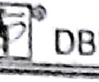BMS {MU-BSC 1n L-14 Lab Manual

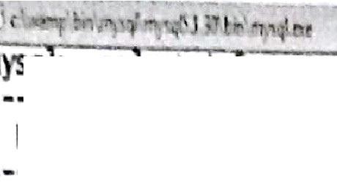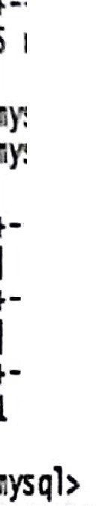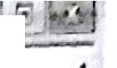

0

)'SQ *se* cct ro.El!lJ)loyee2;

IE _no

--------+------------+-----------+--------+ +

+ I first_nam+I LastJHm +I city

e

e

I+ s lary I +

101 Rajesh

103

104

10

Vedant SW ti ar

po ar jadhav

pune

patil

1J1Umbai

15000

25000

15000

-r------in-+s-e-t--(-0-.-0-0--s-e-+c-)----------+--------+ +

rsql>

ysql> Select* from Employee2 where salary=(Select max(Salary) from Employee2);

105

SYiaraj

j sawant

sawant

I nagpur

nagpur

mumbai

20000 I

28000

I--------+------------+-----------+--------+ +

I --------+------------+-----------+--------+ +

Emp_no I First_nameI Last_name I city I saJary I

1 --------+------------+-----------+--------+ +

104 I **Smar** I sawant I nagpur I 28000 I

row in set (0.00 **sec)** 8

U·



[AvgO](https://e-next.in/)

[The folJowing SQL statement finds the average salary of all employee:](https://e-next.in/)

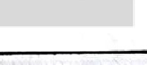

[**For example**](https://e-next.in/)

[select Avg(salary) from Employee2;](https://e-next.in/)

### [I](https://e-next.in/)

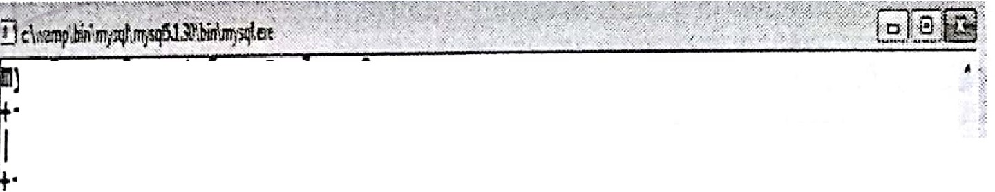

ysq *>* se *ect:* rom Emp oyee2;

I--------+------------+-----------+--------+ +

Emp_no I First_name I Last_name I city I salary I

101 I+

+

103

102 Vedant

Rajesh

105

104

swaraj

swati Smar

powar jadhav

patil

I sawant

I sawant

I pune mullbai 1RJnbai nagpur nagpur

+

+

28000 I

15000

15000

25000

20000 I

rows in +

set (0.00 sec)

+

ysql> select Avg(salary) fr011 Employee2;

I--A-v-g-(-s-a-l-a-r-y-)-+I

I +

20600.0000 I

**ror** in set (0.00 sec)

·-



MS (MU-BSC IT)

L-15 Lab Manual

1. **Sub queries**

**sub-Queries**

Writing a query inside another query is known as nested query or subquery. The inner query get executed first, then the output on inner query is given as input to outer query.

Consider the previous emp table

**Example**

To display records of employees working in SMITH's department

Select * from emp where deptno:::,

(select deptno from emp where ename = 'SMITH');

**Output**

[p. _ **Manlpulatlng : ata**· *:*I](https://e-next.in/)

|  |  |  |  |  |  |  |  |
| --- | --- | --- | --- | --- | --- | --- | --- |
| **EMPNO** | **ENAME** | **JOB** | **MGR** | **lllREDATE** | **SAL** | **COMM** | **DEPTNO** |
| 7566 | JONES | MANAGER | 7839 | 04/02/1981 | 2975 |  | 20 |
| [7788](https://e-next.in/) | [SCOTT](https://e-next.in/) | [ANALYST](https://e-next.in/) | [7566](https://e-next.in/) | [12/09/1982](https://e-next.in/) | [3000](https://e-next.in/) |  | [20 .....](https://e-next.in/) |
| [7902](https://e-next.in/) | [FORD](https://e-next.in/) | [ANALYST](https://e-next.in/) | [7566](https://e-next.in/) | [12/03/1981](https://e-next.in/) | [3000](https://e-next.in/) | ['j](https://e-next.in/) | [20 , '](https://e-next.in/) |
| [7369](https://e-next.in/) | [SMITH](https://e-next.in/) | [CLERK](https://e-next.in/) | [7902](https://e-next.in/) | [12/17/1980](https://e-next.in/) | [800](https://e-next.in/) | [//](https://e-next.in/) | [20 l l... I](https://e-next.in/) |
| [7876](https://e-next.in/) | [ADAMS](https://e-next.in/) | [CLERK](https://e-next.in/) | [7788](https://e-next.in/) | [01/12/1983](https://e-next.in/) | [1100](https://e-next.in/) |  | [20](https://e-next.in/) |

**Data Manipulation Language (Dl\1L)**

[r - I](https://e-next.in/)

* The Data Manipulation Language (DML) is used for accessing and manipulating data in a

database. It allows users to access, insert, update, and delete data from the database.

* + To insert record into the table- **INSERT**
  + To access or read records from table - **SELECT**
  + Update the records in table- **UPDATE**
  + Delete the records from the table - **DELETE**

1. **Using INSERT STATE:MENT**

**1 Inserting record into tables**

After creation of table the insert command is used to insert one or more records in the

table.

Insert query has different forms.

' ,

......

..

.[l'·. '

-..,;._.,

., .

• • : r• •: • :\ ,\\/.,.

ff

DBM (MU-8SC *IT)*

**L-'16**

Lab Manu-al

**Formal l** : **111·rrling n sin lc row of'dntn info uwhle**

**Syntnx**

Insert into table_name[(column_namel, colurnn_name2,... )J values (value], value2 );

**For c.·ample**

**l.** lnscrl *5* records in Employee table

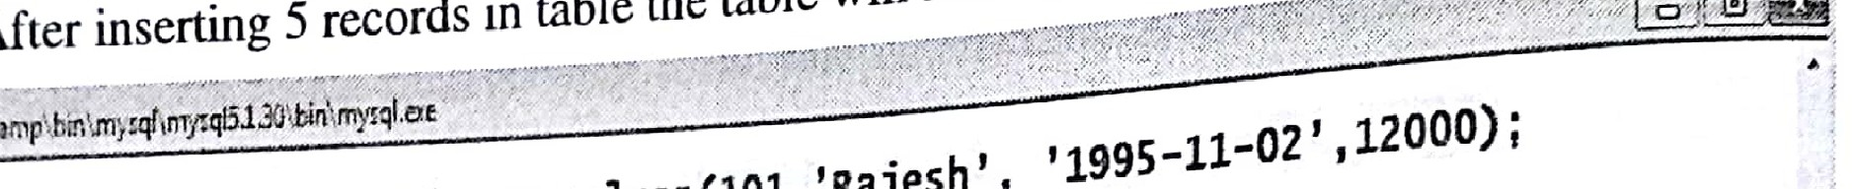

*(102* 'Swati' '2015-01-

Insert into Employee values(101,'Rajesh', '1995-11-02', 12000)' ' '

07',20000), (103,'Vedant','1999-05-03',30000), (104,'Vedika','200S-OZ-

10',52000),(105,'Ankita', '201603-01',8000);



. **ysql> Insert into Employee values(lOl,'Rajesh', '1995-11-02' ,12000)i uery OK, 1 row affected (0.02 sec)**

[**ysql> Insert into Employee values(l02,'SWati', '2015-01-07',20000);**](https://e-next.in/)

[uery OK, l row affected (O.OO **sec)**](https://e-next.in/)

[**ysql> Insert into Employee values(l03,'Vedant','1999-05-03',30000);**](https://e-next.in/)

[· **uery OK,** 1 **row affected (0.00 sec)**](https://e-next.in/)

[ysql> **Insert** into **Employee values(104,'Vedika','2005-02-10',52000); uery** OK, 1 **row affected (0.00 sec)** . .](https://e-next.in/)

[**ysql> Insert into Employee values(105,'Ankita', '201603-01',8000);**](https://e-next.in/) **uery OK,** 1 **row affected,** 1 **warning (0.00 sec)**

**ysql> select\*** from **Employee;**

I --**Em**-**p**-**l**-**o**-**y**-**e**-**e**-**_**-**n**-**o**--+*I* -**E**-**m**-**p**-**l**-**o**-**y**-**e**-**e**-**_**-**n**-**a**-**m**-**e**--*I*+-**j**-**o**-**i**-**n**-**i**-**n**-**g**-**_**-**d**-**a**-**t**-**e**--I+-**S**-**a**-**l**-**a**-**r**-**y**--I+

**1**-I**0**-**1** +f -**R**-**a**-**j**-**e h** *I*+-**1**-**9**-**9**-**5**-**- 1**-**-**-**0**-**2** *I*-+ **1**-**2**-**0**I-**0**-**0** I+

**102**

**swat1** f 2015-01-07 **20000**

**103 *Ved nt*** *I* **1999-05-03** I **30000**

*I*

*l*

**104 Ved1ka 2005-02-10** I **52000**

**105 Ank1ta** 0000-00-00 f **8000**

**5 ro**-**w**-**s** i-n **s**-**e**-**t (**+**0**-**.**-**0**-**0 s**-**e**-**c**-**)** +

**,,rnl'-**

-+ +

* 1. Consider we do not have value for salary while · ·

table. Then the query will be msertmga new record in Employee

It will set salary value for the employee as NULL.

values(l06,'Ankur','2017-03-l5');

Insert into Employee(Employee no; Employee name J . . .

. - .

'·ommg_date)·.

' ··1



, r;f i7 1 ) oyee(Emp1oyee..no,Ernployee_r1c1111e,Joining_date) values(106

ueryOK, 1 rowaffected(0.0Z sec)

,ysql> select* fromEmployee;

. I -------------+---------------+--------------+ +

Em.ployee..no I Employee_name I joining_date I salary I

-------------+---------------+--------------+ +

I

101 Rajesh 1995-11-02 12000

I 102 SWati 201S-0l-07 20000

I 103 Vedant 1999-05-03 30000

104 Vedika 2005-02-10 52000

* + 1. I Ankita I 0000-00-00 sooo
    2. l Ankur I 2017-03-15 I NULL

I --ro-w--s--in---s-e-t-+(-O-.----s-e-c-)------+--------------+ +

00

**,nysql>**

... "' :,,: . ··: . . . . . ,•

**Format 2** : **Inserting data into a table from another table**

**Syntax**

[Insert into table name select column namel, columne name2 from table name;](https://e-next.in/)

[Insert records in newEmployeel table same as in Employee table.](https://e-next.in/)

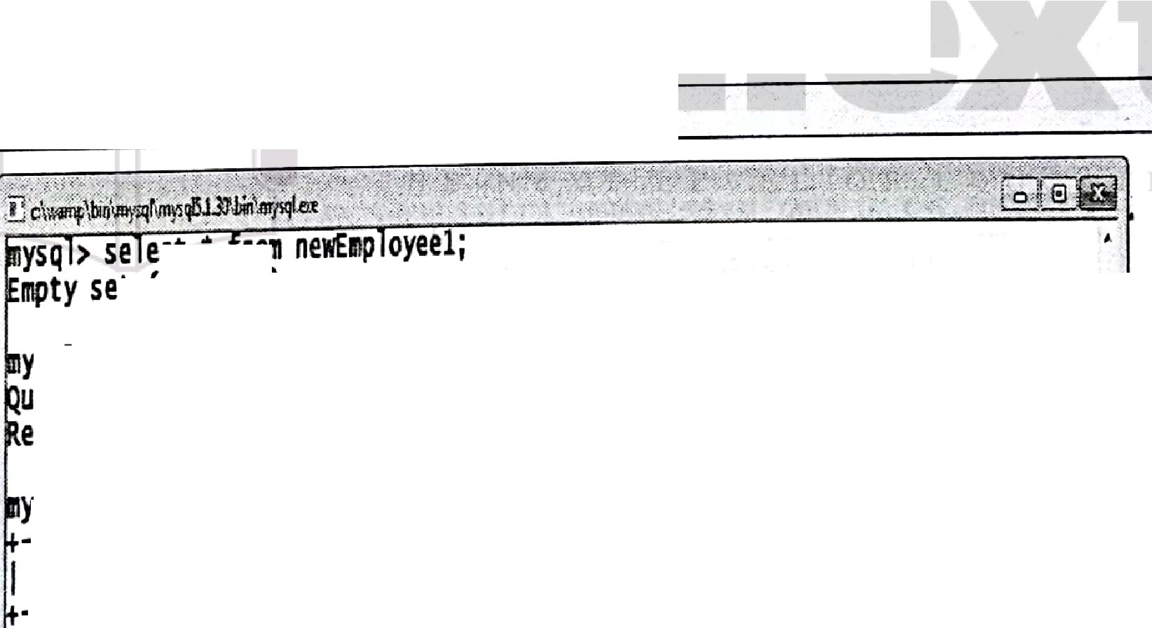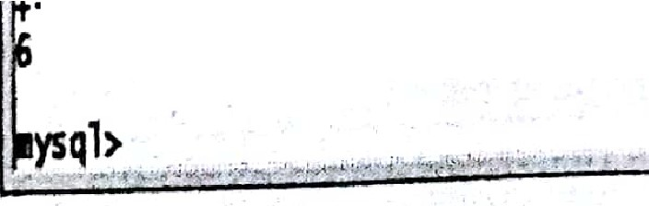

[**For Example**](https://e-next.in/)

[I Insert into newEmployee1 select * from Employee;](https://e-next.in/)

[**ect** r](https://e-next.in/)

et (O.00 **sec)**

ysql> **Insert** into **ne f!Ployeel selectt from Employee;**

**uery** OK, **6 rows affected (0.01.sec) ecords: 6 Duplicates:** o **warnings:** O

**ysql> select t from nelff11Ployeel;**

I -------------+---------------+--------------+ +

**Elll)loyee_no** I **Employee_name** I **joining_date** I **Salary** I

+ +

101 I **Rajesh** I 1995-11-02 12000

102 **swati** 2015-0l-07 20000

**103 Vedant 1999-05-03** 30000

104 **vedika** 2005-02-10 52000

105 **Ankita** 0000-00-00 8000

**106 Ankur 2017-03-15** NULL

+ +

, rows in set (0.00 sec)



DB 1S (MU-BSC IT) L-10 Lab Manual

(l> U ing **DELETE STATEMENT**

**Delete**

A, per r..4uir ·ment, the records from existing table can be removed using delete nunand. Delete command can have 'WHERE' clause optionally.

**Syntax**

I Delete from table name;

**For Example**

'v\ rite a query to remove record of Employee no I 06 from Employee table,

Delete from Employee where Employee no= 106;

"iJ c.\-.:1mp )'l,qf r.;q\Sl.30\btn ;, i.tn / ·, *;':* ·, ,_., ,.,., :. '<::(:.-·cf.\ ►:\,·•:- ---;.s•.·:; jc ·:" :: *;::·-.·* :> ·,t - -- Y: '.;*:·. _;:1-·:-=.r·,·* g



s

**ysql> select• from Employee;** · · ·



r- ;p, ;;;-=..;; -r- ;p, ;;;= ;;;-r-j i i g=d; ;-j-;;,; ;-r

+ + + +

I **101** I **Rajesh** I **1995-11-02** I **12000** I

I [**102**](https://e-next.in/)I [**swati**](https://e-next.in/)I [**2015-01-07**](https://e-next.in/)I [**20000**](https://e-next.in/)I

[I **103** I **vedant** I **1999-05-03** I **30000** I](https://e-next.in/)

[I **104** I **vedika** I **2oos-02-10** I **52000** I](https://e-next.in/)

[I **105** I **Ankita** I **0000-00-00** I **8000** I](https://e-next.in/)

[I **106** I **Ankur** I **2017-03-15** I **NULL** I](https://e-next.in/)

[. **6** --**r**-**o**-**w**-**s**--**i**-**n**--**s**-**e**-**t**-+**(**-**0**-**.**-**0**-**5**--**s**-**e**-**c**-**)**------+--------------+ +](https://e-next.in/)

[**mysql> Delete from Employee where Employee_no** = **106;**](https://e-next.in/)

[**uery OK, 1 row affected (0.00 sec)**](https://e-next.in/)

[**ysql> select* from Employee;**](https://e-next.in/)

· I **Employee_no** +I **Employee_name** I+ **joining_date** I+ **Salary** I+

I -------------+---------------+--------------+ +

**101** I **Rajesh 1995-11-02** I **12000** I

I **102** I **swati 201s-01-07** I **20000** I

I **103** I **vedant 1999-05-03** I **30000** I

I **104** I **vedika 2005-02-10** I **52000** I

I **105** I **Ankita 0000-00-00** I **8000** I 1

-------------+---------------+--------------+ +

* • ,

;,.,"'..:. - Jl,:.,l..l......,,::,.. ..d.'.,:..; ;.:.t,t.. *>4,;..'...,*-*.*

;.';.!':-.; '

•••

.••,..

>.:.,... _: .•:.. .•.•- . .}·. 'w...,::·:< •;,.. : : .it,.i,,.. :"" _;,:.,, ·"' ;,., •-·"·•·.-:- : s.,:..,.,.• :e,.,;,·: -:- 1"""'.i : :.. . ¼ .. ....<...,, ·,:,.»., - . : :-1.C• .',;.

(c) **Using UPDATE STATEMENT**

**Update**

To make changes in the database 'update' command is used. The update command consists of 'set' clause and an optional 'where' clause'. **'WHERE'** clause is used to make changes in specific records.

**Syntax**

~~I~~ Update table name set column_name - new_value [where condition];

***p***

(MU·B CIT)

L-19 Lab Manual

For E'.\llllllJlc

-=

alary=50000 where Employee_no

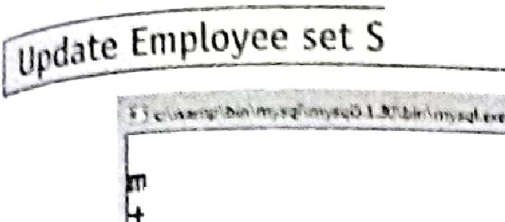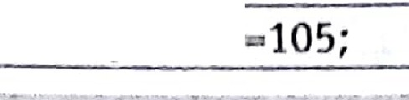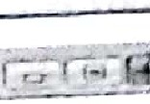

ysql> select* from Employee;

+ + + +

I Employee_no I Employee_name I joining_dat:e I salary I

I + + + +

101 I Rajesh I 1995-11-02 I 12000 I

I

I 102 I swati I 201s-01-01 I 20000 I

I. 103 I Vedant I 1999-05-03 30000 I

I 104 I Vedika I 2005-02-10 52000 I

I 105 I Ankita I 0000-00-00 I 8000 I

·s rows in set +(o_oo sec) + + +

ysql> Update Employee set salary=SOOOO where Employee_no=105; uery OK, 1 row affected (0.00 sec)

Rows matched: 1 changed: 1 warnings: o

ysql> select* from Employee;

I Employee_no +I Employee_name I+ joining_date I+salary I+

[I 101](https://e-next.in/) +[I Rajesh I](https://e-next.in/)+ [1995-11-02 I](https://e-next.in/)+ [12000 I](https://e-next.in/)+

[I](https://e-next.in/)

[I 102 I swati I 201s-01-01 I 20000 I](https://e-next.in/)



[.I 103 I vedant 1999-05-03 I 30000 I](https://e-next.in/)

[I **104** I **Vedika.** 2005-02-10 I **52000** I](https://e-next.in/)

[.:I 1-0-5-+I A-n-k-i-t-a](https://e-next.in/)

[I 0000-00-00 I ·soooo](https://e-next.in/)

[I](https://e-next.in/)

[+---------- + +](https://e-next.in/)

[IUpdate Employee setjoining_date='2015·03·15' where Employee_no=105;](https://e-next.in/)

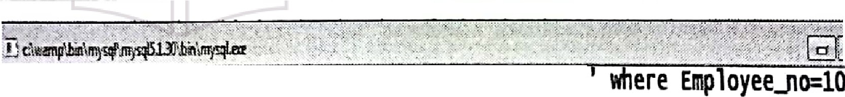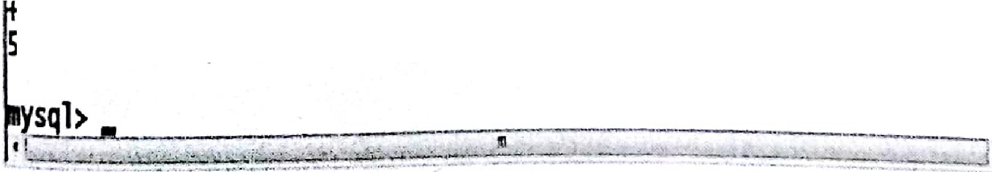

['.'.:.,¾:' .-,](https://e-next.in/)

i

; ysql> update Employee set jo1ning_ ate= 2015-03-15

uery OK, 1 row affected (0.01 sec)

ows matched: 1 Changed: 1 warnings: O

* ysql> select *-t* fr011 Employee;

I-------------+---------------+--------------+ +

Employee_no I Employee_name I joining_date I salary I

--•--------w-+---------••--•-+--------••-••-+ +

I I I I

101 Rajesh 1995-11-02 12000

102 I swati I 2015-01-07 I 20000 I

103 I vedant I 1999-05-03 I 30000 I

104 I vedika I 2oos-02-10 I 52000 I

10s I Ankita I 2015-03-15 I soooo I

-------------+---------------+--------------+ +

5 **rows in** set (0.00 sec)

s·I

-

(wt:DBMS (MU-SSC IT) L-20

**(4. Creating and Managing Tables**

1. **Creating and Managing Tables Creating Table**

The **CREATE TABLE** statement is used to create table in database.

**Syntax**

CREATE TABLE table_name ( columnl datatype[size], column2 datatype [size], column3 datatype[size],

-

);

- ....·- ·:.

. '\ . .. ·. .,_.

' . ..- . ·,\. ..



**Example**

[Following command creates a table Employee having four columns Employee_name, Joining _date, and Salary.](https://e-next.in/)



Lab Manual

--:::::::.... -:

[Employee_no,](https://e-next.in/)

[CREATE able Employee ( · ·. _ .,,·• ·:,:_-., . _](https://e-next.in/)

[Employee.:..no·ii1teger{3)/ '· : · *, :_·:* ,,_- ;](https://e-next.in/)

[·Empioyee..:..nam, va·rchar(20),': joining_d_ate.date ,](https://e-next.in/)

·salary.ir,teger(6));'-· '' --- ::-, .,,';_:-:;·.,/,''

* 1. **Creating New Table from Existing Table**

Consider the existing table Employee

*Creating new table same as of existing table.*

**Syntax**

[. . . --*r*.· -; -](https://e-next.in/)

[*,;.:* . ;. *:,._·:*](https://e-next.in/)

[..](https://e-next.in/)

[*-* . ---\:'](https://e-next.in/)

I:Create:table_:table.:..:name as·'select-*froµierjstmg table name;'} '. ·:·:::::::;\:'.:. '. ::_.·-<:i*,: t:<;p \;*·_,:.'> I

**For Example**



**:_·A;**.**\·**

Crea·te·tab

,.. ·.·, > :_::•,:, _.::;-- .C:: '.<> ...,.

e

le

w"E:mploye t:*(*.*·*'*:*.*-·*··

"-.select from•e:mployee/:,,;:

The newly created table newEmployeel will include all the fields and records as in

Employee table.

►

DBMS (MU-BSC IT) L-21 Lab Manual

*Creatingnewtable havi11g suec;fi fields b111 all the record.,·(mm existing tahle.*

**Syntax**

create tabl table mun as select field l,ficl<l 2... from existing tabJe name For **Example**

After executing this command the newly created table will cont.a.in two fields such as Employee_no and Employee_name , and also contain all the corresponding records as in Employee table.

create table newEmployee2

As

select Employee no, Employee name from Employee;

*Creating new table having specific records but all the fields from existing table.*

**Syntax**

[Create table table name as select * from existing_table name where condition](https://e-next.in/)

[**For Example**](https://e-next.in/)



[Create table newEmployee3](https://e-next.in/)

[**As**](https://e-next.in/)

[select * from Employee where Salary > 80000;](https://e-next.in/)

The newly created table will have same structure as of employee table, but it will contain records of only those Employees who got Salary above 80000 Rs.

*Creating new table having no records but all the fields from existing table.*

That means copying only structure of existing table

**Syntax**

Create table table name as select * from existing_table_name where false condition

**For Example**

Create table newEm p_Loyee4 As

select * from Employee

where 1=2;

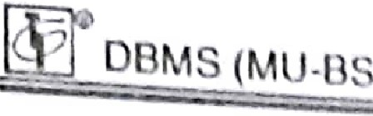CIT) -22

cnndilinn

'171 11'"I *1* 'l"al <l rnhl will h ,v ant. siru turc as of cxislill tublc, but jt will n t copy

n r · rJ. from.

* 1. 1\.1 difying TulJlC'

**ALTER TABLE** query i, uscct to 111 Hlify .lllruclurc of a table which is already exist<;in the

d. labas . **\V** · l'un add, <l lctc or modify c lumn.

Adding Nw lumn in a Table

**Syntnx**

ALTER TABLE table name ADO column name datatype;

**For E 'nmple**



[ ALTERTABLE Emp dept ADD column city varchar(20); l

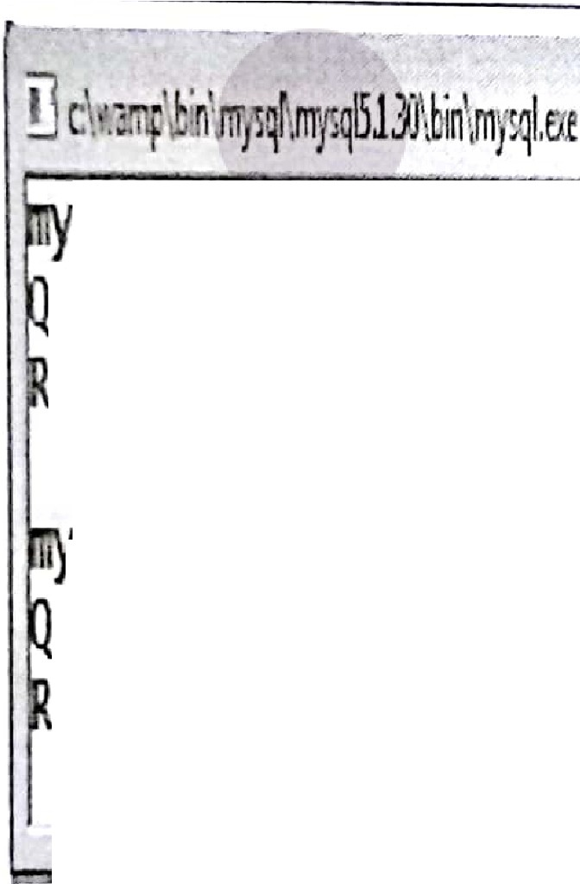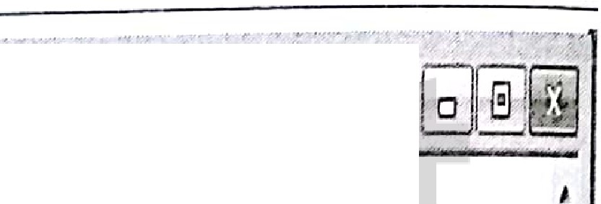

[sql> alter table Emp_dept add column city varchar(20);](https://e-next.in/)

[uery OK, S rows affected (0.11 sec)](https://e-next.in/)

[ecords: S Duplicates: 0 Warnings: 0](https://e-next.in/)

. 1 sql> alter table Emp_dept add column phJJo integer(20); nw

uery OK, S rows affected (0.09 sec)



ecords: S Duplicates: 0 Warnings: 0



Dropping Column from Table

**Syntax**

I ALTER TABLE table name DROP COLUMN column_name; l

**For Example:**

I ALTER TABLE Emp dept DROP COLUMN dept; J

►

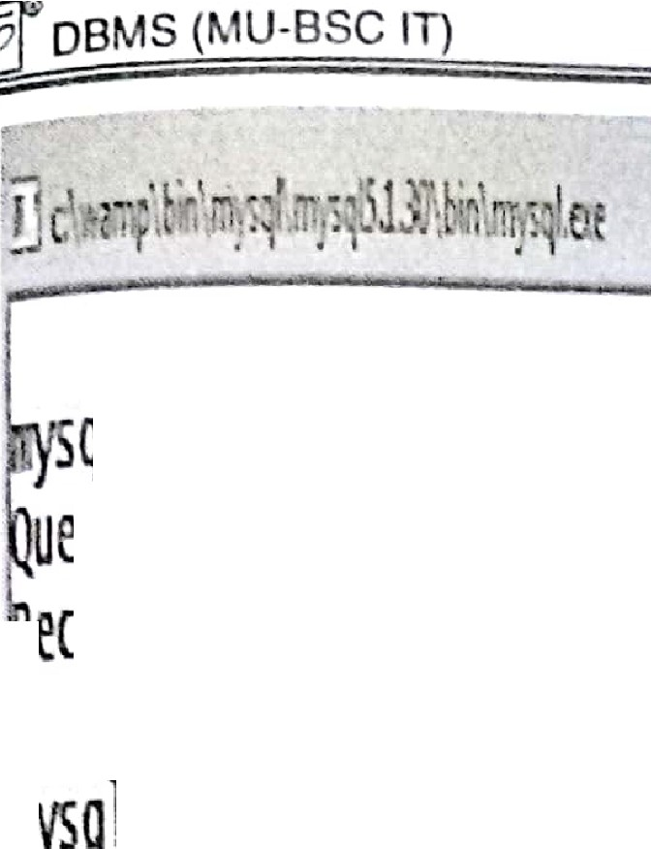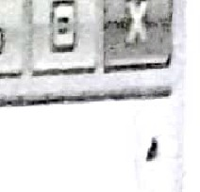

L-23

u:ib ManuaJ

sql> alter table Emp_dept Drop columndept; uery O , 4 rO'·s affected (0.10 sec)

· ecords: 4 Duplicates: 0 arnings: O

i

I I

I **ql>**

Modifying Column of a Table

Here we are changing the data type and size of column roll_number.

Synta

[~~I~~ ALTER TABLE table_name MODIFY COLUMN column_name data_type;](https://e-next.in/)

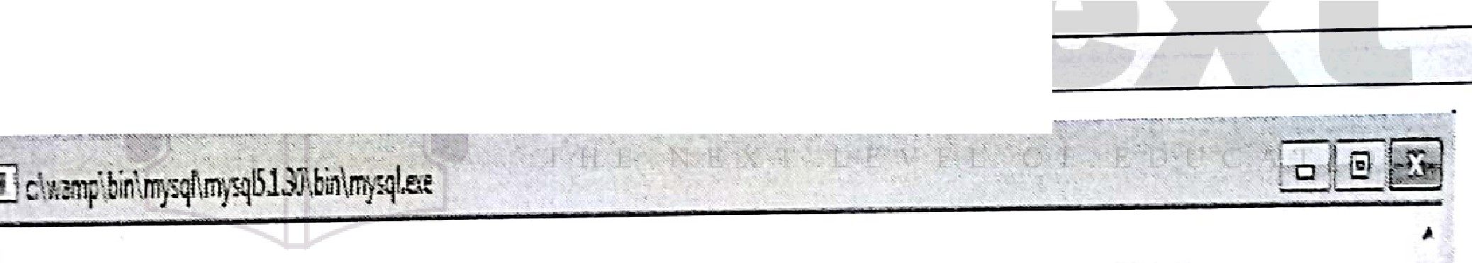

[**For Example**](https://e-next.in/)

[I ALTER TABLE Employee modify column Employee_no varchar(4);](https://e-next.in/)

##### , ysql> ALTER TABLE Employee MODIFY COLUMN name varchar(50);

uery OK, 3 rows affected (0.11 sec)

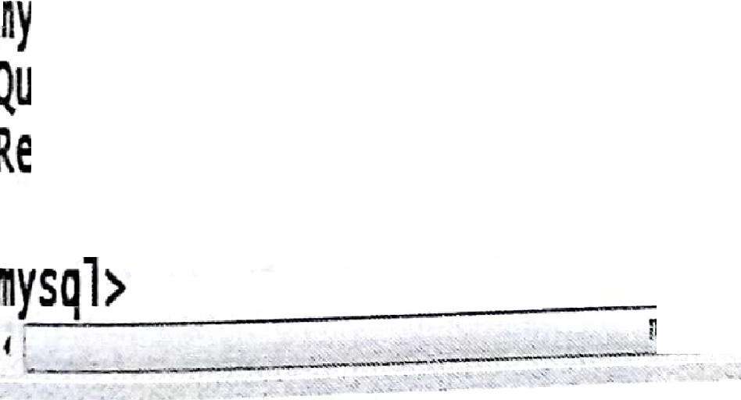

##### ecor s: 3 Duplicates: o warnings: o

..

lll



* 1. **Renaming Table**

**Syntax**

rename table current table name to new table name;

For Example

Gename table Employee to Emptable;

Lab Manual

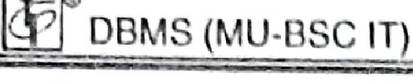

L-24

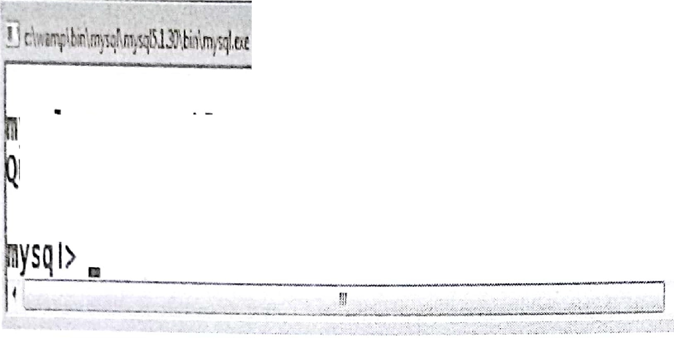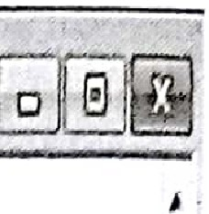

ysql>renametableEmployeetoEmptable; uery OK,Orosaffected(0.00 sec)

r

*..J*

t

t ..,*.i*

* 1. **Deleting Table**

I DROPTABLE query is used to delete table.

[**Syntax**](https://e-next.in/)

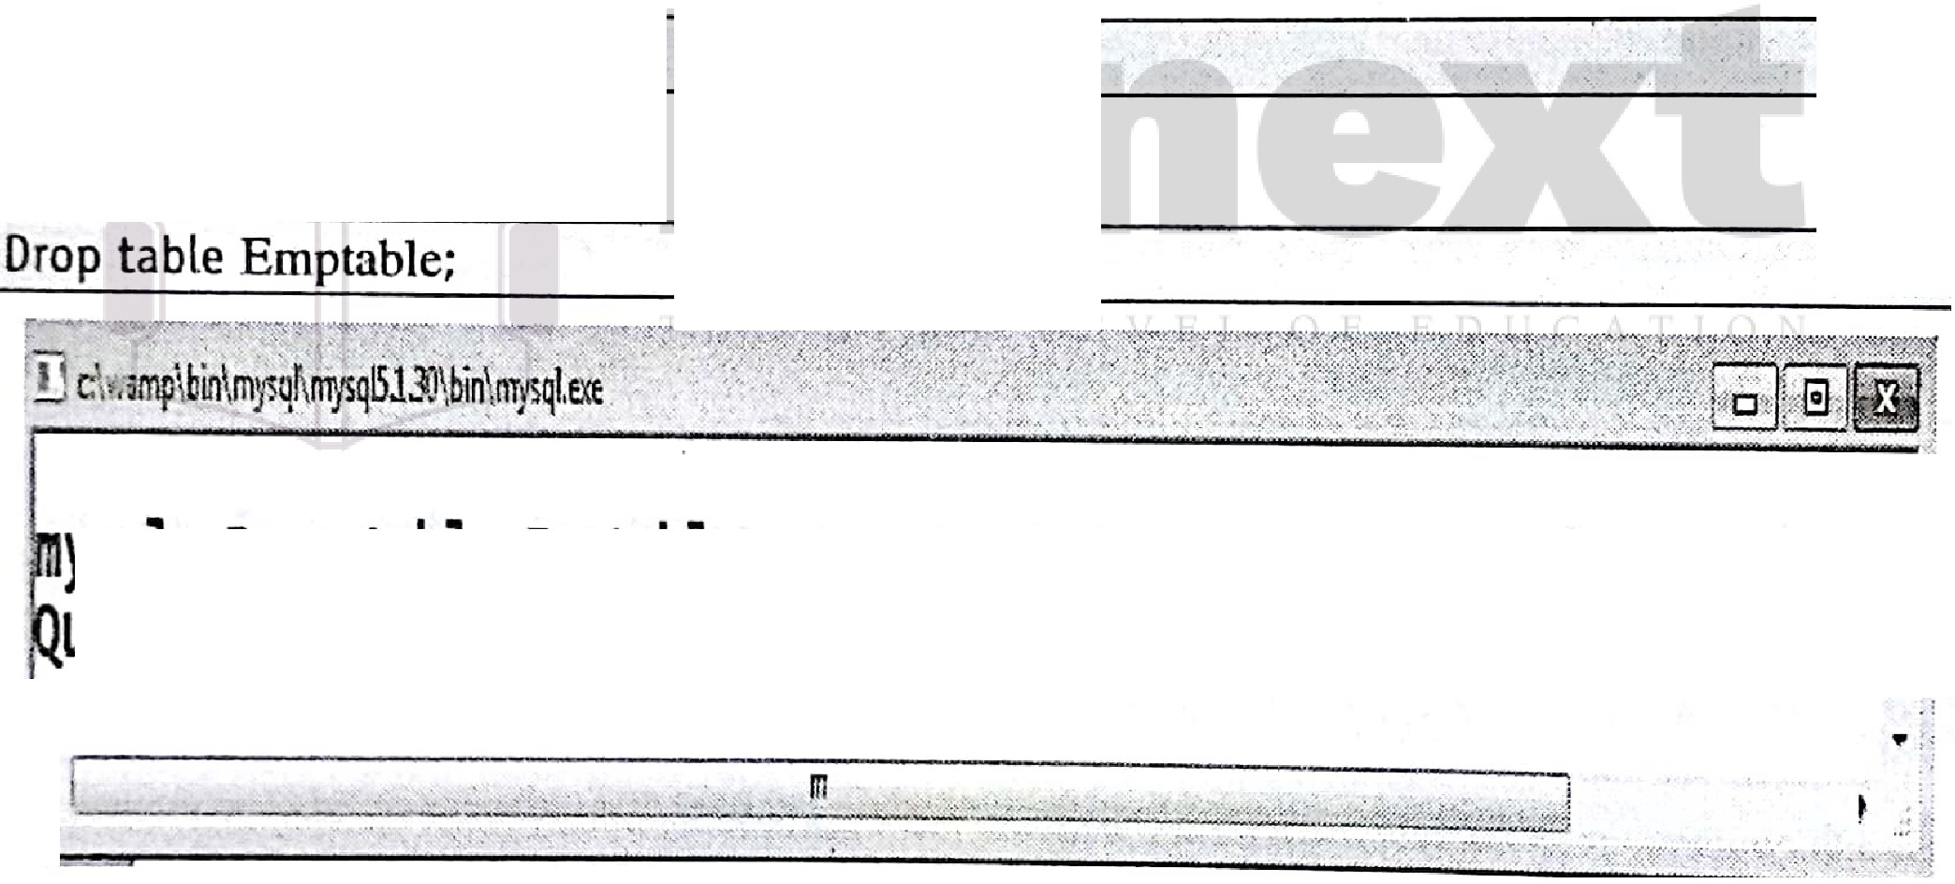

[drop table table_name;](https://e-next.in/)

[**For Example**](https://e-next.in/)

..

ysql> Drop table Emptable;

uery OK, O rows affected (0.00 sec)

r-::?

Lj

awzma:s:...x

1. **Including Constraints NOT NULL constraints**

The NOT NULL constraint enforces a column to NOT accept NULL values

**For example**

Create table Persons(ID integer NOT NUL LastName varchar(SO) NOT NULL, FirstName

varchar(50) NOT NULL, Age integer(lO)); ·



oaMS (MU-BSC IT) L-25 Lab Manual

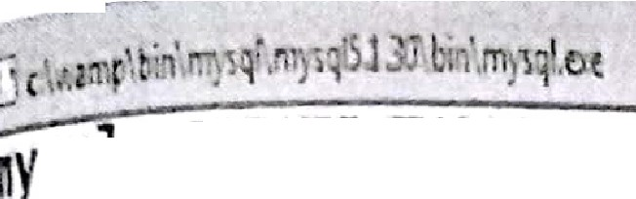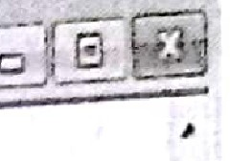

ysql>CR½TE TABLEPERSONS(

->ID 1nt NOT NULL,

-> F1rs Namevarchar(200) NOT NULL,

->. LastNamevarchar(200)NOT NULL '

uery OK, O rowsaffected (0;08sec)

-> Age 1nt);

*4* ! . 111 i

- - - ........... ••• -•• .. ••• .,.. •••• • • •·- nn '"""•••'••• .,. .,. , .,.,, .,. .;..... ; .......... ;•*, ..,: '.'.,:* •,, ".,.•, .,.•••••"" '-,_'", ,".*... :,,,./•., ...,..* ,.,• •• •,•, ..._o..•,:.............. -•••••• 00 ••



[ysql> insert into PERSONS values(!,'sawant', 'sandhy' ,null);](https://e-next.in/)

[uery OK, 1 row affected (0.00 sec)](https://e-next.in/)

[ysql> insert into PERSONS values(2,'sawant', 'null',null);](https://e-next.in/)

[. uery OK, 1 row affected (0.00 sec)](https://e-next.in/)

[ri](https://e-next.in/)

#### l'ysql>insert into PERSONS values(2,'sawant' ,null,null);

RROR 1048 (23000): column 'FirstName' cannot be null

f.r .... .... . . . .--·•.·.". ' "-- . .. . .·

_,,.,.._.......,..-,.....,,.. • :•-•.-. ., *•.•.....:::* ..J ._ ,' • • ,_.._,,., ..• •,.• .,.. 0...- ...,· ....· ••. *-<< , .*

,*...*· ...· ..-.,-. • ...;.,. ,.....,............u u ..... -..:·:•·. •,. .,.,,.,,• .,,..,,..., ;.,. ' .. ,•,•.-.. '.- :,.:."••;•·•·,.;':."'•\.., ·;., ..•--••• · : .•• ;

**Unique constraints**

The UNJQUE constraint ensures that all values in a column are different.

**For example**

Create table Persons(ID integer NOT NULL UNIQUE, LastName varchar{SO) NOT NULL

FirstName varchar{50) NOT NULL, Age integer{lO)); · , , '

ysq, l CREATE TABLE PERSONS2

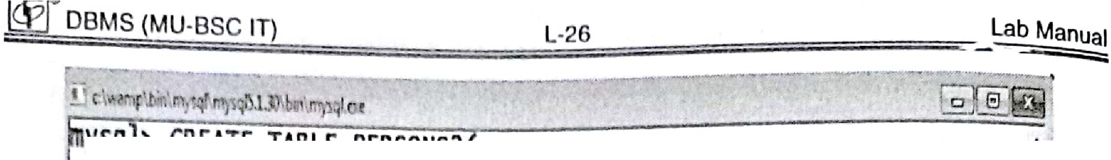

- ID int NOT NULL UNIQUE,

-,.L stName varchar(200) NOT NULL,

-> F1rstName varchar(200) ,

-> Age int);

###### uery OK, O ro\s affected (0.05 sec)

ysql> insertinto PERSONS2 values(l,'sawant'',samarth' ,null); uery OK, 1 row affected (0.02 sec)

ysql> insert into PERSONS2 values(!,'sane','sanika' ,null); RROR 1062 (23000): Duplicate entry '1' for key 'ID' ysql>.





·,I

* .._ ......... ••m• ••••,.... - .. Um,., ..............,., ••.,,, .. ••• ........ '"-- ... - _••••• M . _,,...- -:,

i

·<·- .:_'1:..{f-;···1: :-:J

....L-,..,*·*.,.*,*" *n* z< -- i:

[**Primary key constraints:** Primary keys must contain UNIQUE values, and cannot contain NULL values](https://e-next.in/)

[**Primary key on create table**](https://e-next.in/)

[**For example**](https://e-next.in/)

[Create table Persons(IO integer NOT NULL UNIQUE, LastName varchar(50) NOT NULL,·](https://e-next.in/) FirstName varchar(50) NOT NULL, Age integer(10) PRIMARY KEY(ID)).;

·



ysql> CREATE TABLE PERSONS2(

-> ID int NOT NULL,

-> LastName varchar(200) NOT NULL,

-> FirstName varchar(200)

-> Age int,

-> PRIMARY KEY(In)

-> );

uery OK, O rows affected (0.03 sec)

ysgl>

D

f - •

*:*-*•* •; ': _::··:i::J: - --• :c-·- :._c ,,,•·. - --- ..:. :.,.:..:.:.J

. ► ......:. }.' -- ). .._••



'

.

►

DBMS (MU-BSC 11)

**Primary key on Alter table**

**For exnmple**

L-27 Lab Manu-al

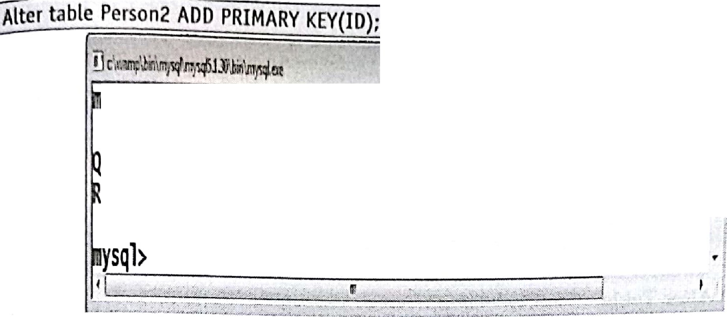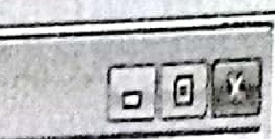

,ysql>ALTER TABLE PERSONS

-> ADD PRIMARY KEY(ID);

uery OK, 2 rows affected (0.05 sec)

ecords: 2 Duplicates: o warnings: o

0

**Drop ptjmary key constraints:** [**For example**](https://e-next.in/)

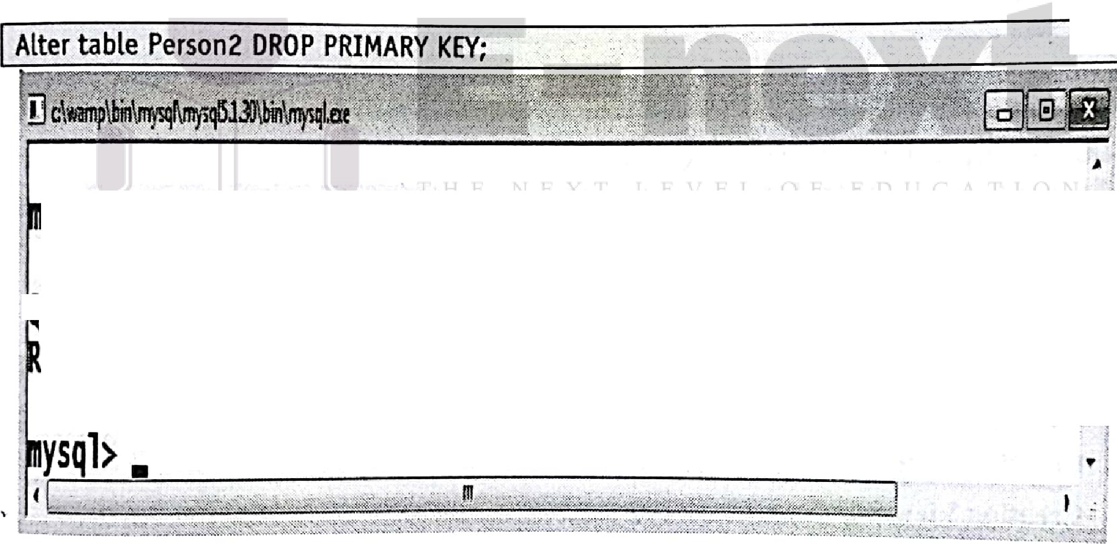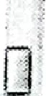

[**ysql> ALTER TABLE PERSONS2**](https://e-next.in/)

.' uery OK, o rows affected (0.06 sec)

·ecords: o Duplicates: o warnings: o

-> **DROP PRIMARY KEY;**

..

, i

**CHECK Constraint**

The CHECK constraint is used to limit the value range that can be placed in a column.

**CHECK on create table**

**For example**

**aeate table student(ID** i_nteger NOT NULL, LastName varchar(50) NOT NULL,. firstName _ varchar(SO) NOT NULl, Ag ·integer(lO) CHECK(Age>=18)); ·

lwi osMs (Mu-ssc IT) L-28 Lab Manual

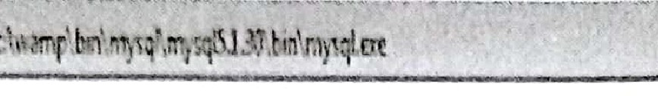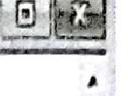

ysql> create table student(

>IO integer NOT NULL,

-> L stName varchar(SO) NOT NULL,

. ->F1rstNamevarchar(50) NOT NULL,

-> Age integer(lO), CHECK(Age>=18));

uery OK, O rows affected (0.03 sec) ·

ysql>.



"

0

* I , ..*m*. , ,

., .., ,,

..,.,.•'-"½---.•:2<·

:-;::,,;, _,·:•:,;1,,_ "':"''-:-:J

CHECK on Alter Table

For example

[](https://e-next.in/)I Alter table student ADD CHECK (Age>=l8};



[it' '.bin (](https://e-next.in/)

[**r-----.......:;...;.;....,;,..;.._ ;;,_..:..;..:... ..................---,**](https://e-next.in/)

[.](https://e-next.in/)

[,!.](https://e-next.in/)

[*{*](https://e-next.in/)

[ysql> Alter table student ADD CHECK **(Age>=l8);** . I](https://e-next.in/)

[uery OK, o rows affected (0.08 sec) c{](https://e-next.in/)

[ecords: O Duplicates: o warnings: o ,](https://e-next.in/)

[. "*•:*](https://e-next.in/)

ysql>. TJ

Q

, 1 . , - -- -, , .;' -:. -;: : : ::: : \:: i: : ;:· ; " ·::; ; : ;:;:::.:. :; :; ;L 1;,j,t,, ;: :w ;K:;•1;d

js. **Creating and Managing.Other Database Objects** ·I

1. **Creating Views Creating View**

Consider we have existing table as Employee (Employee_no, Employee_name, joining_date, Salary).

* 1. **Creating view having all records and fields from existing table Syntax**

CREATE or replace VJEW view_name .·. . ·

SELECT olumri I column2, .-.. *1* • *:·--*•.•·., • .

AS . , . · ·, .·

FROM tab]e nam

.,· ._ :.. ,- ..·.- ., *c::(/:··:· _::*

*I.*





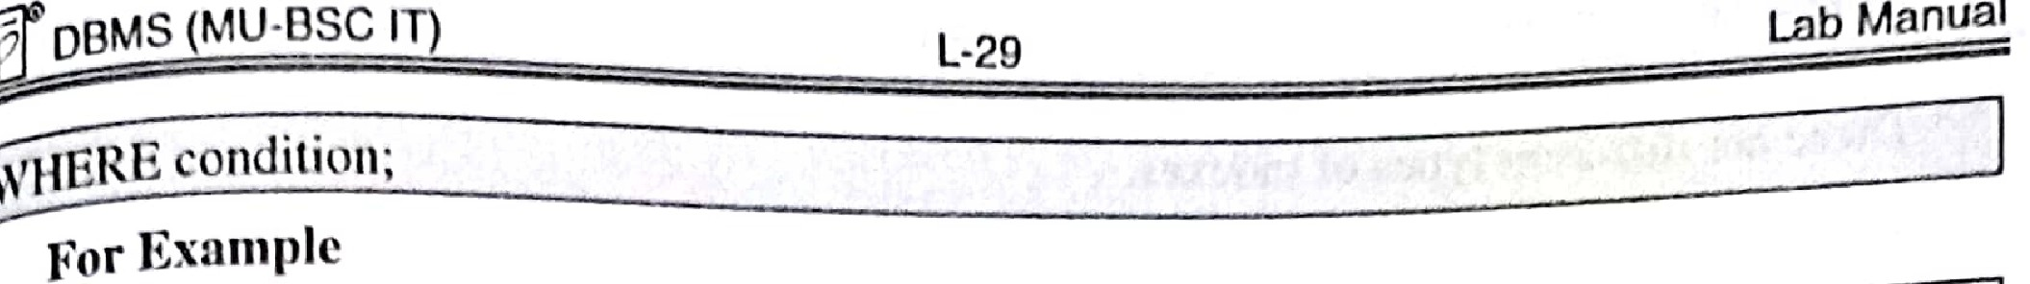

create or replace view Emp_viewl

As

select • from Employee;

Thisstatement will create view having aJJ the fields as *in* Employee table.

* 1. **Creating view having specific fields but all the records from existing table**

**Syntax**

Create or replace view view name

As

select field 1, field 2... from existing_table name;

**For Example**

Create or replace view Emp_view2

As

[select Employee no, Employee name from Employee;](https://e-next.in/)

[This statement will create view having specific fields from Employee table.](https://e-next.in/)

[**J. Creating new view having specific records but all the fields from existing table Syntax**](https://e-next.in/)



[Create or replace view view_name](https://e-next.in/)

[As](https://e-next.in/)

select * from existing_table_name where condition;

For **Example**

Create or replace view Emp_0ew3

As

select * from Employee where Salary > 80000;

' .

1. Other **Database Objects**

An index is a pointer to data in a table. An index in a database alphabetical index of a book present at the end of book.

Indexes can be created or dropped with no effect on the data.

Creating **Index**

1s similar to the

CREATE INDEX statement is used to create an index. In Lhis statement we have to mention name of the index, the table and column, and whether the index *is* in ascending or descending order.

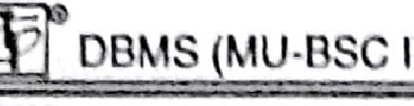

IT

l-30

Lob Monuol

Th re nrc differ·nt I I c of ind •x •s. Syntnx

0

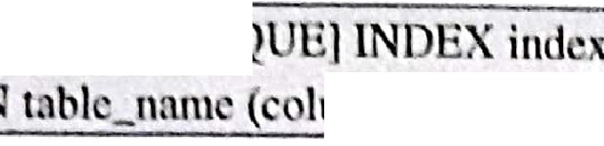

REATE [UNI

hnnn_nnm I ,Lcolumn_nnnie-, colunm_namo3,...]);

ForExampl

I. CREATE INDEX cmp_indl on Employee(Employee_name);

CRE TE INDEX emp_ind2 ON Ernployee(Employee_no, Employee_name);

* 1. CREATE UNJQUE INDEX emp_incl3 on Employee(Employee_name);

**Displaying Index** : To display index information regarding table fo11owing query is used.

**Syntax**

[Show index from table name;

For Example

~~I~~ Show index from Employee;

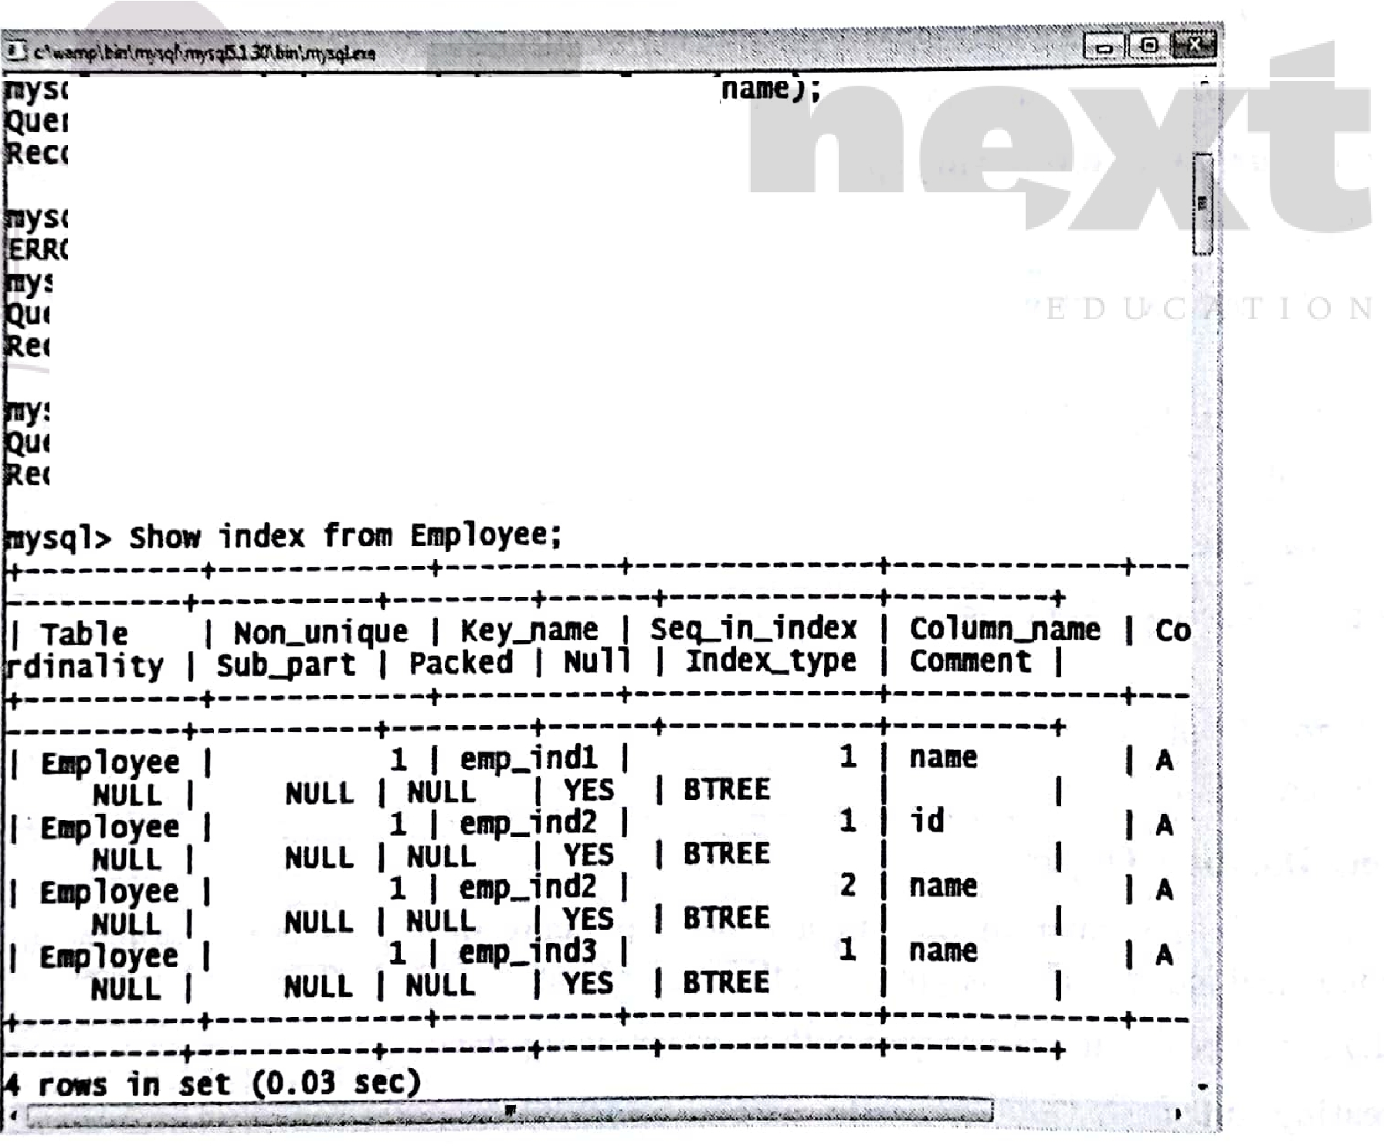

[**q** > **create** ,](https://e-next.in/)

[1 **on Emp oyee**](https://e-next.in/)

[**ords: o DUplicates: o warnings: O**](https://e-next.in/)

[ysql> **create index emp_ind2** on **Employee(no,name);**](https://e-next.in/)

[ry **OK, o rows affected (0.09 sec)**](https://e-next.in/)

[OR 1072 **(42000): Key column 'no' doesn't exist** in **table**](https://e-next.in/)

[uery OK, o rows affected (0.09 sec)](https://e-next.in/)

[sql> create **index** emp_ind2 on Employee(id,name);](https://e-next.in/)

[ecords: O ouplicates: o warnings: o](https://e-next.in/)

uery OK, o rows affected (0.05 sec)

[sql> create index emp_ind3 on Employee(name)i](https://e-next.in/)

ecords: O ouplicates: o warnings: 0

Dropping Index

To drop index of a table following query is used.

m:;;;;□.::B_M;;;S;;::;;;(;;;;;M..::U==·B:;:,;S= --'T;;;;)=== === l -3 1=========:;:;;::;;:;;:::;:::;La==-;;b_M_a=nu=a



**Syntax**

§,Pindex indc,-_uu-n1 oa lable_name;

**For Example**

Dropindex emp_ind2 on Employee;

**Sequence**

**Sequence**: A sequence is a set of integers. Sequences are generated in order as per requirement. Sequences are used to create unique values for the rows.

**Creating sequence**

**For example**

varchar(20)Jsal integer(6));

create table emp2( eno integer(3) auto_increment,-primarykey(eno. ), enan:ie

[-](https://e-next.in/)

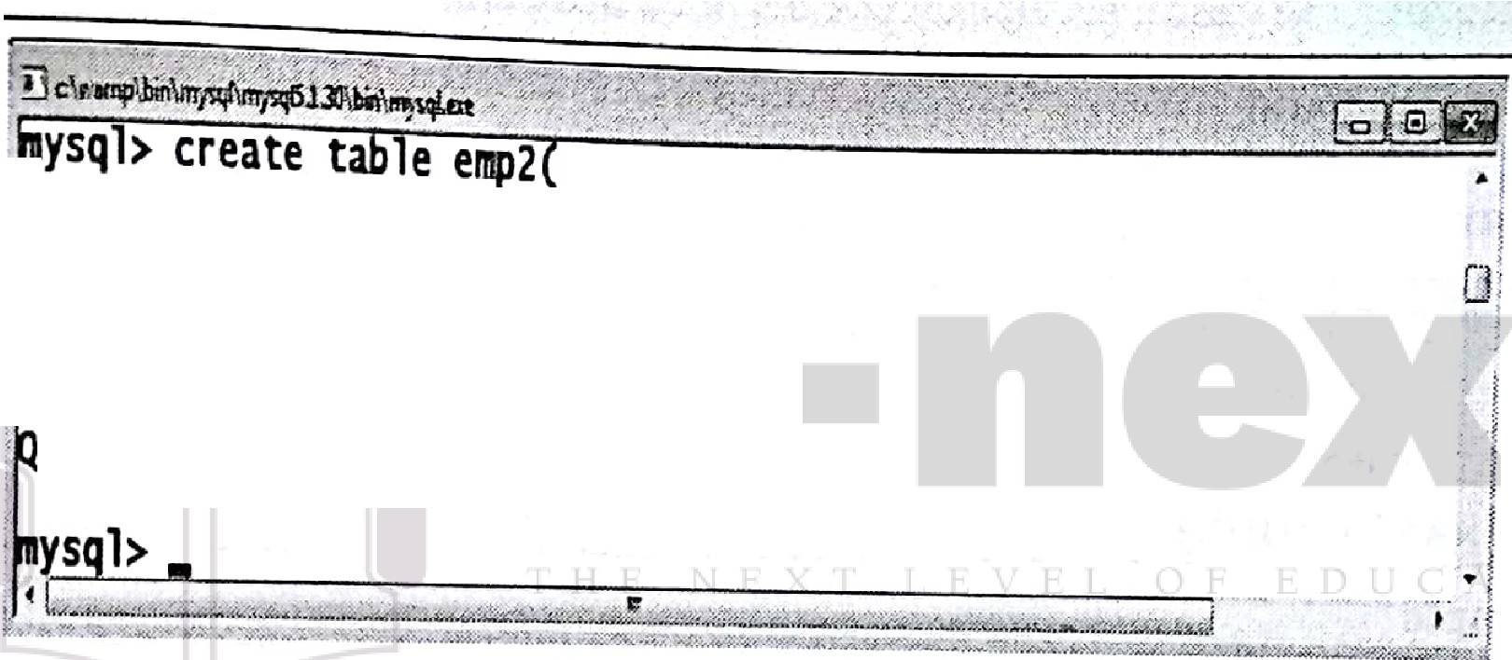

[! -> eno integer(3) auto_increment,](https://e-next.in/)

[-> primary key(eno),](https://e-next.in/)

[-> sal integer(6)](https://e-next.in/)

[-> );](https://e-next.in/)

[uery OK, o rows affected (0.05 sec)](https://e-next.in/)

[-> ename varchar(20),](https://e-next.in/)

Now insert records in the table For example

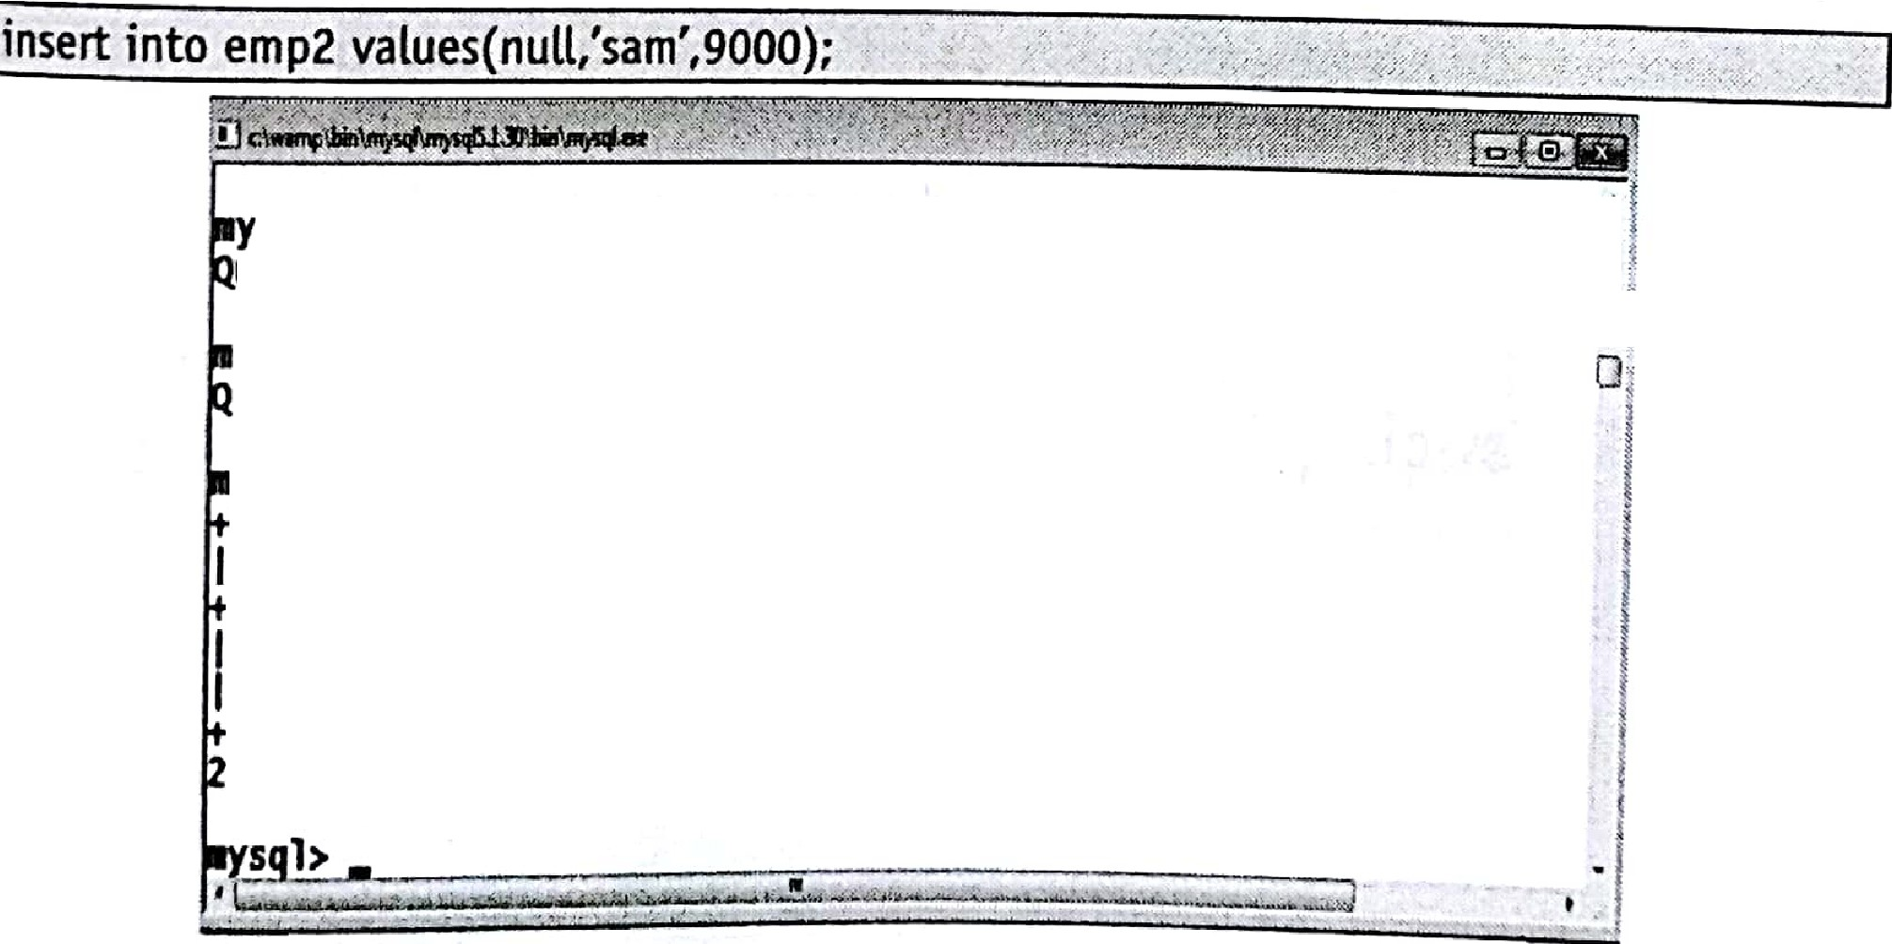

sql> ;nsert ;nto emp2 values(null,'sam',9000); uery OK, 1 row affected (0.00 sec)

ysql> ;nsert ;nto eap2 values(null,'teju',10000); uery OK, 1 row affected (0.00 sec)

. ysql> select* from emp2;

**,-; -,**+**-; a**-**a**-**e**--+I --s-a-l---+I

I

-----+-------+ +

1

I **Sall** I 9000 I

--r-o-w-s+;--n--s-e-t-(+0-.-0-0--s-e-+c)

2 teju I 10000 I



DB 1S (MU·BSC IT) Lab Manual

Here the 1umn no h auto increment values.

SynonJ111

111 n m are basically aJtem::itivc names for a table, view, sequence, procedure, stored fun ti n, package et . Synonym provide both data independence and location tmn paren y.

Creating Synonym in Oracle

Create s nonym e for emp;

1. Controlling User Access

* **Grant** : to allow specified users to perform specified tasks.
* **Revoke** : to cancel previously granted or denied permissions.

[**Grant command**](https://e-next.in/)



[**Syntax**](https://e-next.in/)

[**GRANT** <abject privileges>](https://e-next.in/)

[**ON** <object_name>](https://e-next.in/)

[**TO** <User_Name>](https://e-next.in/)

**[WITH GRANT OPTION]**

Example GRANT ALL

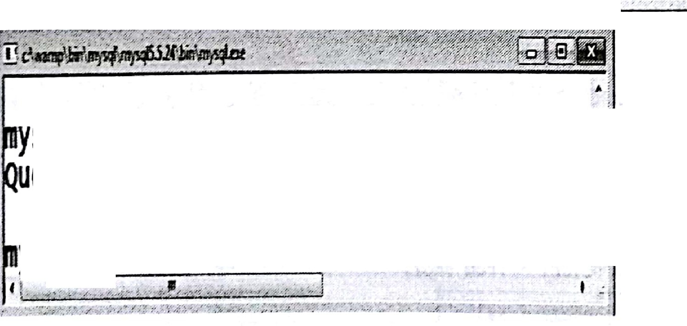

ON cust TO anand

WITH GRANT OPTION;

. ,,. ' ,.,,,.

#### sql> grant select,update ON cust TO anand; f

ery OK, O rows affected (0.03 sec) u1

ysql>.

Granting cprivilege lo a user is ns follows:

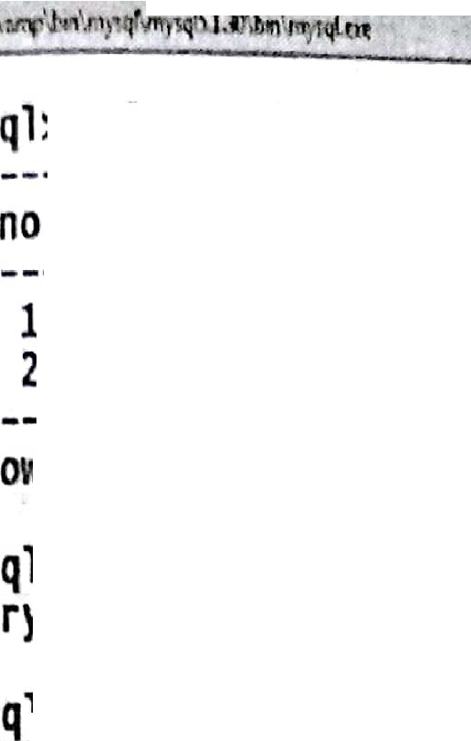



ysql>select* from em 2;

I + + +

eno I ename I sal I

I + + +

1. I sam I 9000 I

I 2 I teju I 10000 I

+ + +

1. rows in set(o.oo sec)

ysql> GRANT select ON e11p2 TO sam;

uery OK, O rows affected (0.00 sec)

_g- '------- . •. :

'' --, _.:-"-ci.. ""';;";.:;:tii<l-',;,,-.0.,.v'-«,, •i?· ..1.«.. <'% ·.' *..:.i..".'::.'.".'-,.<... ,.-, .:....;:...:-* •..,,. --' -- ,J., ,,:,:

Granting multiple privileges to a user is as follows:

[](https://e-next.in/)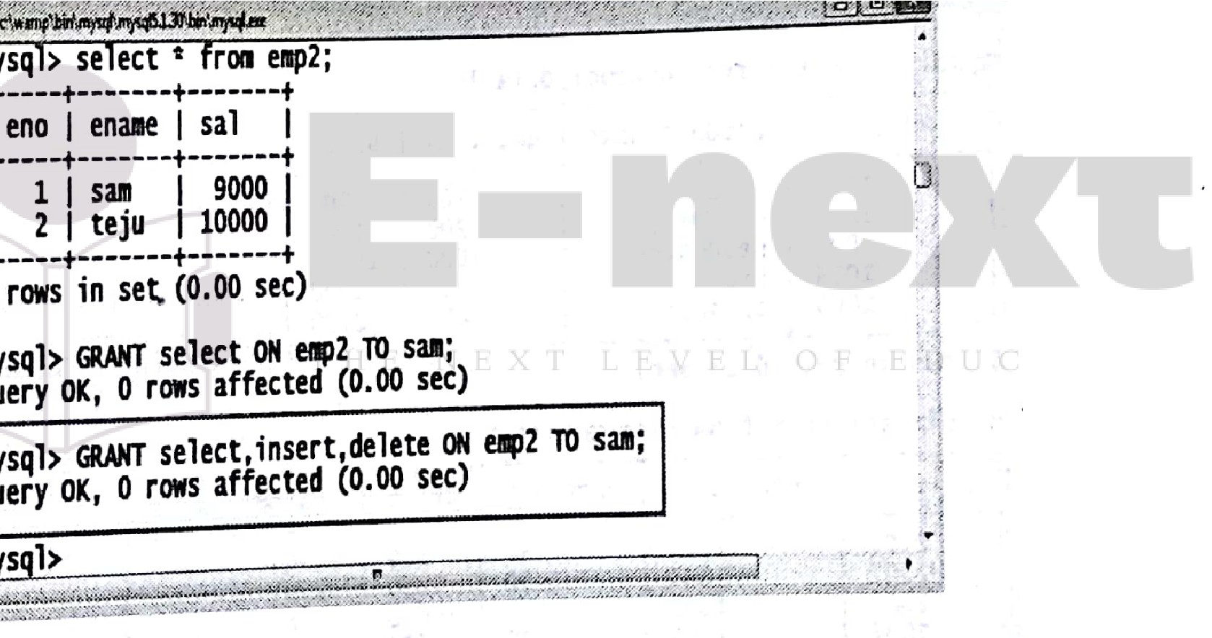

Revoke command

Syntax



**REVOKE**Object.J vileg s ,;-; :- ..



.

/ . ' : ":·. ' .--. . .- ·· , ' .,, .... : ·; *(* ·:.'

*.'•f)"<*

ON <ObJect.;.:,Name>..:·,,':._.,..:'..

**FROM** cUser....N.ame>,:.. <>·\;>\. ;_:··:·:··

Example





DBMS (MU-BSC IT) L-34 Lab Manual

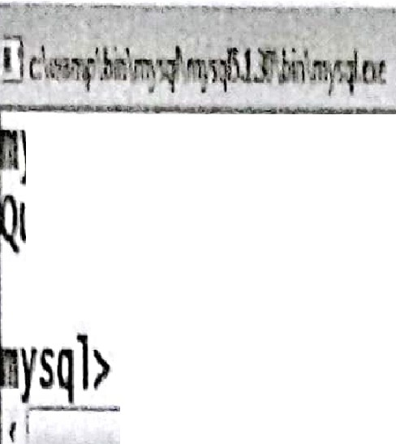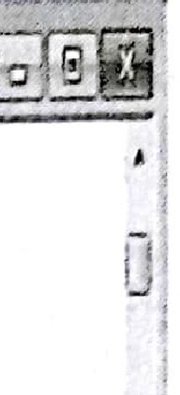

ysql> REVOKE select,insert,delete ON emp2 FROM sam;

ueryOK, Oros affected (0.00 sec)

"

I ,

6. Using SET operators, Date/Time functions, GROUP BY clause(advanced

features) and advanced subquerles

1. Using SET Operators

TI1e different Set Operators are as follows

o Union o Union All o Intersect o Minus Coru;ider following two tables product_details and Sale_details :

[ysql> select• froa producLdeta;ls;](https://e-next.in/)



[I producLid I+ product...nuie I quant;ty](https://e-next.in/)

[+I price I](https://e-next.in/)

[. *:* I 1001 I+ pendrive I 100 I+ 900 +](https://e-next.in/)

[1002 I harddisk I I 200 I 4000](https://e-next.in/)

[**1004**I DVD 20I 1000](https://e-next.in/)

[1003 I headphone](https://e-next.in/)

[1000 I 15000](https://e-next.in/)

[1005 speaker 600 2400 I](https://e-next.in/)

[(l 5 rows ;n set +(0.03 sec) +](https://e-next.in/)

'i ysql> select• fr011 sale_details;

'.·,I sale_no +I producL;d +I quantity I+ price I+custome.r...nue I +

, *r* I 2-0-0-1-+I 1-0-0-1-+I 5-0-+I 9-0-0 I+-s-a-v-n-i I-+

, I 2002 I 1004 I 10 I 1000 I savni

I 2003 I 1003 I 120 I 15000 I savni I

I 2004 I 1005 I 420 I 2400 I harsh I

· I 2005 I 1002 I 40 I 4000 I Akash I

5 -rows ;n se+t (0.03 sec) + +

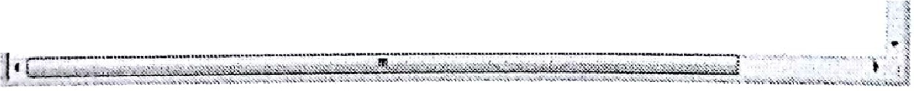

Union

The union operator returns all distinct rows selected by either query

Syntax

|  |  |
| --- | --- |
| Select column_name from table_!  Union . ·- .. ''/• | |
| Select column_name•from table_2.· :_ • .•,· ' | ... |

***p-=-===·***:::.::---===---==== ======= ­

for**Exrunplc**

Write 3qu () t0 retr•' eve J·ds of all the products even if they were sale or.

si-orage room.

select Product_id from product_details

union .

select Product_1d from sale_details;

present

·an

the

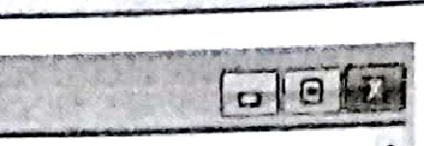

**c\Mm \I · ··**

'.

**ysql> select Product.id from producLdeta;1s**

-> union

-> **select ProducLid from sale_details;**

I--**P**-**r**-**o**-**d**-**u**--**cL**--**;**-**d**-+I

- +

I

1001

1002 I

1003 I

1004 I

[· 1 1005 I](https://e-next.in/)

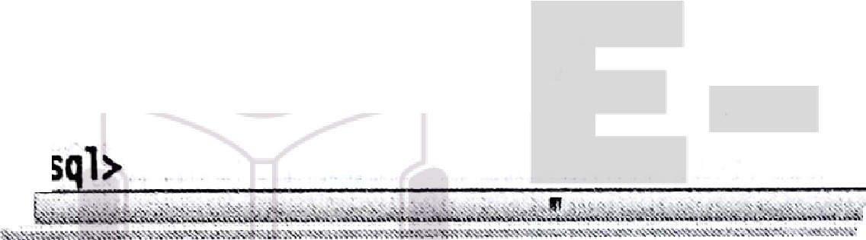

[-----------](https://e-next.in/)

[rows in set (0.00 sec)](https://e-next.in/)

[y](https://e-next.in/)

[.](https://e-next.in/)



['](https://e-next.in/)

[...,. .·."" ,_."](https://e-next.in/)

[... !-·"-,-'·' ·•"-·•.'"i](https://e-next.in/)

['](https://e-next.in/)

[! - - --](https://e-next.in/)



I

[' i](https://e-next.in/)

[·!•](https://e-next.in/)

[I](https://e-next.in/)

[](https://e-next.in/)

[**Union All**](https://e-next.in/)

The Union All operator returns all rows selected by either query including duplicates.

**Syntax**



For **Example**

Write a query to retrieve ids of all the products even if they were sold or present in the storage room.





lwJDBMS(MU-BSC1n L-36 lab Manu,

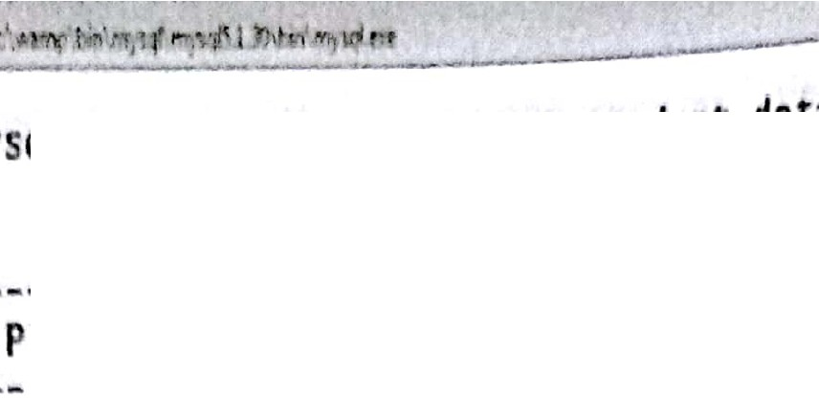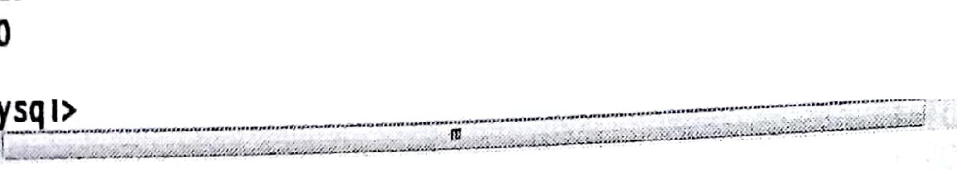

,y ql clct rroduct_id from product_details

-> s·1ectProduct_idfromsale_deta1ls,

I --P-r-o-d-u-c-t---di-tI

1001 1+

1002

1003

1004

100S

- unionnll

..

1004 I

1001

1003

I

I

1002 I

0---r-o-w-s--i-n--s-e+t (0.00 sec)

100S

[**Intersect**](https://e-next.in/)

[The intersect operator returns only those rows which are common to_both the queries](https://e-next.in/)

[Syntax](https://e-next.in/)

[Select column_name from table_1](https://e-next.in/)

**intersect**

l

* • • '

Select column_name from table_2

[*1* ..](https://e-next.in/)

·. ... • *,>'.;)* . ::..

: -- -- . . "

**For Example**

Write a query to retrieve ids of all the sold products.



Select Product_id from produ details· · .·

intersect

7

select Product_id from sale.;...details;

**Minus**

Minus operator displays the rows which are present in the first query but absent in the

second query, with no duplicates and data is arranged in ascending order by default

**Syntax**



Select column_name from table_1 .

Select colum·n name fro·rntable:i:v<,f.-<(,: :{ tt:\,-:

minus .

. ... ". :·:- *)'* ..::.· _ *:* ,_· ...;'..''\: .

. '; *:,:* ...

-,

• • , • - ,A- ,• ·• ,••,>·I.. ,

[g[DBMS (MU-BSC IT} Lab Manual

L-37

**For Example**

Select Product_id from product_details

minus

select Product_id from sale details·,

1. **Datetime Functions**

**NowO:**

**NOW()** returns the current date and time.

**Example**

The following SELECT statement:

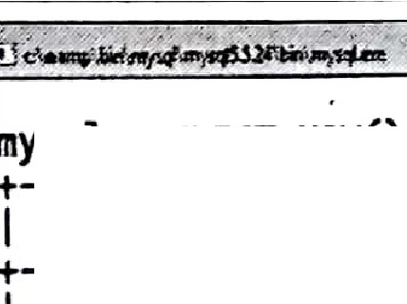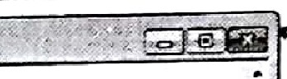

[I N-O-W-(-) ---](https://e-next.in/)

**ysql>** SELECT **NOW();**

[+I](https://e-next.in/)

[: +](https://e-next.in/)

['I--2-0-1-7---0-6---0-1-1-0-:-3-3-:--5-4-+I](https://e-next.in/)

[0](https://e-next.in/)

[; row in set (0.03 sec)](https://e-next.in/)

['](https://e-next.in/)

['](https://e-next.in/)

[: •-....:--.u..........-e- ....- .-::::J-](https://e-next.in/)

[-·--](https://e-next.in/)

[I •](https://e-next.in/)

[ SELECT NOW();

[](https://e-next.in/)

[DateO](https://e-next.in/)

. Extracts the date part of a date or date/time expression

i ysq > se ect ate 2014-05-1 ; •

·*i* 1--d-a-t-e-(-'-2-0-1-4---0-5---l-'-)-+I

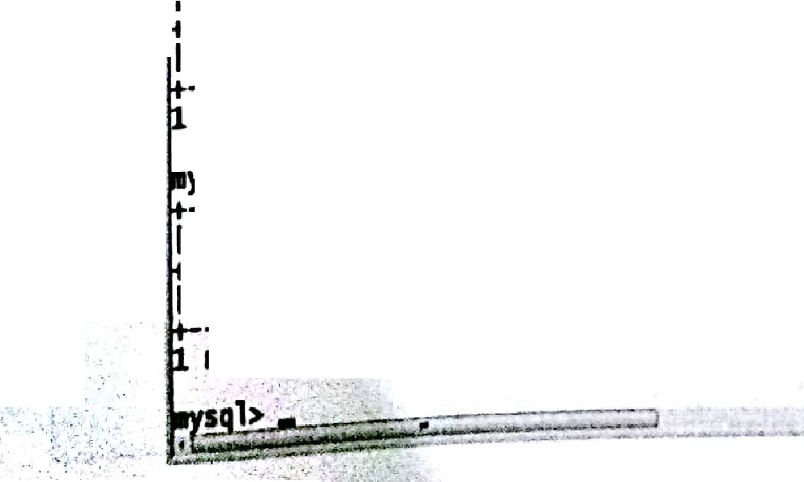

Example

Select datef2014-5 1');

Select date('2014-5-111:00:00.0');

**,,aiul-i"••IIS• -·** ,...*·'.!'.·* .•,..,, "' -·.,_.. *•:» -* ., - o 8 ;

* *F.. _G$<-, tJr_1;·e*

*·..:;;* -..;....

, .. *;•a ...-:,%:,>-- z,,,, -.;s:"\·J,:11.•:* v:.:- v,.;;.,.,/*;*

-

*:* ,. 1

' 1 +

2014-os-01 I

--r-o-w--i-n--s-e-t-(-0-.-0-0--s-+ec)

ysql> select date('2014-0S-1 13:00:00');

, ; .

I --d-a-t-e-C-'-2-0-1-4---0-5---1---1-3-:-o-o-:-o-o-'-)-+I

- +

I

. 2014--os-01 I +

; i;·; t-(0.00 sec)

.· , .



. ·:- *>·.:-:* ......, !·J·· *,:*



DBMS (MU-BSC IT) L-38 Lab Manual

DayQ

ln SQL Ser\'er (Tran act-SQL), the DA y function returns the day of the month (a number from 1 to 1 gi n n dale alu .

Example

I Select day('2014-4-28 11:00:00.0);



I +

**2015-4-28**

I +

DAY('201S-4-28') I

- +

28 I

row in set (0.01 sec)

I +

sql> SELECT DAY('2015-4-28 11:00:00.0');

DAY('2015-4-28 11:00:00.0') I

[28](https://e-next.in/) I

[1 --ro-w---in---s-e-t--(0--.0-0--s-e-c-) +](https://e-next.in/)

I +

[Time()](https://e-next.in/)

[The time function returns the time.](https://e-next.in/) Example

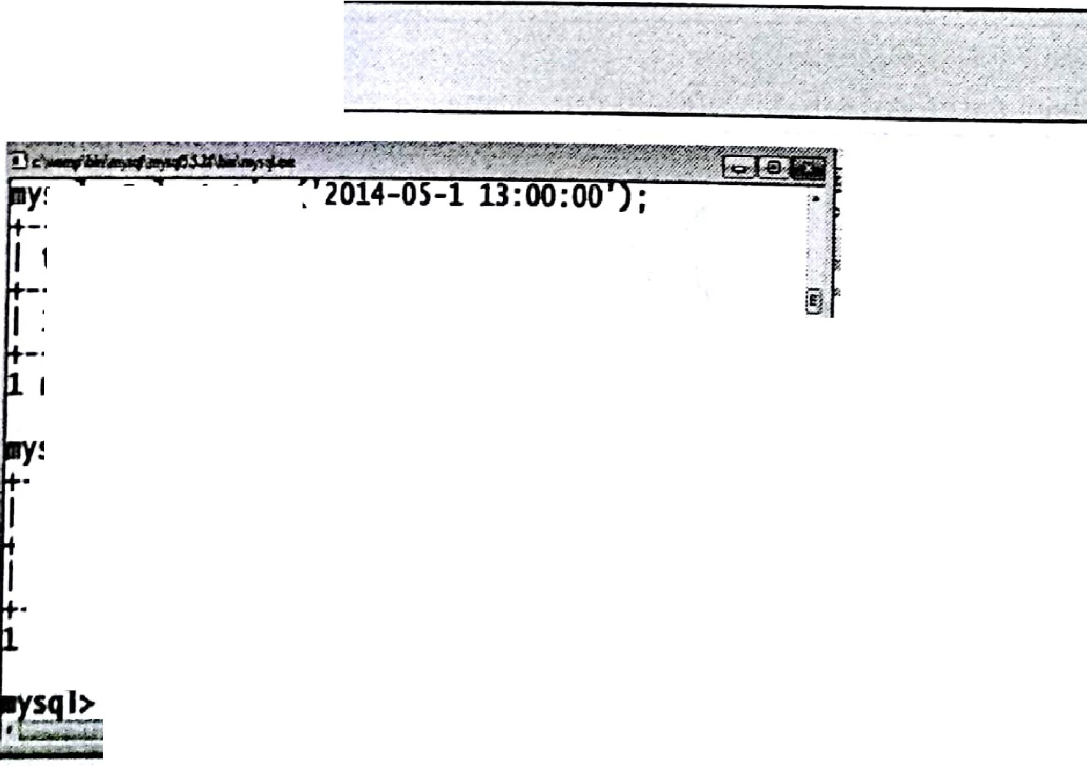

Select time{'ll:00:00.0');

Or Select time('2017-3-1 11:00:00.0');

1-3-:-o-o-:-o-o

sq > se ect t1rae

time('2014-05-113:00:00') I

I 1-1-:00-:00

*r*-*a*-*w*---i-n--s-e-t-(-0-.-0--0--s-e-c-) +

sql> select time('13:00:00');

I --ti-a-e--(-'l-l-:0--0-:-0-0--')--I+

+I

-r-o-w--i-n--s-e-t--(-0-.-0-0--s+ec)

+I



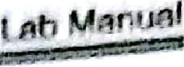

IT'

* ,1





Th l K . l ' HY., II

fn I 1 1_ 1 I m I toM ..

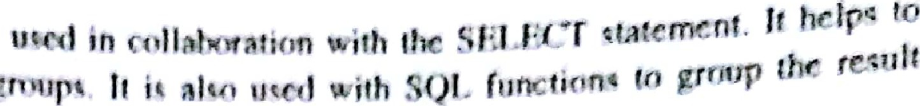J111,,n



-· : i

. L(Cl h .mnt#colurnn2

1 **M** ttbl _natn

tUJE { tondiHons ]

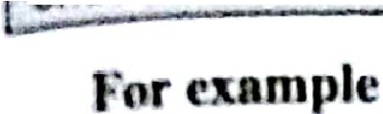G UPBY cotumnl, cotumn2

Dl -ploy sum of salaries department wise.

[**e- P**group by d ptno;](https://e-next.in/)

[deptno,sum(sal) from](https://e-next.in/)

[Output](https://e-next.in/)

|  |  |
| --- | --- |
| [-](https://e-next.in/)  [**DFPrNO**](https://e-next.in/) | [**SUM{SAL)**](https://e-next.in/) |
| [30](https://e-next.in/) | [00](https://e-next.in/) |
| [20](https://e-next.in/) | [10875](https://e-next.in/) |
| [10](https://e-next.in/) | [8750](https://e-next.in/) |

**,(d) Advanced** Subquerles

In

Ried sub q-uery:



·

e

,

" :·.,



stUCT ,otu,mn:_ncame{ ,tolumn_nameJ · • · ROM tablet {, table2 ]'· . . . WHW cotumn_name OPERATOR

..'.DI (SELECT column_name.[f column_name)

I:.;··_,WHER' ''\:, .x:e;.)';_ :::

,' flOHbl 1 L tlb.112]

.. ·

>·:, ·. , ,· ..

\ :,:::.

'

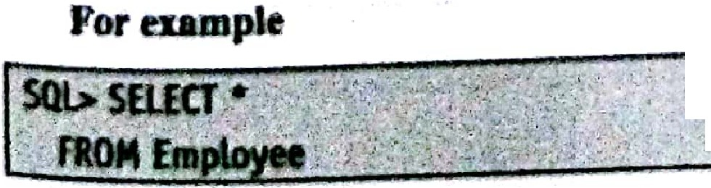

. '

,•,-- ' ..

•• •



<

lwr DBMS (MU·BSC IT) L-40 Lab Manual

WHERE Employee_no IN (SELECT Employee_no FROM Emp_dept

WHERE Employee dept 'computer);

It

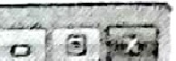

'Jlir, • # •.\ M '.tin_' IITl)ll_ _ttt ..------'-_ ._: -====::



ysq > se ect ro Emp oyee;

I EIIIJ)-loyee_no +I Employee_name I+ joining_date I+Salary I+

1-0-1

+-R-n-j-e-s-h

+ 1-9-9-5---11---0-2

+ 1-2-00-0-+

102 swati 201s-01-01 20000

103 Vedant 1999-0S-03 30000

104 **Vedika** 2005-02-10 52000

105 Ankita 2015-03-15 50000

S rows in set {+0.00 sec) + + +

ysql> select c from Emp_deptj

I --E-q-,-l-o-y-e-e-J-1-0-+I --E-mp-l-o-y-e-e-_-d-e-p-t--+I

1-0-1-+I -c-o-m-p-u-t-e-r +

1. [computer](https://e-next.in/)
2. [civil](https://e-next.in/)
3. [**ETC**](https://e-next.in/)
4. [Electrical](https://e-next.in/)

[--r-o-w-s--i-n--s-e-t-(+0-.--0-0--s-e-c-)------+](https://e-next.in/)

[, ysql> select• from Employee where Employee_no IN(select Employee_no from Emp_d ;](https://e-next.in/)

[: pt where Employee_dept='computer'); · *}*](https://e-next.in/)

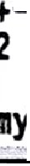

[. I --E-mp-l-o-y-ee-.-.-.-.n-o-+I--E-m-p-l-o-y-e-e-_-na-m-e--+I--j-o-in-i-n-g-_-d-a-t-e--+I -S-a-l-a-r-y--+I · . *'Y*-](https://e-next.in/)

## I, [+](https://e-next.in/)

101 j Rajesh 11995-11-02

[+](https://e-next.in/) I [+](https://e-next.in/)

I [+ *i*](https://e-next.in/)

: 102 swati 2015-01-07 20000 >

12000

*i*

, --r-o-w-s--in---s-e-t-(+0-.--0-3--s-e-c-)------+--------------+--------+ . : -;:I;

.j

ysql>•

....,,.._ u.w .,,,,,.,..,..;, }7,-. .....,.. ,r '""!" '"' - *w""r l)',r,'"").½*,,.."!·•,,uv-;•, ,,,'/.·-·.-"'""' ·••"1••w+> ;.Y, '';'-":s1:,:'. Y.r:;l(:-"'f :'.'¾H.-• ,,,r.,:,-/..ry v.: ,_,,;--,x ---:,..,.;• . · ..,,t"".Y:l'-;;+· ·• -· •··:>-;.o•,..*-4""'"'r : ,x,-.,,:••,r.,y(.I*

Update sub query Syntax



UPDATE table ,

,... *:, ,_,._:* ,. ., ,,. ·.

SET column_name ='new valiJe

_[ WHERE OPERATOR [VALUE]:.

FROM TA LE_NAME),'.· :_> >:.:: / *-.:::_·;.* :,_i;•

(SELECT COLUMN NAME . ·· ..

[ WHERE) ]

, . ;' , :.:,;.', •··.'.·. •·.;if_,., ,•.:.·:::;:{:: '·.• •,•

* *:.* ' ·'::; ·. *::::* ;' :, *,. >,* '

jP



DBMS (MU-BSC IT)

for exan1ple:

L-41 Lab Manual

UPDATE Employee



sET SALARY"" SALARY "' 0.50

WHERE Employee_no IN (SELECT Employee_no FROM Emp_dept WHERE Employee_deptc:'ETC');

"'"'"' *:* -\ "'¥-' .....-. ..·--·---·- _,,_'<.Y,.., .

' . -- rw,-,er-,......,,. ,

filt\! *"t .l.i\hm 1ql.Qe. . , '.. ' *·:* · , · .,,,.,. , *"" :* · ---- ·, · ::;- · ,:7': ·; .·'.

.•

ysq > UPDATE Emp oyee . •

· -> SET SALARY= SALARY t 0.50

-> WHERE Employee_no IN (SELECT Employee_no FROM Emp_dept

. -> . WHERE Employee_dept='ETC'); uery OK, 1 row affected (0.02 sec)

; ows matched: 1 Changed: 1 Warnings: o

: ysql> select t from Employee;

t ;I +

+ + +

Employee_no I Employee_name I joining_date I salary I



;n?FR M, - p e f,),::_

WHERE Employ't={e dept;;,,'clvil');::}::: <·< ::.\<.:,

WHE,REE, p o·yee n } ·:·c I sff P:}o

DELETE FROM Eroployee \t,,\: ??:{i-/??t.)',;. '.'.·_··:::·_.:·_\:,, ., ·•...···.·•·••\/··?.;. :· ·:-,}_:i {:: ·'-.:·;,

[!\ -------------+---------------+--------------+ +](https://e-next.in/)

[I](https://e-next.in/)

[101 I Rajesh 1995-11-02 I 12000](https://e-next.in/)

[e](https://e-next.in/)

[102 SWati 2015-01-07 20000](https://e-next.in/)

[I](https://e-next.in/)

[r 103 Vedant 1999-05-03 30000](https://e-next.in/)

[, 104 Vedika 2005-02-10 26000](https://e-next.in/)

[r I 105 Ankita 2015-03-15 50000](https://e-next.in/)

[5;. --r-o-w-s--i-n--s-e-t-+(-0-.-0-0--s-e-c-)------+--------------+ +](https://e-next.in/)

[t ysql>](https://e-next.in/)

[,>.](https://e-next.in/)

[,.](https://e-next.in/)

Delete sub query



DELETE FROM TABLE_NAME. ,-'-' [WHERE .OPERATOR[VALUE. ]

-IN (SELECT COLUMN_NAME.·

FROM TABLE..:.NAME)

[WHERE)]-: .. *:>* ,

- ' . ' .

*·: :_, ::_,.* _'.' *:-' ..,.--* .,. ,.- ;

.·' ..•

',· .

**For example**

,,, ''.' .-\,' .

&\IDBMS (MU-BSC IT) L-42 Lab Manual



I

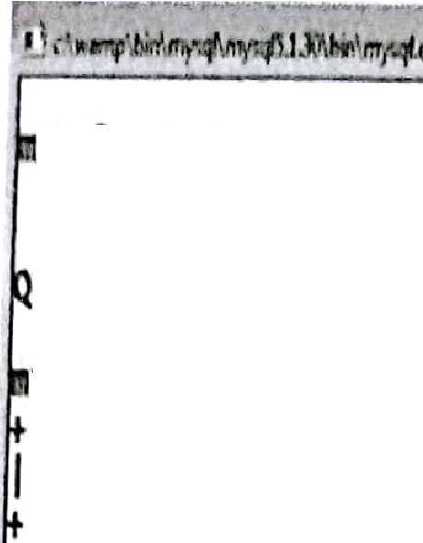

ysql> DELElt FROM Employee

-> ERE Eq>loyee_no IN (SELECT Employee_no FROM Emp_dept

-> **WHERE** Ernployee_dept='civil'); uery OK, 1 row affected (0.00 sec)

ysql> select 1 fr011 Employee;

I Employee_no I E ployee_name

+

I joining_date +I Salary I +

105

101

102

104

Rajesh + swat; Vedika

Ankita

1995-11-02

201s-01-01

2005-02-10

2015-03-15

+

+

12000 +

20000

26000

50000

-rows in set (0+.00 sec)

ql>.

...

*4*

*t*

*i*

• *". i, .* .•: ., .l:rM-K •:\.,--»:" =«·· *R?.lt . JZ!!."21%1M..::;..r iJ:; ; w. 1. 1:i:r-..a1.'.t),!'}.A%.. z>r ;W..&';;>",.?,'z.;.N:.r1,1; rJi:".*

*:, z.z :..t%f ?9"' ,,..%f?' :;.,?,;.cz,$,,J:%/Zttt'),*

[Insert sub query](https://e-next.in/)

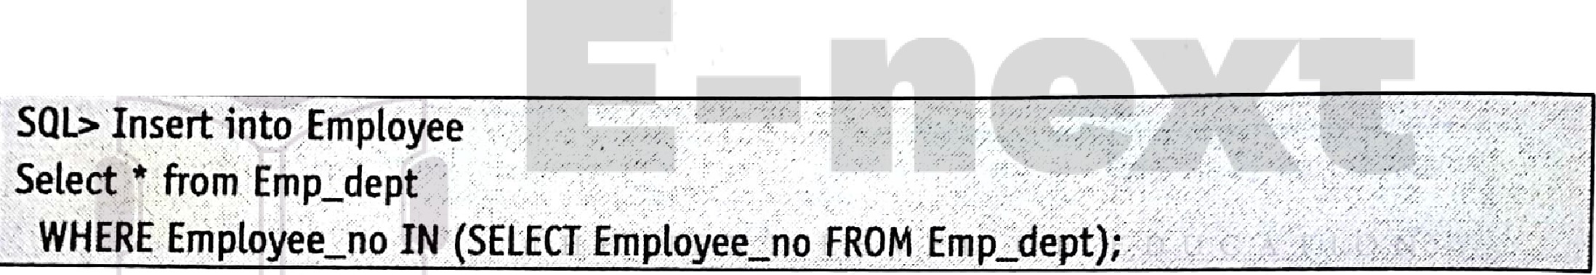

[For example](https://e-next.in/)



; sql> Insert into EDl)loyee

: -> Select * from Emp_dept

-> WHERE fmployee....no IN {SELECT Empleyee_no FR<Jf Eq>_dept);

uery OK, 5 rows affected (0.00 sec)

*1* ecords: 5 _Duplicates: 0 Warnings: _O

: ·· . ·►+ . .

ql> select* from f111>1oyee;

··-+ ·.·

+- ·

11

*ii*

*! I*

*i* I

*i* I

; ·

*i* I fmp1oyee....no I £mployee_name I joining_dat_e_I Salary I

+-· .

105 I Electrical

102 I computer:

103 I civil

104 I ETC

I NULL

*I* NU L

I NULL

_I NUL

+ · ·...

I

· I

I

NULL I NULi. I NULL I

+

' ·..: :..._ _,.. ;,. - ..;.,;.;_..;_+:;,.-------..:.:.. + '.,;,_. _:.;;._,..

101 I computer

I

I'NULL

I NULL I

NULL I

*j*

*I* rows in set (0.00 sec)

.

' .

►



fl o;i::B:::M:::S:::(M=U=•B;;;:S:;:;;C==I-T)f::: ===-=== L -4 3=---==:::;;;;:;====== L ab Man u al

**Updnlc ub query**

.

UP~~DATEtable~~  SET column_name new_value

[ WHEREOPERATOR[ VALUE]

NOT IN (SELECT COLUMN_NAME FROM TABLE_NAME)

[ WHERE) ]

**For example:**

-UPDATE Employee

SET SALARY = SALARY * 0.50

WHERE Employee_no not IN (SELECT Employee_no FROM Emp_dept

WHERE Employee dept,.,'ETC1;

[](https://e-next.in/) 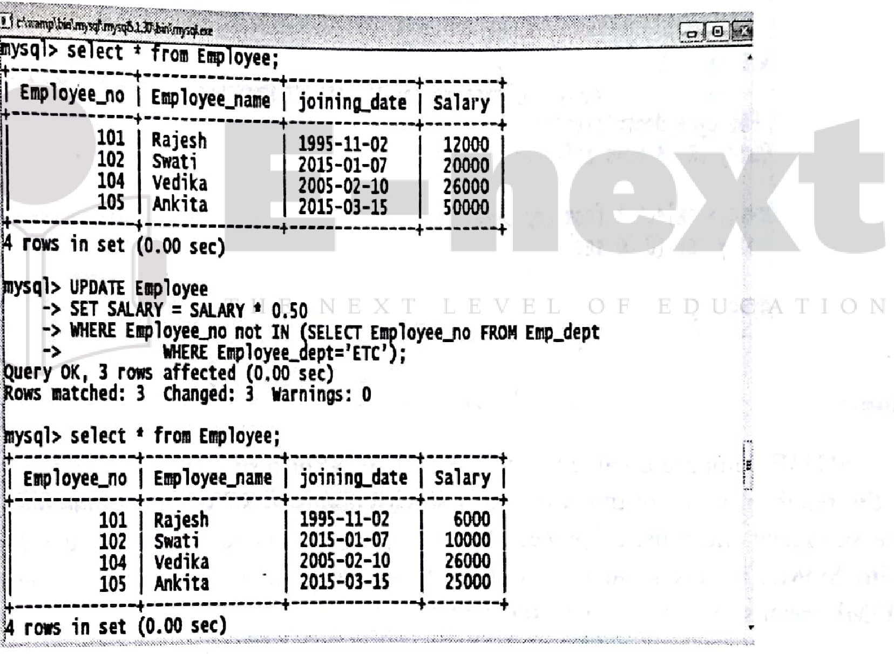

**Delete sub query Syntax**



DELETE **FROM TABLE NAM**, **:** _<·:<.· .. ; ·.., ·

[ **WHERE OPERATOR** [VALUE] . - . .

**IN (SELECT.COLUMN_NAME FROM TABLE_NAME)**

[ **WHERE) l ..**

' '

...

lwr DBMS (MU-BSC 1n L-44 Lab Manual

,tr....-

,,

For example



DELETE FROM Employee

WHEREEmployee_no not IN (SELECT Employee_no FROM Emp_dept WHERE Employee_ dept 'civil');

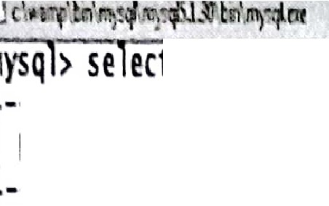

ct t fr011 Employee;

I Employee_no I Employee_na!leI joining_date I Salary I

-------------+-------··-·····+-·············+·-----··+

·--·---·-----+-··············+·······-------+ +

101 Rajesh

10s

102

104

swati Vedika

1995·11·02 I 6000

I 10000

Ankita

2015·01·07

2005-02-10

2015-03·15

I 25000 I

I 26000

: f

- 1

····-·-··--·-+---··-----·---·+-·---·---·····+ +

rows in set (0.00 sec)

; 1

: *t*

' ysql> DELITT FROM Employee .

- ·>

[Employee_dept='civil');](https://e-next.in/)

WHERE Employee_no not IN (SELECT Elll)loyee_no FROM **Elll)_dept WHERE;**1

; -J

[uery OK, 4 rows affected (0.00 sec)](https://e-next.in/)

[•- t,](https://e-next.in/)

[: ysql> select t fr011 **Employee;**](https://e-next.in/)

[r mpty set (0.00 sec)](https://e-next.in/)

[i](https://e-next.in/)

[I ysql>](https://e-next.in/)

[·.](https://e-next.in/)

['](https://e-next.in/)

['](https://e-next.in/)

[T:. '. t,:°'./=- .-: t1°c-.l:;x.:.!J.:·;c.- :J.- ' :(,;;_: tt ;::X·t} ; JklI:¾li :;*h;..¾:.4r: X:M z-i:tk\.t fafill" ?k 'Wiii* tif--t )i ¾ i ti iJ](https://e-next.in/)

[l4](https://e-next.in/)

Some

[](https://e-next.in/)SOME compare a value to each value in a list or results from a query and evaluate to true if the result of an inner query contains at least one row. SOME must match at least one row in the subquery and must be preceded by comparison operators. Suppose using greater than ( >) with SOME means greater than at least one value same as it if we use less than ( <) with SOME means less than at least one value.

**Syntax**



SELECT [column_name •.. I expiessi tJ:··t\ '..

FR0M[table_name] .. - .. ·_,- ... ;·:, _: ;:..:,;._.<',.',:>;:;,- .:.:···,.?::·,.. <,:;: '.)> i\·.

-WHEREexpression2 compariso·n.:_opera or_{ALL.·AN'(:fsoMEf(-s _bque );\::·:;,,.:,::'i*:-* :·::,:

**For example**

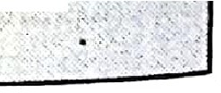

**SELECT•** from'Empl9yee,<:_::_'/·:.:*<;;{.* :;/.' .. ,.

"'•

'

•

•• • .

•

*h* t

•

**WHERE** ,:i_o-SOME( :sELEOnoJ O -- pJjept.

) ··_; ··• ·· ·. -,·· ·•: ·.·-.· --·-:.: : -t.. --..;.::..-•,,. •-;,- .......

. . .

'

' ·,. ). : .........

.... .· .,- .. '·, <"' •

'

**WHERE** dept-'computerl);,:.,-;:_'_ ::::/_)::y,:;\r *i* ·; ,.·

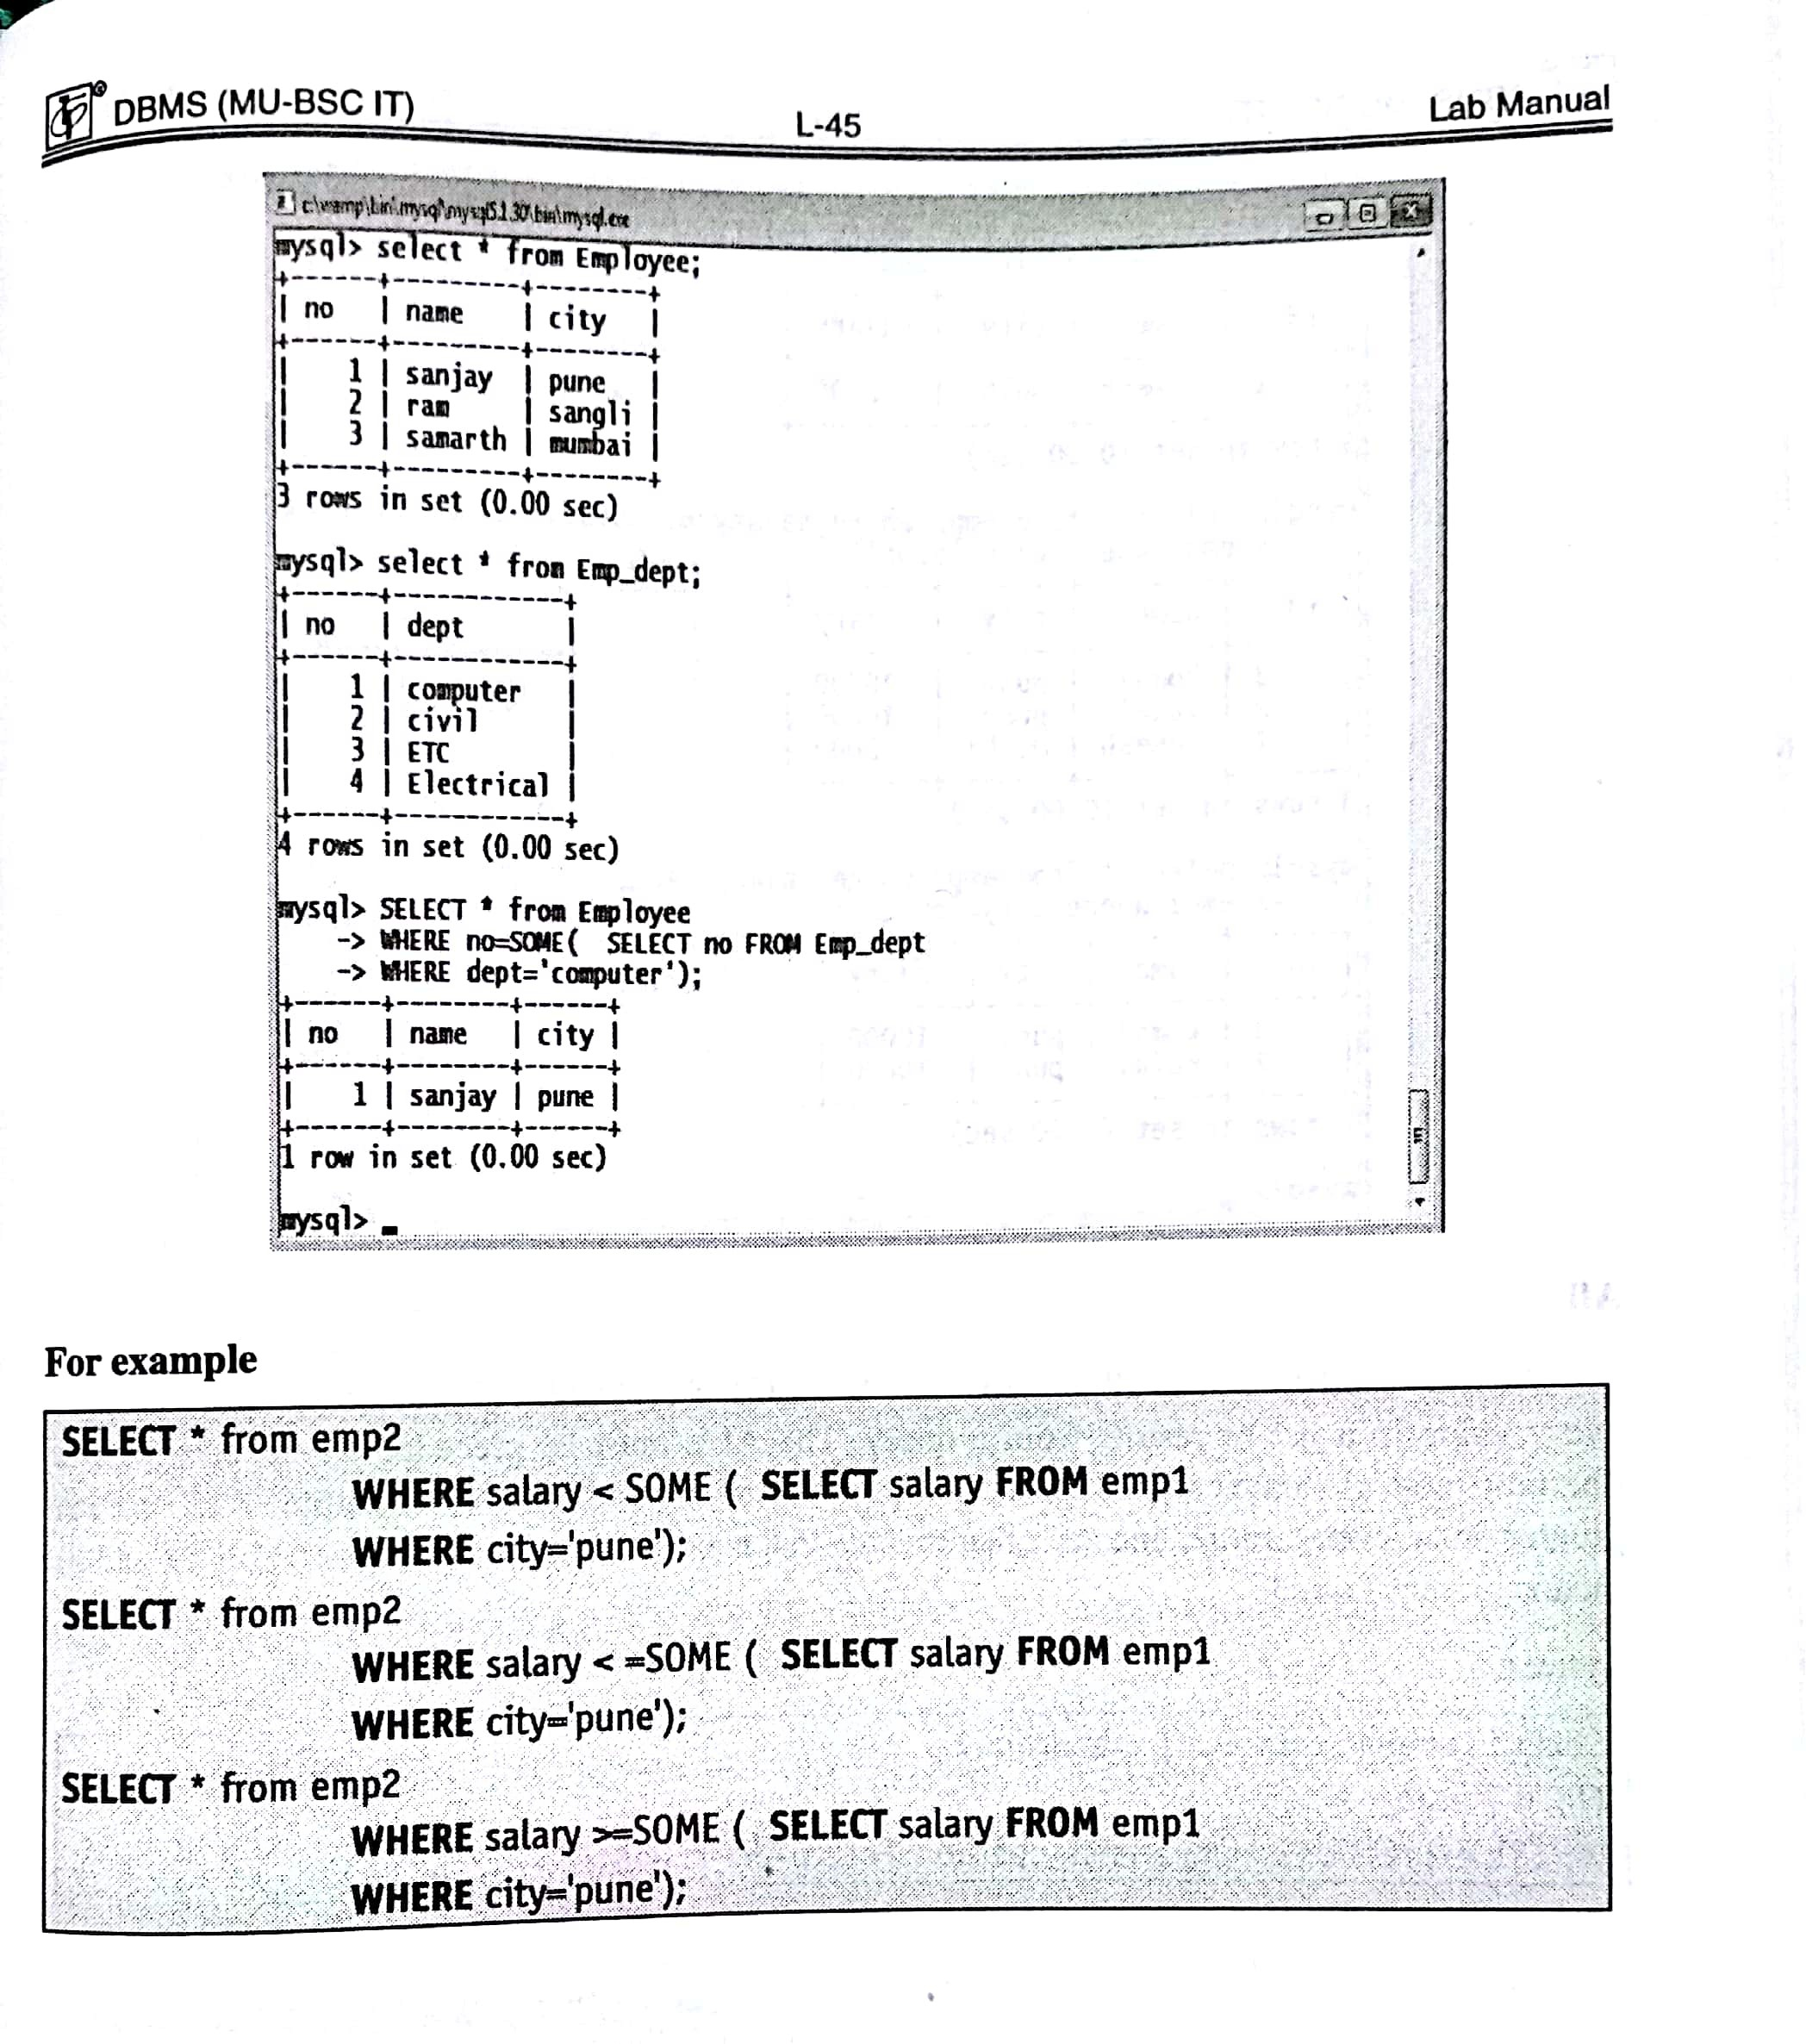

[https://E-next.in](https://E-next.in/)

Scanned by CamScanner

*r* DBMS (MU-BSC IT) L-46 Lab Manual

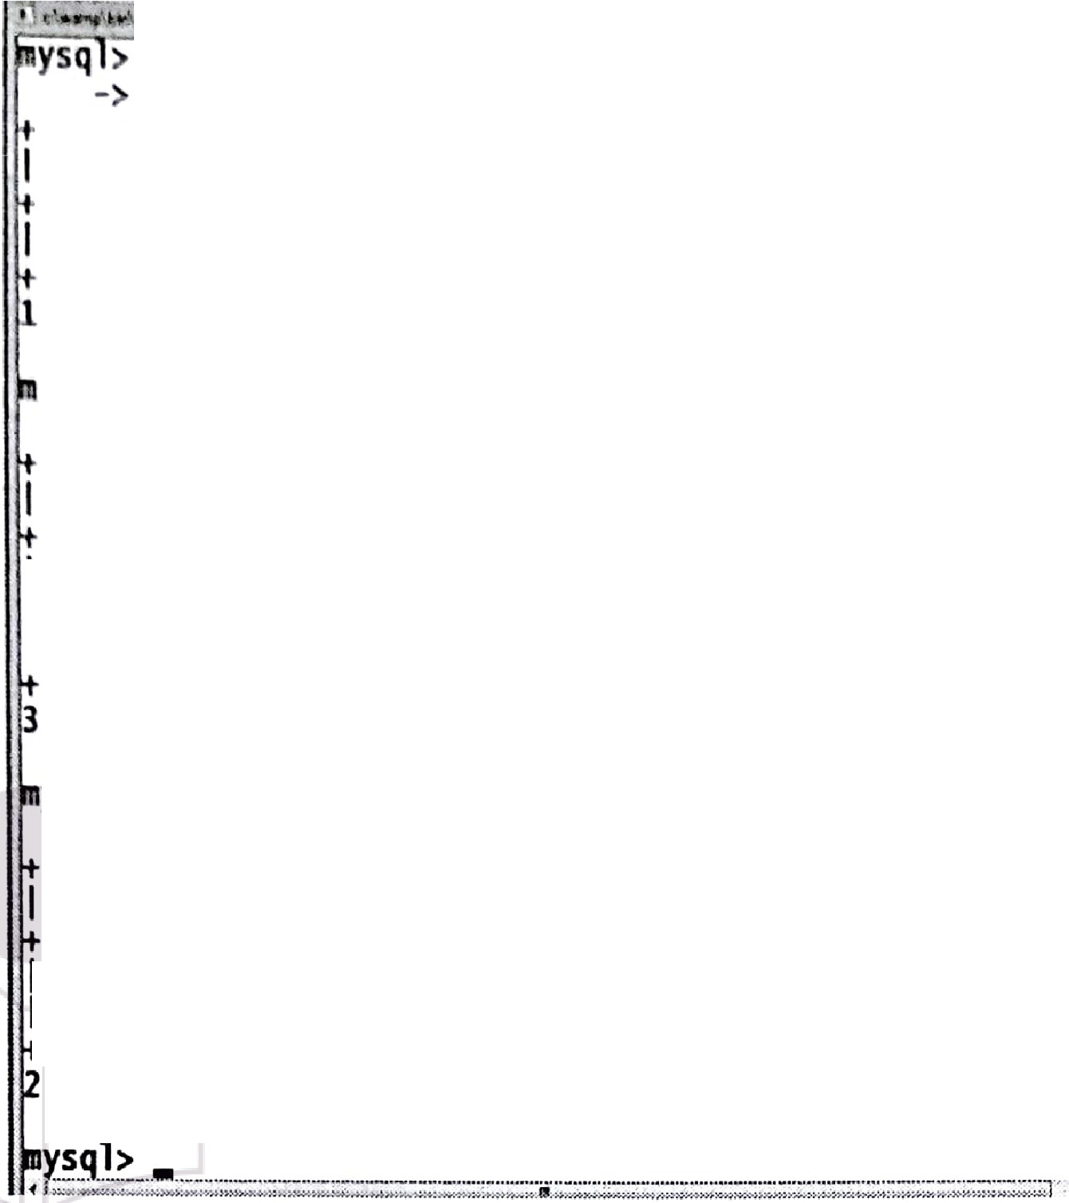

I _• _ ,

... **VI**  ..,.

...;...;:..;-=---c=

r--- -..- ... _,....._-.-• - .,·..,. t ary rom

cmpl where city= punc');

S ect rom cmel

ere sa ary<some se cc sa

I id I name

+

+

+

I

1 I Ramesh I oelhi I 2000 I

+

I city I salary I

+

row in

+ set(0. + sec) +

00

+

+

ysql> select* from eme2 where salary<=some(select salary from

I id +I name I+ city I+ salary I+

-> cmpl where city= pune');

I

I

3 komal I pune 10000 I

+ + + +

3--r-o-w-s-+i-n-s--e-t-(-0-.+0--0-s--e-c-)+ +

[ysql> select* from em 2 where salary>=some{select salary from](https://e-next.in/)

I 1 Ramesh I oelhi

2 kajal pune

10000 I

2000 I

[I --**id**----+I -n-a-m-e---I+-c-i-t-y--I+-s-a-l-a-r-y--I +](https://e-next.in/)

[-> empl where city= pune');](https://e-next.in/)

[I 3 I komal I pune I 10000 I](https://e-next.in/)

[------+-------+------+ +](https://e-next.in/)

[. I](https://e-next.in/)

[. ------+-------+------+ +](https://e-next.in/)

[I](https://e-next.in/)

[2 I kajal I pune I 10000 I](https://e-next.in/)

[rows in set (0.00 sec)](https://e-next.in/)

**All**

ALL is used to select all records of a SELECT STATEMENT. It compares a value to

every value in a list or results from a query. The ALL must be preceded by the comparison operators and evaluates to TRUE if the query returns no rows. For example, ALL means greater than every value, means greater than the maximum value. Suppose ALL (1, 2, 3) means greater than 3.

**Syntax**

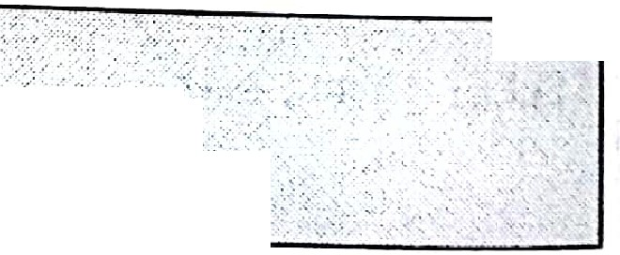

:: c:i _::;: me.:l:,ext!t l;;'].( *J;*[*:*'*f*'i:if*? 'f}*·*:*·•··,,.;,*,?·.*

. .,, ''

WHERE expression2 comparfso·nl_:o'p,frjt:9r'{Alt l{ANtf's.i>MEff: ub J 'fyt)':,·..

Ill"



DBMS (MU-BSC IT) L-47 Lab Manual

'

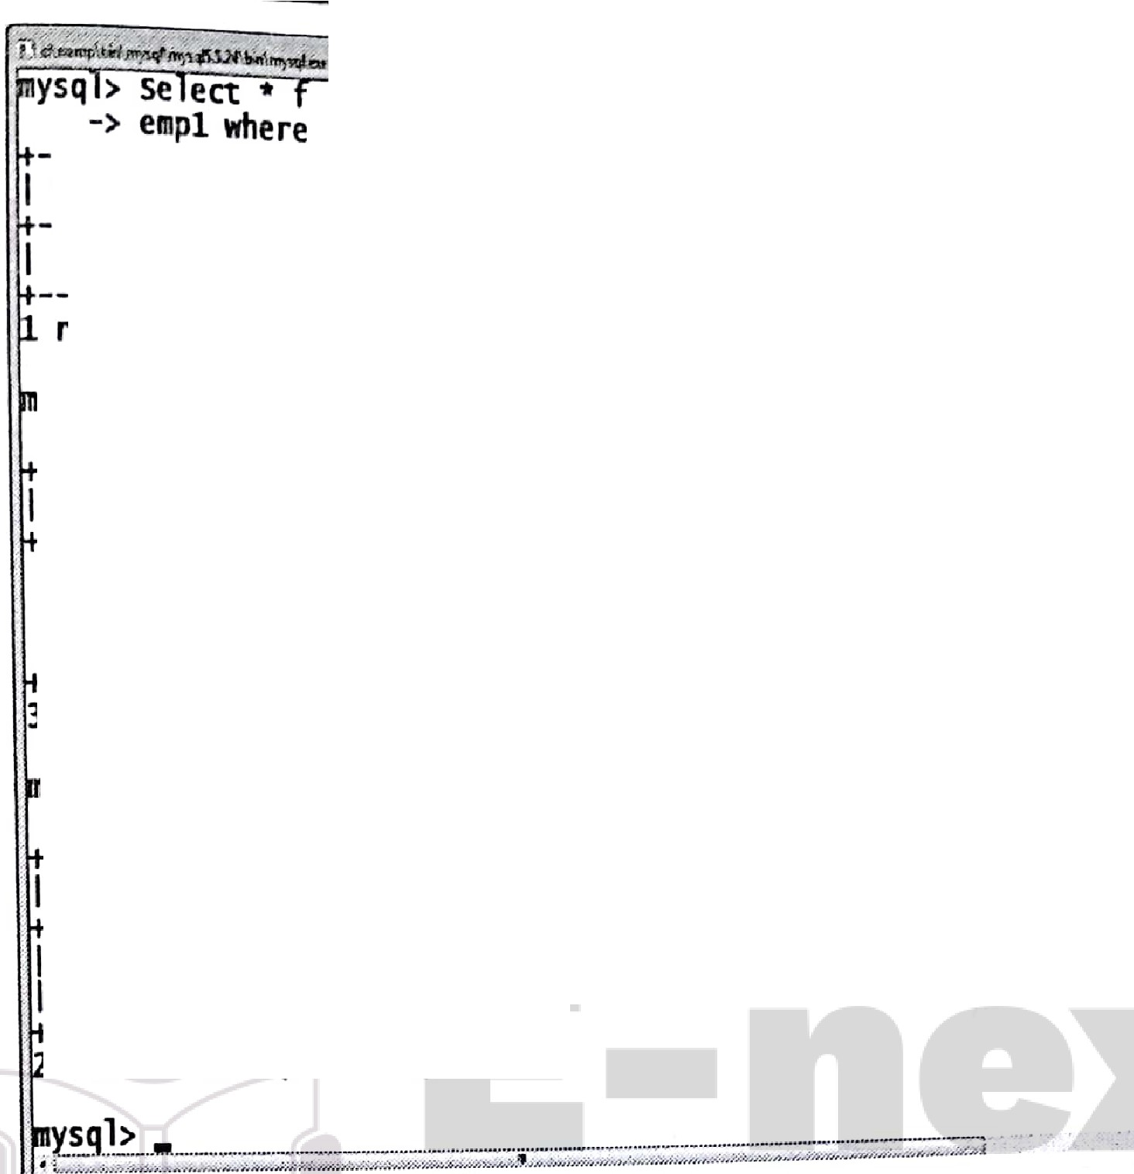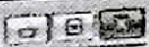

ro em 2 ere sa ary<a

id---j- ; i city j-;;1; ;-j

cny= pune')·

se ect sa ary rom

----1-+--------+-------+ +

-o-w-.1+n--s-e-t-(-0-.-+0-1--s-e-c-)-+ +

I Ramesh I Delhi I 2000 I

ysql> Select* from **em 2** where salary<=all(select salary from

-> empl **where** city= pune');

·I------+--------+-------+ +

I -:----+--------+-------+ +

1d I name I city I salary I

I 3 I komal I pune I 10000 I

: ------+--------+-------+ +

I 1 I Ramesh I Delhi I 2000 I

1. I kajal I pune I 10000 I
2. rows in set (0.00 sec)

ysql> select* from em 2 where salary>=all(select salary from

I ------+-------+------+ +

-> empl where city= pune');

[I------+-------+------+ +](https://e-next.in/)

id I name I city I salary I

[: ------+-------+------+ +](https://e-next.in/)

[I 2 I kajal I pune I 10000 I](https://e-next.in/)

[3 I komal I pune I 10000 I](https://e-next.in/)

[rows in set (0.00 sec)](https://e-next.in/)

.

[](https://e-next.in/)

[-7,;t,::t:,.._,:.{;,:. .·,:, .- • ;•:1,.• '/'"; ,,,_ .,.,, •./ •](https://e-next.in/)

[7:ir;l(a:fi!/sa1S'eas1cs1<](https://e-next.in/)

1. Declaring Variables

Question : Displaying sum of two numbers

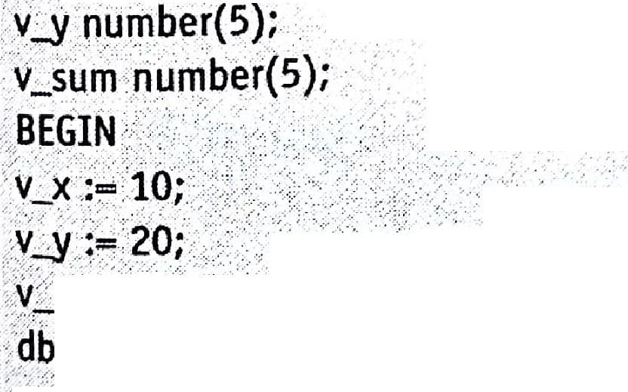

iti 1 tt !ry;:rr iti't!,:::::t;,o:"

- vl:)(riurnber(5);;. ·,.· *... ·,).::. ,,:* .

, , *,/·\.>*

,, ::,·_

: *r*

-,·,,•.:;r.. \..:/:.-·::;,•'(. ·.-.· ..- ;:.···..-•..·.. .·.··::.:·.,:,.:;...:. . . . ;.., ' ,.. . ..

*r* • • "·'., ',*/*: *',>*..

t t- "---- -:----- ----- - - ,:-"c

lf11:;:i1f*f*

,end""· ·,• · ·· .. · • · • · • · · · · · •• •

:iiI,*

)r, ir1ifitl



l jDBMS (MU-BSC IT) L-48 Lab Manual

**OUTPUT**

Sum is 30

P/L SQL procedure successfully completed.

1. **\Vriting Executable Statements**

**Question** : Displaying salary of a specific employee

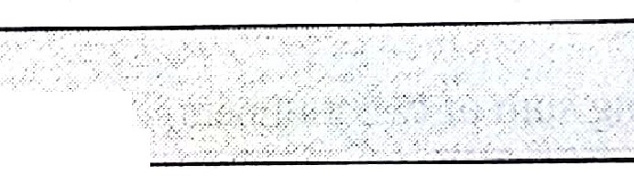

Set serveroutput on; declare

var_sal number(6); var_emp_no number(4); BEGIN

var_emp_no:='7369'; SELECT sal

INTO var_sal

FROM emp

WHERE empno == var_emp_no; [dbms_output.put_line(var_sal); end;](https://e-next.in/)

[*I*](https://e-next.in/)

[,,](https://e-next.in/)

[' _.- ---- ·](https://e-next.in/)

[, '•;' ...., ;,, , -·,](https://e-next.in/)

[.,](https://e-next.in/)

[. .](https://e-next.in/)

[--](https://e-next.in/)

[.- -](https://e-next.in/)

[, .](https://e-next.in/)

[**800**](https://e-next.in/)

PL/SQ°Lprocedure·successfullycompl ·ted y:

[](https://e-next.in/)

1. **Interacting with the Oracle Server**

,,.



*set* serveroutput on; . declare

var_x number(5); var_ y number(5)'; ·

var_sum number(lO); ..

vacavg number(tO) ..

:;·be in ., _,

**.var_x:=&var_x;**

.·.•

....', .,

'var :,.;,& acy; ...' ; > '*.".:·..*.. , . . .

*I* end;.· ; . ·.

db s_output.put_line('av, rage:_=,'flvar/x/varj); < _.-.

doms_output.put_line('Sum :=iflvatx+va(y};.···: '.·/ '. ·;;_

*:.-.-..* ,.;.. . ,,

.:.,....

, , : /,\ ·

·, ,,..

;'> -·/. .,. ·,

: . *>.-.--·:-.*·

...

• ,.•·,,,;•··,•:•.•;,":".-... .-; ...•. :·:·-. 'c

.,

•

,

O ,

, ', • .,. f , '·•, *•,:•<,-.u* ••,•. ••;•.: I -•·.;-''

0

,"; • ' '

•

• ' • '· '



* + , ., ;:,1-

..., ·-,.•,.·

.

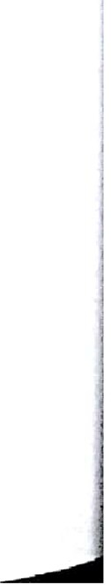*:·* '



• ·•

.. '

. ---""'..•••--- .-------•--------------·---••

**r DBMS (MU-BSC IT)**



**oVTPUT**

**L-49** Lab Manual

Enter value for var_x: 2

old 7: var_x:::o&var_x;

new 7: var_x:=2; Enter value for var_y: 2 old ff: var y:==&var y; surn=4

average==2

PL/SOL procedure successfully completed.

1. **Writing Control Structures**
2. [](https://e-next.in/)**Using if Statement**



Set serveroutput on; DECLARE

strl VARCHAR(l2); [s 2 VARCHAR(12); BEGIN .-](https://e-next.in/)

[str1 := 1TECHMAX';](https://e-next.in/)

[str2 := 'TECHMAX';](https://e-next.in/)

[IF **strl LIKE str2** THEN](https://e-next.in/)

[DBMS_OUTPUT PUT LINE(strl II /iss me like.' 1Lstr2);,:](https://e-next.in/)

[**ENDJF;**](https://e-next.in/)

**.'END;**

";,

['.. ,](https://e-next.in/)

[-.](https://e-next.in/)

[.. . ··. .:](https://e-next.in/)

[..](https://e-next.in/)

[.](https://e-next.in/)

[. ,](https://e-next.in/)

[·' *.•;-:.·* > .>.•](https://e-next.in/)

. ,. . •,•

[](https://e-next.in/)**OUTPUT:**

·1ECHMAx·ts·t1·me like TECH**MAX.**

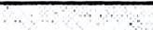

P.L)SQL pr d ;e successfully completed ....

• - ----_--;.--- ------.;._';.. ;_ -'--------:-- , : -- ••• - •• _·, : •• .. --_·-- - ::: ::_ ; -_. •._·· .•·.· • -. ----- • -------

--.-_ .. ..·.·:_ ·-. - ·-· *:* •' *:,.* , .,. .=:·:.; --

1. Using if -then-else statements



,de lare·· :r ·::·:> ;·:. i>_:_::: _·

x· µmber{-10);.•. . . .

Set servetoi.Jtputon; *>··;:._-*

-_y_number{10); ·< .1.

:b_egin.:-:·-,; Ir,h}{::r::::.\._

lwi osMs (Mu-ssc ,n l-50 Lab Manual

x:=7782;

select sal into y from mp where cmpno.,.,x;

if y>4500

then update rnp et sal=(sal+2500w) here emp110°x;

l if y 3500

then

update mp set sal=-(sal+1500) where empnocx;

else

update emp set sal=(sal+500) where empno=x; end if;

end;

*I*

**OUTPUT**

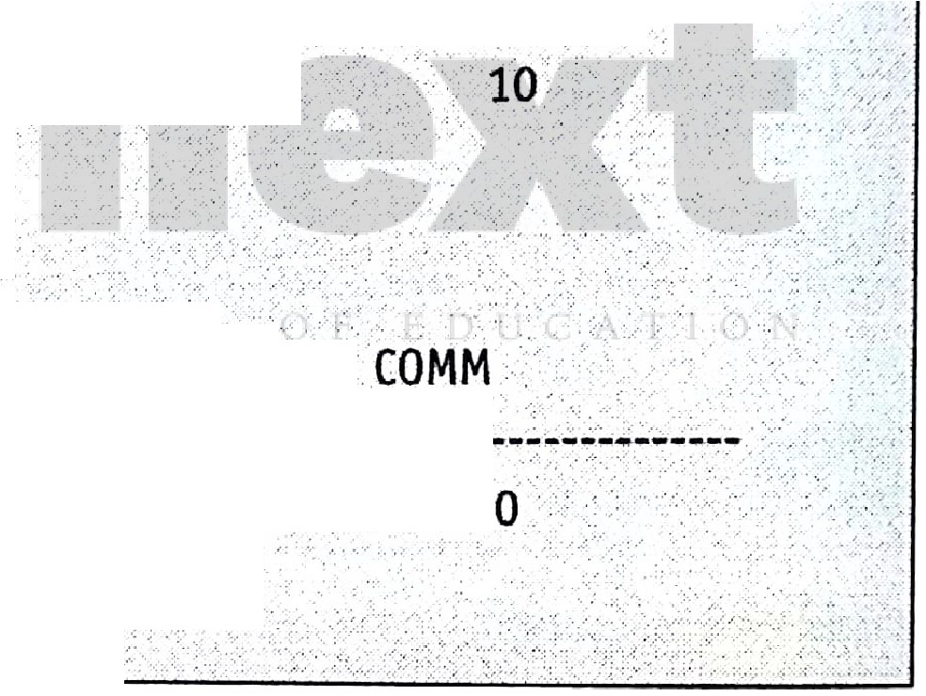

SUL> select * from emp where empno=7782;

/• *·:* ". *i; ·-.*

[EMPNO ENAME · JOB](https://e-next.in/)

MGR HIREDATE .•. SAL; ; COMM .,,· ',.·, --.. . ·. :,,_>-,.

['](https://e-next.in/)

[. . ···' .··](https://e-next.in/)

[,·](https://e-next.in/)

[, .•' .](https://e-next.in/)

[.. :- , .](https://e-next.in/)

[. . ._ ,](https://e-next.in/)

[· '!""-. . :](https://e-next.in/)

[7782 CLARK MANAGER](https://e-next.in/)

[7839 09-JUN-81' 534.8 .](https://e-next.in/)

[SOL> select * from emp where empno.=77 ?; .](https://e-next.in/)

[-..: · ..:...•·'.:" .](https://e-next.in/)

[EMPNO ENAME](https://e-next.in/)

[JOB MGR HIREDATE - · . SAL C](https://e-next.in/)

[. -. '""'](https://e-next.in/)

[;](https://e-next.in/)

[_,··-. , ·.-, ·-..·,·:-·.. •, ..,-- -:.-•...-](https://e-next.in/)

7782 CLARK

-MANAGER . 7839 (jg;;JUNl81 /515.9 :.. ' ; . / '10. ' '::

PL/SOL procedure successfully completed '. , ·- .. ·,

(ill) **Nested** if **-then-else statements**



Set serveroutput on; · .·'.:

DECLARE

percent NUMERIC;

BEGIN

percent := '83';

IF percent >= 75 THEN

DBMS_OUTPUT.PUT_LINE('DISINCTION.');

ELSIF percent>= 60 AND percent <75 THEN DBMS_OUTPUT.PUT_UNE('FIRST CLASS);_ ·_

ELSIF percent>= o AND:pe cent<60.T. HEN.

* 'f '·

,.

-. '•. ,,·

' ,, '. • •

,..

• ' ' ,, ·, ••

• ..... ' ♦ ·, • ·'\ '· '



DBMS (MU-BSC IT)

l9l

***....z-*** · L-51 Lab Manual

.--DBMS OUTPUT.PUT LINE('SEC=ON=D:-C--.LA =,=. ==-====-===== :

ELSIF percent !,:; '40' AND percent

<50 THEN

SS ),

OBMS_OUTPUT.PUT_LINE('PASS CLASS, ; ELSE ),

DBMS_OUTPUT.PUT_llNE('FAIL ');

END IF;

END;

*I*

**OUTPUT**



DISINffiON

1. **Using CASE** - **WHEN statement**



[·SQL>set sen,eroutput-on;-... *::*.](https://e-next.in/)

[DECLARE](https://e-next.in/)

[grade CHAR{l); BEGIN](https://e-next.in/)

[grade := **'A';** ·](https://e-next.in/)

[CASE grade](https://e-next.in/)

[WHEN '0'JHEN DB S_OUTPU.T.P !-LINECOutstanding');'](https://e-next.in/) **WHEN 'A'** THEN DBMS_OUTPUT.PUT_UNE{'Excellent'); **WHEN-'B'**'THEN DBMS_OUTPUT.PUT_UNE('Good'); · . · **WHEN** *'C* THEN_DBMS_OUTPUT.PUT_UNE('Satisfactory');

**WHEN** 'F' THEN DBMS OUTPUT.PUT.:..LINE('Fail');.

..... [._,,](https://e-next.in/).. [,](https://e-next.in/)

*('*

.

ELSE **DBMS** OUTPUT.PUT...:.UNE('InvaUd grade');·.·

- .

. .

END CASE.; . . . . .. . .

**END;** -.

*I*

.. ...\ : :·::.:_::·_:-_ *i*:/:·.-/::,<.->_ .·.:

'- _..,.. -. . *.·.:* ..-:•.·..-.·_:.. . , .•·>..-. ·.

**OUTPUT**

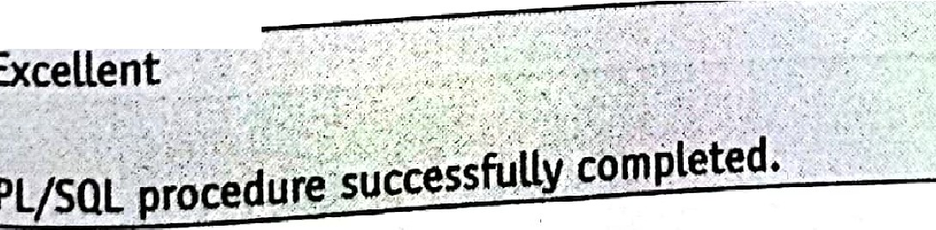



1. **Using While Loop**

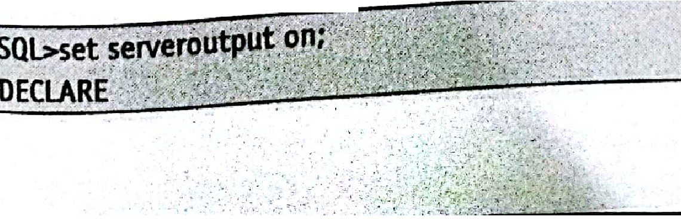

[](https://e-next.in/)

[https://E-next.in](https://E-next.in/)

Scanned by CamScanner **d**

lwiosMs (Mu-ssc IT) L-52 Lab Manual



grade CHAR{1);

BEGIN

grade := 'A';

CASE grade

WHEN 'O' THEN DBMS_OUTPUT.PUT LINE('Outstanding'); WHEN'A' THEN DBMS_OUTPUT.PUT_LINE('Excellent'); WHEN 1B' THEN DBMS_OUTPUT.PUT_LINE('Good');

WHEN 1C'THEN DBMS_OUTPUT.PUT_LINE('Satisfactory'); WHEN 'P THEN DBMS_OUTPUT.PUT_LINE('Fail');

ELSE DBMS_OUTPUT.PUT_LINE('Invalid grade'); END CASE;

END;

*I*

*,,I*

;'

**OUTPUT**



Excellent

[PL/SQL proced_ure successfully completed :-_- -](https://e-next.in/)

[**(vi) Using For Loop**](https://e-next.in/)

[Set serveroutput on;](https://e-next.in/)

[DECLAR. E](https://e-next.in/)

[ans NUMBER(4);](https://e-next.in/)

BEGIN

ans := 5;

DBMS OUTPUT.PUT_LINE('S x' ii num 11'='11 ans);·.

ans := ans + 5; END LOOP; END;

*I*

FOR num IN 1 ••10 LOOP

**OUTPUT**

•,· .-·..... *!* : ..

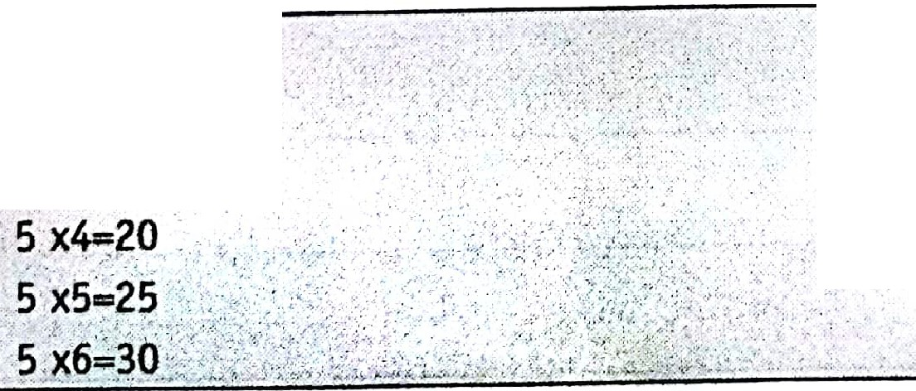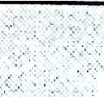

**5 X1=5**

. ·.

5. x2=10

\ ..

.

...

.

**-5 X3=15**

. •, .. -

*:.* • - '!>•• :-:

. .. ..

'·., '.

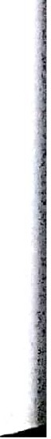

. '.



"' ..·

.... *i.* ·....•'' .

_

*[M* DBMS (MU-BSC 1n

-

L-53 Lab Manual

5 x7-35

5 x8=40

5 x9=45

5 x10=50

PL/SOL procedure successfully co pleted.

**(vii) Using Continue-When** in **Loop**

.

SOL> BEGIN- *:,,*

fO ,num **IN 1** .. 10 LOOP

CO TINUE WHEN MOD(num:'2) != o;

< BMS-:-OUTPUT.PUT_:_LINE(num);

:ENO:LOOP· ,

',tNb;··

*{.f,* ,· .;.,

*I*

*'//* ', '

.' .,.:; • *t_* ; ,·*:* '

[**OUTPUT**](https://e-next.in/)

[-](https://e-next.in/)

[;·'.2 <:<](https://e-next.in/)



[*.4,:.*](https://e-next.in/)

['6<](https://e-next.in/)

[: ,·',](https://e-next.in/)

'i[/SQL procedure successfully completed.

[ :.,:**C mposite data types, cursors and exceptions.**

1. **Working with Composite Data Types**

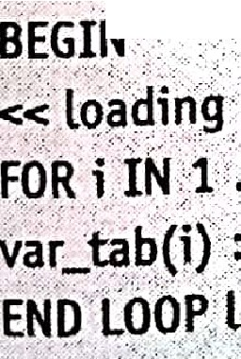

.; rfetitypeI

:.scll.>,:DECLARE'•,

_

S !ABLE OF NUMBER(10)

, *.)* ,.,. -· . .

;;:f s4 P --typer..: .· .: ::_... · · :

? IND·EeXv·e'INARY_)NTEGER;

.. . .

;:vat:-indxNUMBER;····.·...

, ..

·.;v•a"r•':;.'ta·•b··,:o•''e· {i:Tr( c:,';

:' - ;_... - .··.!..:. - ,,

*j+.;:;'.'.:·:,:* • ·.*·:"* : :. ·

-- .¥.·.;,;,_::,::,,:;._•?;..;..,.·,:. .;.;_:·.---'-· ,,: :

:_, :

..:

_J

. .., .

·'\,'

* + T :',.-.

' ' '.; ,·. O;_. ··../)_.):<:;{:• :};:

lc\3i DBMS (MU•BSC IT) L-54 Lab Manual

var_indx := var_tab.FJRST;

<< displaying *>*

WHILEvar_indx I NOT NULLLOOP DBMS_OUTPUT.PlJT_UNE{'Displaying....' 11 var_tab(var_indx) ); var_indx : var_tal>.NEXT(var_indx);

END LOOPdisplaying; END;

*I*

**OUTPUT**

Displaying 1



Displaying 2

Displaying 3

Displaying 4

Displaying 6

Displaying 7

[PL/SOL procedure successfully completed.](https://e-next.in/)

1. [**Writing Explicit Cursors**](https://e-next.in/)
2. [**Using explicit cursors**](https://e-next.in/)

[SQL> DECLARE](https://e-next.in/)

[var_emp_no char(4); var_emp_namevarchar(l0);](https://e-next.in/) var_emp_sal number{B,2); var_emp_addrvarchar(10); cursor c_emp 1s

select emp_no, emp_name, emp_sal, emp addr from emp;

**BEGIN**

open c_emp;

Loop , .

·.':•·;.; .*:*.

:...

...

fetch c_emp into var_emp_no,var_emp_name,var_emp_sal,v r_emp_addr;

exit when c_emp%notfound;  var_new_sal ::: var_emp_sal +5000;

insert into emp **values(var_emp_no,var_emp_name,var_new_)al,var_emp_addr); end loop;**

**close c_emp;**

**END;.**

*I*

,.. "'

.. ·'· -.:.... •' ; ' -- .

►

DBMS (MU-BSC IT) L-55 Lab Manual

**OUTPUT**



SOL> select * from emp;

EMPNO ENAME SAL

ADDR

4012

CLARK

9000 MUMBAI

PL/SOL procedure successfully completed.

',., ,, *F*

1. **Using loops** in **cursor**

, . ,.. ·,, . ·, , ,.



c**D**u**E**r**C**s**L**o**A**r**RE** '. . , ':-:·-,·;,,\,;:'< <'.> '.·. *<,:* ' ,·/,-, . . : ;',-. . ;,:.•' .. ' . ;,:. ,.' , ·• . . , -;

cl is select Jro_mefop\vhere·s·ab.2sooandJob!;;;'presidept';·--.;'.<-,: .

:- . . : .: ' . .. , . . . ., ._' .. , . . , . ' ' . . . '• '_. . , .,; .·. *:·*. ·• .

x emp%rowtype;

BEGIN

[open cl;•](https://e-next.in/)

[LOOP](https://e-next.in/)

[-fetch c1·tnto'.x; _ ..](https://e-next.in/)

[DBMS_OUTPUrPUT_LINE(x.enani·e); -](https://e-next.in/)

. -,

['](https://e-next.in/)

[exit when(cl°lo:notfoun ); ._ .. _ _ _ _](https://e-next.in/)

[if(x.job,..'managers'·and x.s l 2s99_) >-:*r,* -)_;.·-,](https://e-next.in/)

[.then update emp setsal,;;sal+SO;.. ;·;: .](https://e-next.in/)

[l.sif(x.job \ina_lyst' and x.sal>2500).' •](https://e-next.in/) then update:erjlptsal:= al+ Q;,;-· end if;

end loop;:

dose c1;·

ENO··

* • *I*

*I*

**OUTPUT**

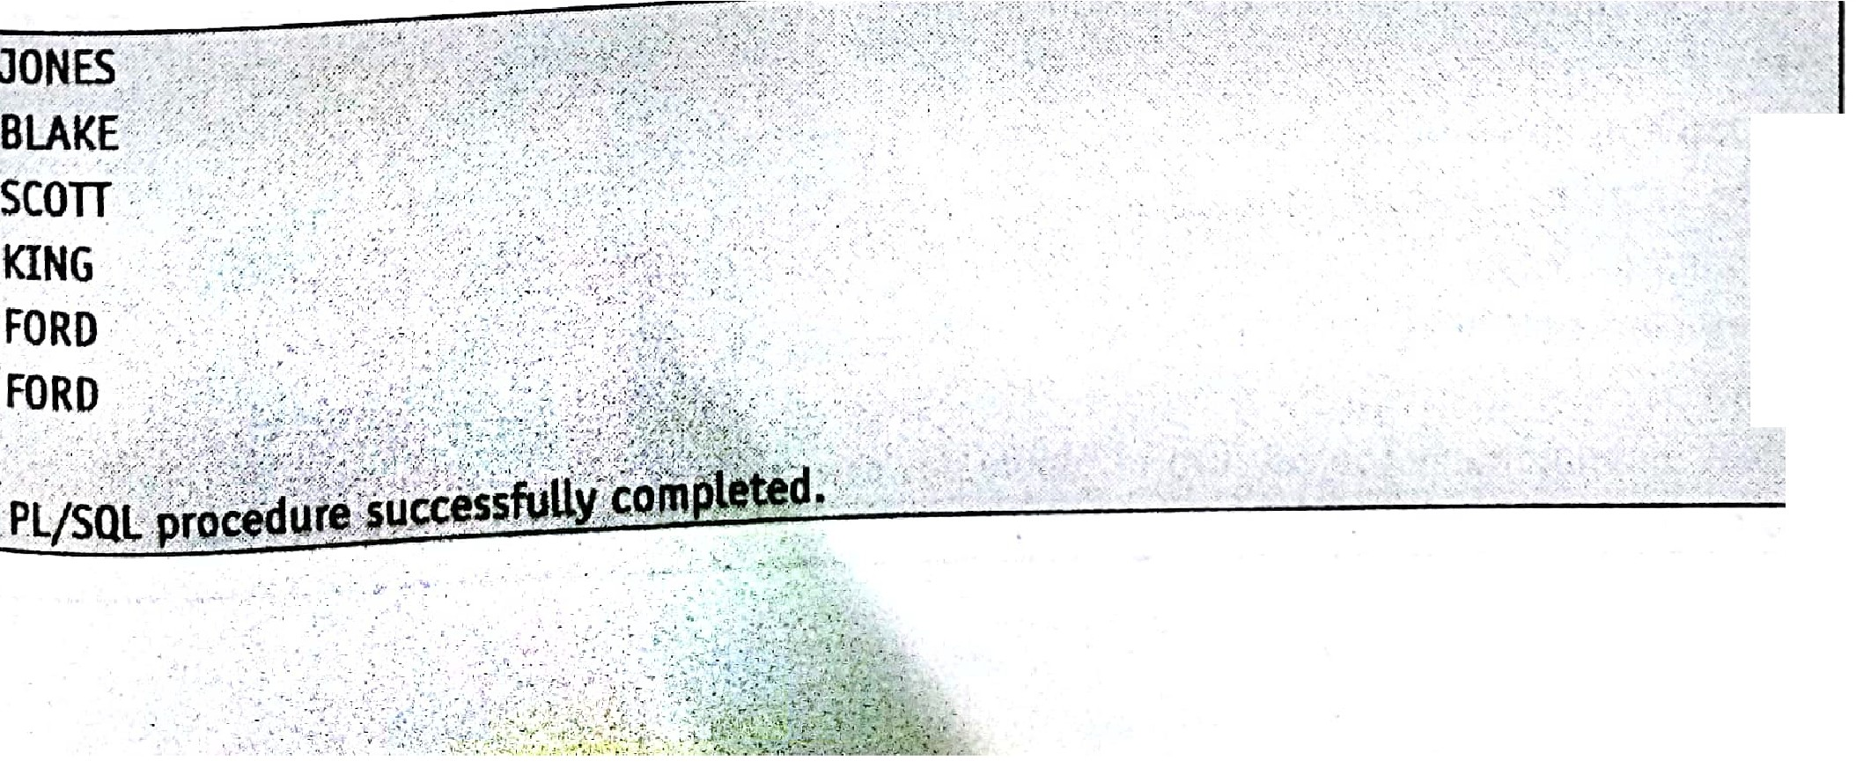

..

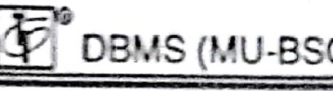

CIT)

L-56

Lab Manua1

(c Handlin cptions

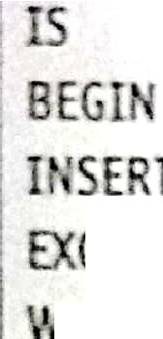

SQL> C

TE OR REPLACE PROCEDUREnew_dept (d_no IN

CH R, d_ am I VARCHAR2)

I TO department (dept_no, dept_name) VALUES ( d_no, d_name ); CEP1l0

1 HH OUP_VAL_ON_INOEXTHEN

raise_application_error (-2 001,'0epartment No. already existing');

WHEN OTHERS THEN

raise_application_error (-25002,'Error inserting new Department.');

END;

*I*

**OUTPUT**

Case **1**

[exec new_dept;](https://e-next.in/)

[Department No. already existing.](https://e-next.in/)

[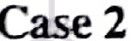](https://e-next.in/)

[Exec new _dept;](https://e-next.in/)

[Error inserting new department.,](https://e-next.in/)

[**19.**](https://e-next.in/) **Procedures and Functions**[I](https://e-next.in/)

1. **Creating Procedures**

[- ,, ,.. .,](https://e-next.in/)

[/ ,' ,. '• ,, ,](https://e-next.in/)



[,';' *;?*-/ -:',,,,- :;:;,;,'}:'} ;>')-/:);, ,. *,tt,;,,'.I:*](https://e-next.in/)

**Question 1** : Create a procedure that adds the details(empno,ename,job,sal) of newest employee from table Emp into a, table newperson having structure as (eno,firstname,lastname,design,salary).The last name of a person is to be passed to the procedure as read only value.



Id emp empno%type; Fnameemp.ename%type; Des emp.job%type; Salary:emp.sal,;,/otype;.

·,· -

-Begin';-:-_;;::,_- .. - i:<:/. ; <:L{/·/ :- ,···

Select empno enarne,j9b,satiht9Jd,fnaine, es,salary

f om'eril·pJ:.}t :)'', \?<'./'.::t:: ] t, f)tff·- ?,/,· -:,

'

' : . a,·-; · .



·\:.··_.'.c<(,f::2/ .,. ....

i:D;B M S; mM U;·:B ;SC :IT;) ;;;;;; -::-::-:: L;;;·:5 7:-:-:-:-:=:=:=:=:=:-:-:=:=:=:=:-:=:=:-:- :La b M a=n u al

Wherme pno-(sclect rnax(empno) from emp);

Insert rnto person(eno,firstnameL t . .

. , as narne,des1gn,salary)

Values(

1d,fna me,lna me,des,salary);

End newperson;

*I*

**OUTPUT**

|  |  |  |  |
| --- | --- | --- | --- |
|  | | | |
| Exec newperson; |  |  |  |
| Select * from person; |  |  |  |
| ENO FIRSTNAME | LASTNAME | - DESIGN . | SALARY |
| 4012 JHONNY | DEP | HEAD | 4023 |

-

[](https://e-next.in/)**Question 2** : Create a stored procedure namely raise that receives the employee number [and raise in salary as parameter. It then raises the salary of that employee in the table emp.](https://e-next.in/)

[Create or replace procedure raise_emp(empl integer,increase float)](https://e-next.in/)

[Is](https://e-next.in/)

[Currentsalary float; Salary exception; Begin](https://e-next.in/)

[Select sal into currentsalary from emp where empno=emp1;](https://e-next.in/) If currentsalary is null then

Raise salary_exception; Else

Update emp · .

Set sal=sal+increase Where empno=:=emp}; End if; ·

Exception

When no data found then ·. · · ·

Insert into audit Values(empl,'unknow employee');

. When salary_exception then

Insert into ·audit value (empl,'nullsalary');



\ · •. - *;*.,*:*'*:_;-::.;;*,:·:·*.:;*

:_ . ,

. •.

·- ; , *.:·*



l$j DBMS (MU-BSC IT) L-58 Lab Manu-a-l

OUTPUT



Exec raise;

Select ,., from emp;

EMPNO ENAME

SAL

ADDR

4012

JAY

·

13000 NEW YORK

Select * from audit;

EMPNO

SAL

..

,.

., ; ,.,_

*"':.*

**4012**

nullsalary

. -- -, *,.· ...:. , .·,,_,(,*

,• . - ... ,, , ,., ., , ;';''*:-/* '

**Question 3** : Create a stored procedure that provides the details of customemame and city

from table customers having structure (cid,name,city,status,credit).To obtain these details

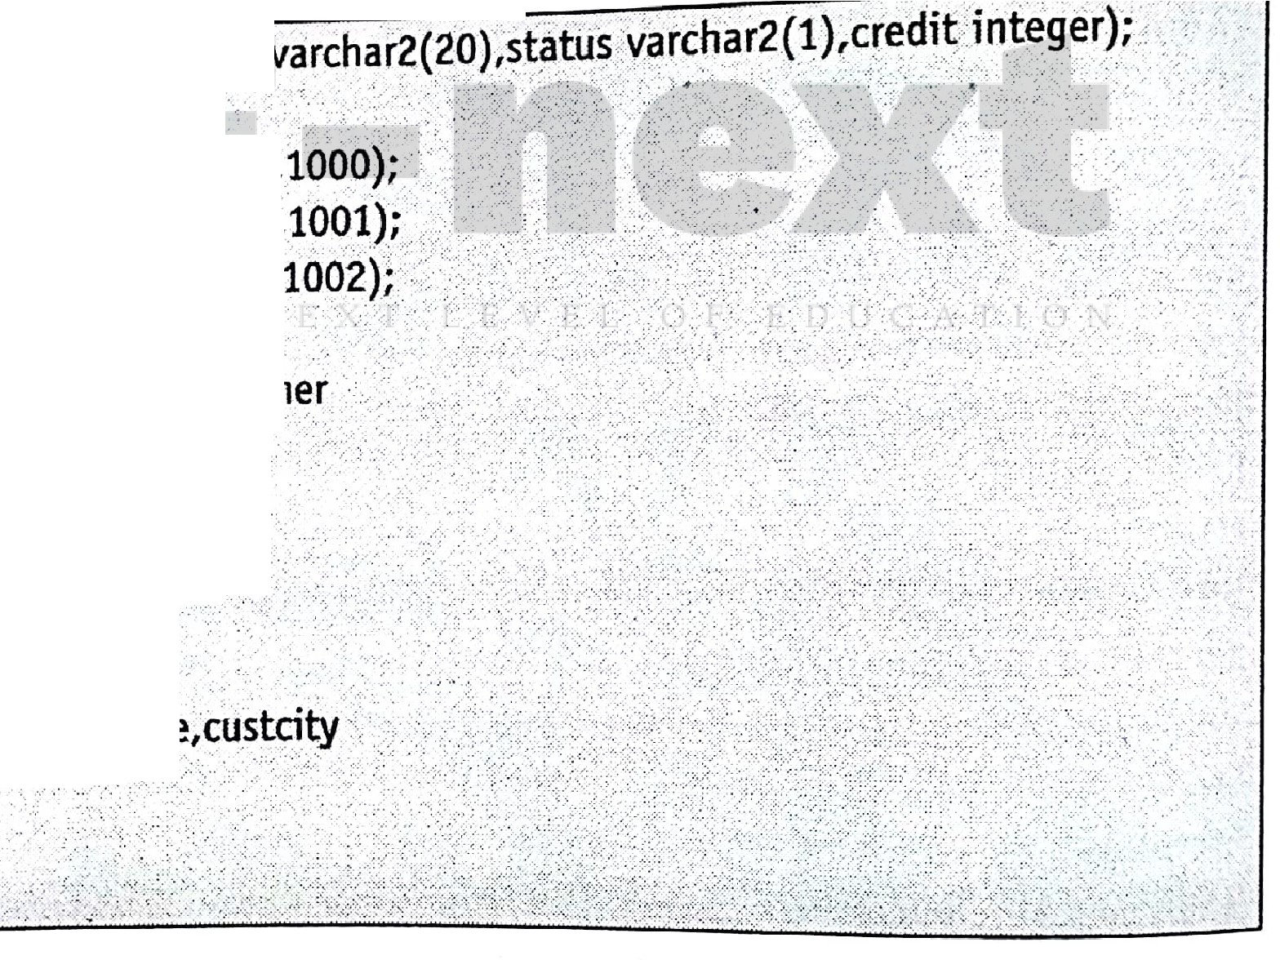

[the customer number is passed to the procedure.](https://e-next.in/)

[**C eate table** cListOl{ddinteger,n me](https://e-next.in/)

[..](https://e-next.in/)

[, .](https://e-next.in/)

[. .](https://e-next.in/)

[.](https://e-next.in/)

[Insert into cust0l values(101,'aa','s1'](https://e-next.in/)

[Insert into.cust 01values(lOJ/cc',' 3'](https://e-next.in/)

[Insert into cust01 valu'es(102,'bb','s2'](https://e-next.in/)

[. '•• . ,_](https://e-next.in/)

[*·:*](https://e-next.in/)

[Create or replace pro. edure getc sto ei •.](https://e-next.in/) ( custid in customer.cid'%type. ;. . . , .

Custname out cutomer.cname%type,

Is

Custcity out customer.city%type)., .

Begin

... > ... .

.. ·.'

. .

. ·.·... ..·..

.·

From customers. .. . . ··.. :,>· •.*/* . -;. ;.:

.Where cid=eustid; ·

En.d getcustom r; :,. *='* .

Select cname,city •into c str1am ,cu_stcity

**OUTPUT**

ex c ge cu. ,omer,.·, ,,,.,.;.;-,. >-:•;>",..;: i



# rllilil!llii[(':



[g?J: DBMS (MU-BSC IT)

1. **Creating Functions**

L-59 Lab Manual

**Question**: Createa function that return doubled contdbuted amount (contamt) from table donation if it is more than 10 o.w. it returns trip1ed contributed amount fora given id no.

Create or replace function func_cal1

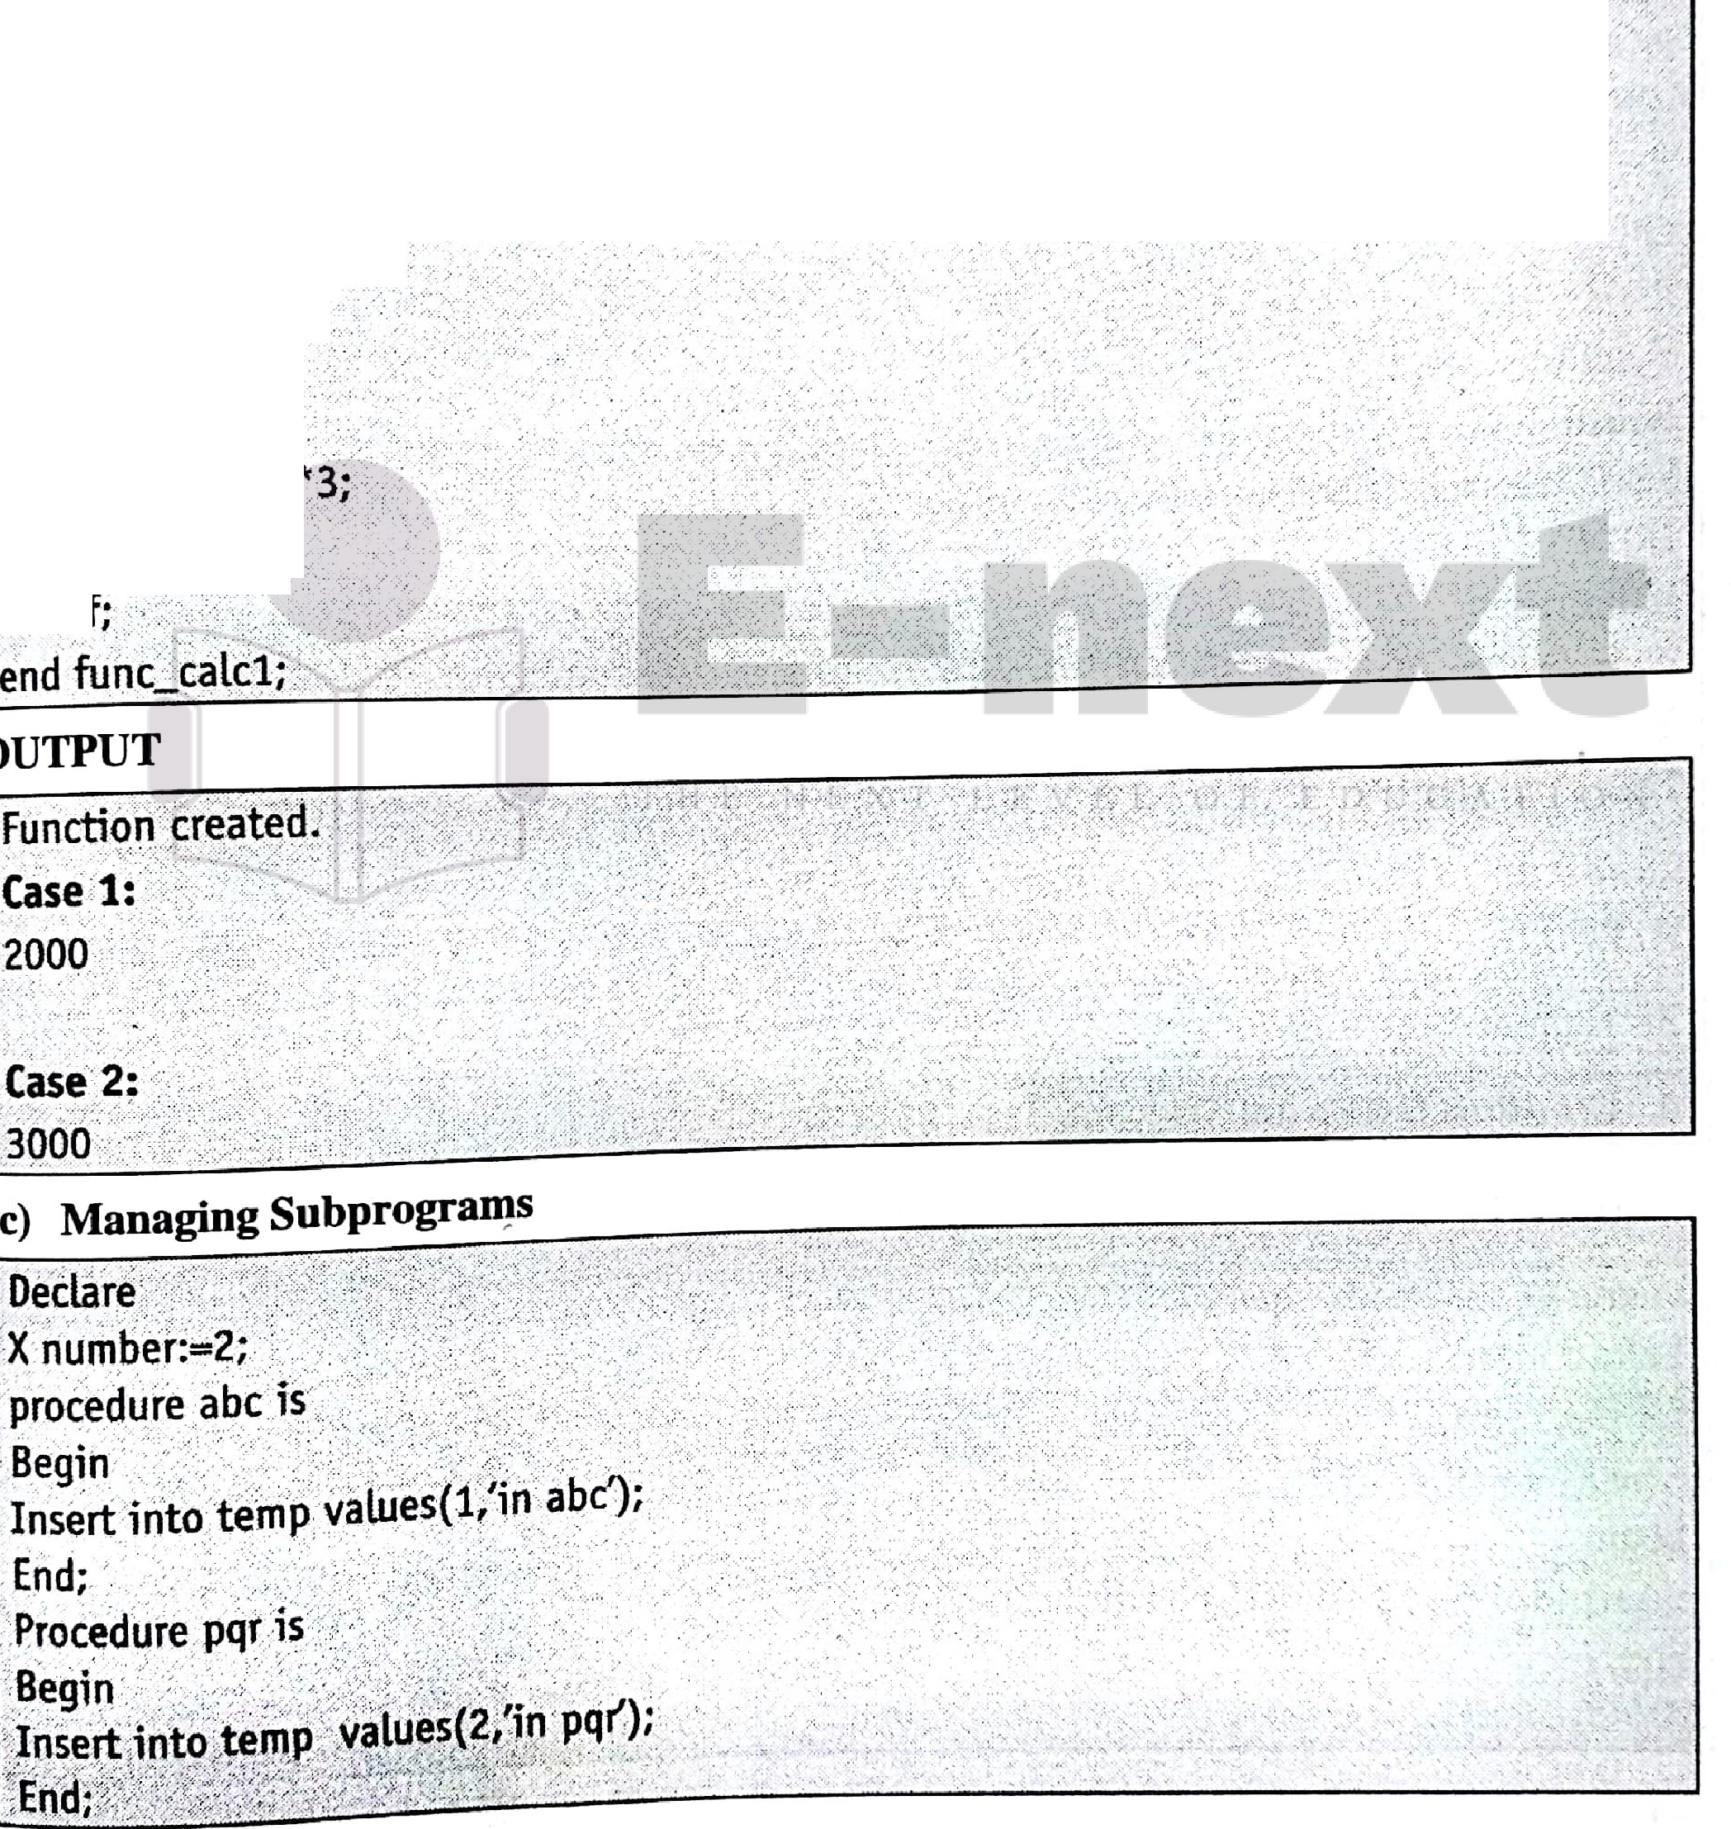

(vidnodonation.idno¾type) return number Is

vamtdonation.contamt¾type;

·vret_urndonation.contamt¾type;

,eegin

,Select.conta mt into vma _t

lfiorndonation

'.Where idno=vidrJo; ..

Jf ya_mt>lOthen

.'.return vretum;.

'•., . ..,-...

'else

[)i furn:=:v mt,t3;/](https://e-next.in/)

[return \/return;](https://e-next.in/)

[end](https://e-next.in/)

·•,



\ •, l •·. ',

-...·,.,-·.::*·':·,· lt:\.._,;.,=""'"'•.::.c.-,*

l@F osMs (Mu-ssc ,n L-60 Lab Manual

Begin

Insert into temp values(x,'in main'); abc;

pqr;

End;

*I*

1. **Creating Packages**

Create or replace package emp_salas

· Procedure find_sal(e_no number);

CREATE OR REPLACE PACKAGE BODY emp_sal AS

PROCEDURE find_sal( e_no number) IS e_sal number(lO);

[BEGIN](https://e-next.in/)

[SELECT emp_sal INTO e_sal](https://e-next.in/)

[FROM customers](https://e-next.in/)

[.. , ..](https://e-next.in/)

[''](https://e-next.in/)

[WHERE emp_no = e_no; dbms_output.put_line{'Salary: 'Ir e_sal);' . END f.ind_sal;](https://e-next.in/)

[END emp_sal;](https://e-next.in/)

[,·](https://e-next.in/)

*I* _, .·

[](https://e-next.in/)**OUTPUT**



**/10. Creating _Dat se Triggers·f**

* 1. **Trigger**

. ,, .. '



·betoiein. ert on fil _A.·\.·.·.··, -,.

create or .replac¢trigg T.)<yz··,·­

*fcir* each .row

.. ; -.

. when(ne\\'tfir!=lOf.-:.. ·/ ', _:::: :··:-'.:' ..'._ :x : :··

.:begi ;'.'.

.insert,inio'fite:._a·valties(!11ew fjr;'rec<>rd');::,. :: •,-:

;j" )'.:;*'i:.,J} t':'*·•.: :i:Jif(J1,tt : ii i{kl ),.i;,7\ ....

: •. , *·,i*·;,.:.. ·;::<:: :'(•:, ·_, •.·.:·.·. •·

,.·.

' .·. -

·,·

 

,.--

[g[DBMS (MU-BSC IT) Lab Manual

L-61

**oVTPUT**

Ert

into file_ A values(12,'hello'); l

* 1. **Trigger**

-

create or replace trigger upd_trig

before update of sal on emp for each row

begin

if :new.sal<:old.sal then

raise_application_error(-20001,'salary can not be reduced'); end if;

end;

*I*

[**OUTPUT**](https://e-next.in/)



[First of all create··a copy of mp table and then u·se this query Update-emp set sal=sal-1000 where sal 4000, ; . -•; '.'. .,._](https://e-next.in/)

[(ill) **Trigger**](https://e-next.in/)



. - ; .,.. "." ., -.: .

.

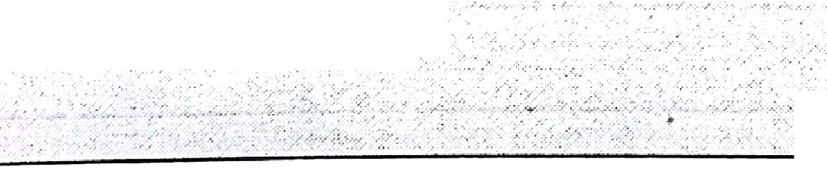

[create:or replace trigger ps:al](https://e-next.in/)

[·-·0·,: ..;;•_-i,,;--,.,:.. '.· ·;:,··](https://e-next.in/)

fo(each ro-w ,_

before delete or insert or.update n emp,· ·· · · ·

.. -· .... ;-_;,,;.,:,:-,,_.

h n(new.emp_no>O)

_

declare sal iff,number(B,2}; begin.·

saldiff:= : new.sal;.:old;sa l; dbms output.put_line(:old.sal);

dbms output.put_line(:rfow,.sal);

dbms_ot.itput.put_line,( new sat- Q d:sal);_· ·

. . .

, ... . . .:• . ,_.: ,: . -·.·.. ,

end;·

. •.• :-.

.. - ...

·..•..:.;,..,

.



-.···>.. ?- ;;',:, •·:> -:'" :·; *:-. ...* :-: ,·c:.. ..

. . ...,. •. - ··' ..

,, ·• .'-·. ' ' .



**OUTPUT**

**-**

|  |  |  |  |  |
| --- | --- | --- | --- | --- |
| Up at | | e-e p_, -elfs l:J9.P9e:.. -- 4q9,0t ._.,_'- , . | | . |
| **Pl/SQ(** | **,Proce_dure·S ·ccessfully** | | **,:executE!d**- . , ·:< _.,:. |

□**DD**